ABCmouse中班下Letters Review r-s-t&Colors,Part1课时8
复习素材：  - Brandon’s blue world.  - Blue All Round Cutout Puzzle. | 新授素材内容：  - Look at all the colors I can see video.  - Blue Jigsaw Puzzle.  - Color Painting:Blue.
素材截图：
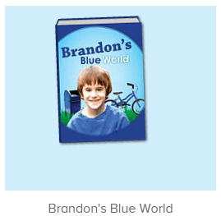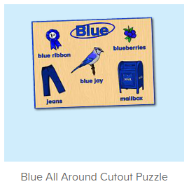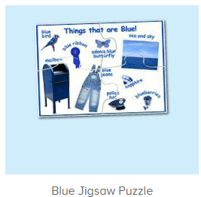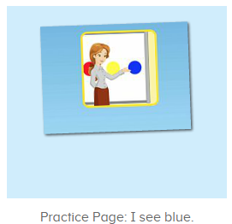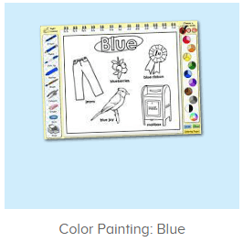
年龄段：中班下
教学目标：
- 能流利看图说出图书词汇。
- 能流利说出句子I see blue.并用I see...句型套用图书词汇和拼图造句。
- 能跟唱整首并表演TPR。
教具准备：1.图书词卡
使用游戏：1.Guessing game 2.TPR 3.Look and find.
教学步骤： |  | 备注
- 成果公布及展示：  T: Hello kids,good morning.  S:Good morning Yama.  T:First,let's praise Andy,Jason...They have finished their activities.  S:Good,good,very very good!  T:Andy,come here please, show us your activities  J:Ok.  T:Well done!(请完成家庭活动的幼生上前自主操作网站，向其他幼生展示家庭活动成果)  Everybody look,how many activities have Andy finished?  S:Four.  T:Wow,very good thank you Andy.  Coco come here, please show us your pet.  C:OK.  T:Everybody look,what is this?  S:This is my pet park.  T:Good!Coco,please introduce your pet park.  C:OK.Look,this is my pet park.This is my dog,Doggy.He is yellow.He can run fast.He likes to eat puppy food.I feed him everyday.  T:Very good,Coco.Let's praise.  T&S:Good,good,very very good! |  | 成果公布及展示我的宠物(单个幼生展示)
- 集体学习活动：  快乐唱吧  T:Now let's sing a song,listen and sing.(教师点击进入图1素材，请幼生跟唱整首歌曲)  S:Look at all the colors I can see.I see big red apples in the tree.I can see my yellow cat.I can see my big blue hat.Oh,look at all the colors I can see...  T:Good job!Once again.（重复播放第1-3句）  S:Look at all the colors I can see.I see big red apples in the tree.I can see my yellow cat.I can see my big blue hat.Oh,look at all the colors I can see...  T:Now stand up and dance with me.（加上动作）  T&S:Look at all the colors I can see.I see big red apples in the tree.I can see my yellow cat.I can see my big blue hat.Oh,look at all the colors I can see...  趣读图书  T:Now let's read a book.（教师点击进入图2图书素材）  What is the name of this book?  S:Brandon’s blue world.  T:Who is this?  S:This is Brandon.  T:What color does she like?  S:He likes the color blue.  T:Well done.Now listen and repeat.  S:This is Brandon.He likes the color blue...  Listen and choose  T:Now let’s play a card game.(把图书图卡贴在白板上，请幼生听图书发音挑出正确的图卡进行排序)  Listen and choose.  Peter,you are the first one,then Lily next,then one by one come here,ok?  S:OK.  T:Ready go!(点击播放图书，关掉屏幕，请幼生一个接一个上前挑选图卡)  趣味复读机  T:Awesome job!Now let’s learn a new sentence.  Listen and repeat.  S:I see blue.(跟读2-3遍)  T:What color do you see?  S:I see blue.  T:Good job!  Now let’s open the book,and tell me what do you see,ok?  S:OK.  T:What do you see?  S:I see blue bicycle/blue sky...  拼一拼，说一说  T:Well done!Now let's play a puzzle game.Who can try?（点击进入图3-图4素材）  S:Let me try.  T:Kelly/Lily/Lucy...please.  Everybody listen and repeat.  S:Blue/jeans/mailbox...  T:Terrific!  Now tell me what do you see?  S:I see blue/jeans/mailbox...  美术涂涂乐  T:Very good!Now let’s do something painting.（点击进入图5素材）  Who can try?  S:Let me try.  T:Ken/Fiona/Paul...please.  Everybody listen and repeat.  S:Blue/jeans/mailbox...  趣味大扫描  T:Nice job!Now let's sing again.  Listen and sing,ready go!  S:Look at all the colors I can see.I see big red apples in the tree.I can see my yellow cat.I can see my big blue hat.Oh,look at all the colors I can see...(边唱边做动作)  T:Very nice.Can you tell me what do you see in the book?  S:I see blue sky/blue bicycle...  T:Nice job!Now let's count our tickets.  Who can try?  S:Let me try.  T:Candy please.  T:How many tickets do we have today?  Let's count with ABCmouse.  S&ABCmouse:One,two,three...  T:So How many tickets do we have today?  S:We have ten tickets today.  T:Candy,how many tickets do we have today?  C:We have ten tickets today.  T:Thank you Candy.Very good! |  | 图1  图2  图3  图4  图5
- 家庭活动布置：
T:Now I'll show you the activities.（将已放入功课的作业界面打开）
T: Look,how many activities do you need to do?
S:...
T:Very well.Now I will show you how to do it.Please listen carefully.
Jason come here and show us how to do the activities.
Good job!Thank you Jason!
Please finish the activities and show me tomorrow,ok?
S:OK!
T:Class is over, Goodbye everyone.
S:Goodbye Yama.

