ABCmouse中班下Letters Review r-s-t&Colors,Part1课时10
复习素材：
- Look at all the colors I can see video.
- Rina's red world.
- Brandon's blue world.
- Yasmin's yellow world.
- Practice Page:I see red/yellow/blue.
- Primary Colors Butterfly Catcher.
- Primary Colors Memory Match.
素材截图：
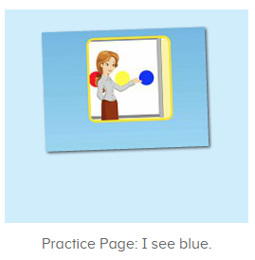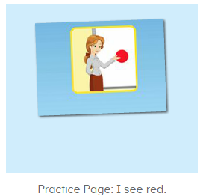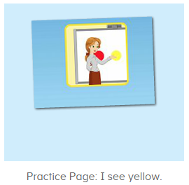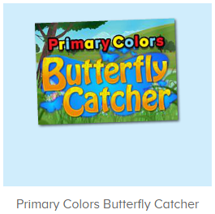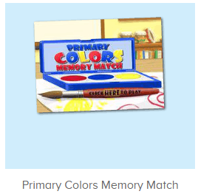
年龄段：中班下
教学目标：
- 能流利说出三种原色的名称。
- 能流利说出句子I see red/yellow/blue.并用I see...句型造句。
- 能跟唱整首并表演TPR。
- 能流利说出图书名称及图书词汇。
教具准备：1.图书词卡
使用游戏：1.Guessing game 2.TPR 3.Look and find.
教学步骤： | 备注
- 成果公布及展示：  T: Hello kids,good morning.  S:Good morning Yama.  T:First,let's praise Andy,Jason...They have finished their activities.  S:Good,good,very very good!  T:Andy,come here please, show us your activities  J:Ok.  T:Well done!(请完成家庭活动的幼生上前自主操作网站，向其他幼生展示家庭活动成果)  Everybody look,how many activities have Andy finished?  S:Four.  T:Wow,very good thank you Andy.  Coco come here, please show us your pet.  C:OK.  T:Everybody look,what is this?  S:This is my pet park.  T:Good!Coco,please introduce your pet park.  C:OK.Look,this is my pet park.This is my dog,Doggy.He is yellow.He can run fast.He likes to eat puppy food.I feed him everyday.  T:Very good,Coco.Let's praise.  T&S:Good,good,very very good! | 成果公布及展示我的宠物(单个幼生展示)
- 集体学习活动：  快乐唱吧  T:Now let's sing a song,listen and sing.(教师点击进入图1素材，请幼生跟唱整首歌曲)  S:Look at all the colors I can see.I see big red apples in the tree.I can see my yellow cat.I can see my big blue hat.Oh,look at all the colors I can see...  T:Good job!Once again.  S:Look at all the colors I can see.I see big red apples in the tree.I can see my yellow cat.I can see my big blue hat.Oh,look at all the colors I can see...  T:Now stand up and dance with me.（加上动作）  T&S:Look at all the colors I can see.I see big red apples in the tree.I can see my yellow cat.I can see my big blue hat.Oh,look at all the colors I can see...  记忆对对碰  T:Well done!Now let's play the memory match game.(教师点击进入图2素材)  Everybody listen and repeat.  S:Blue/tomato...  T:Who can try?  S:Let me try.  T:Paul/Leo/Tina...please.  趣读图书  T:Now let's read a book.（教师点击进入图3图书素材）  What is the name of this book?  S:Rina's red world.  T:Who is this?  S:This is Rina.  T:What color does she like?  S:She likes the color red.  T:Well done.Now listen and repeat.  S:This is Rina.She likes the color red...  Guessing Game  T:Now let's play a card game.(把图书图卡背面贴在白板上，请幼生猜图卡)  What is it?  S:Red stop sign/red cherries...  T:Right?Let's check.  Wow,good job!/Oh no!What is it?  S:Red bricks...  T:Let's continue.  趣味复读机  T:Awesome job!Now repeat the sentence.（打开图4素材）  S:I see red.(跟读2-3遍)  T:What color do you see?  S:I see red.  T:Good job!  Now let's open the book,and tell me what do you see,ok?  S:OK.  T:What do you see?  S:I see red bricks/red stop sign...  趣读图书  T:Now let's read a book.（教师点击进入图5图书素材）  What is the name of this book?  S:Yasmin's yellow world.  T:Who is this?  S:This is Yasmin.  T:What color does she like?  S:She likes the color yellow.  T:Well done.Now listen and repeat.  S:This is Yasmin.She likes the color yellow...  Flash Cards  T:Now let's play a card game.(快速出示图书图卡，请幼生猜图卡)  What is it?  S:Yellow boot/yellow banana...  T:Right?Let's check.  Wow,good job!/Oh no!What is it?  S:Yellow hat...  T:Let's continue.  趣味复读机  T:Awesome job!Now repeat the sentence.（打开图6素材）  S:I see red.(跟读2-3遍)  T:What color do you see?  S:I see yellow.  T:Good job!  Now let's open the book,and tell me what do you see,ok?  S:OK.  T:What do you see?  S:I see yellow hat/yellow flowers...  Butterfly Catcher  T:You all did a great job!Now let's play a game.(打开图7素材)  Who can try?  S:Let me try.  T:Sherry/Coco/Bonnie...please.  Everybody listen and repeat.  S:Blue/red/yellow...  趣读图书  T:Very well!Now let's read a book.（教师点击进入图8图书素材）  What is the name of this book?  S:Brandon's blue world.  T:Who is this?  S:This is Brandon.  T:What color does he like?  S:He likes the color blue.  T:Well done.Now listen and repeat.  S:This is Brandon.He likes the color blue...  Flash Cards  T:Now let's play a card game.(快速出示图书图卡，请幼生猜图卡)  What is it?  S:Blue sky/blue bicycle...  T:Right?Let's check.  Wow,good job!/Oh no!What is it?  S:Yellow car...  T:Let's continue.  趣味复读机  T:Awesome job!Now repeat the sentence.（打开图9素材）  S:I see blue.(跟读2-3遍)  T:What color do you see?  S:I see blue  T:Good job!  Now let's open the book,and tell me what do you see,ok?  S:OK.  T:What do you see?  S:I see blue sky/blue car/blue bicycle...  趣味大扫描  T:Nice job!Now let's sing again.  Listen and sing,ready go!  S:Look at all the colors I can see.I see big red apples in the tree.I can see my yellow cat.I can see my big blue hat.Oh,look at all the colors I can see...(边唱边做动作)  T:Very nice.What color do you see?  S:I see red/yellow/blue.  T:Nice job!Now let's count our tickets.  Who can try?  S:Let me try.  T:Candy please.  T:How many tickets do we have today?  Let's count with ABCmouse.  S&ABCmouse:One,two,three...  T:So How many tickets do we have today?  S:We have ten tickets today.  T:Candy,how many tickets do we have today?  C:We have ten tickets today.  T:Thank you Candy.Very good! | 图1  图2  图3  图4  图5  图6  图7  图8  图9
- 家庭活动布置：
T:Now I'll show you the activities.（将已放入功课的作业界面打开）
T: Look,how many activities do you need to do?
S:...
T:Very well.Now I will show you how to do it.Please listen carefully.
Jason come here and show us how to do the activities.
Good job!Thank you Jason!
Please finish the activities and show me tomorrow,ok?
S:OK!
T:Class is over, Goodbye everyone.
S:Goodbye Yama.

