ABCmouse中班下Letters Review r-s-t&Colors,Part1课时9
复习素材：
- Look at all the colors I can see video.
- Colors,Part 1 Practice.
- Colors,Part 1 Quiz.
- Colors,Part 1-C Animation.
- Primary Colors Painting Page.
- Practice Page:This is red/yellow/blue.
- Primary Colors Cutout Puzzle.
素材截图：
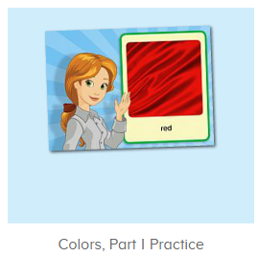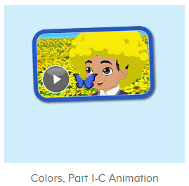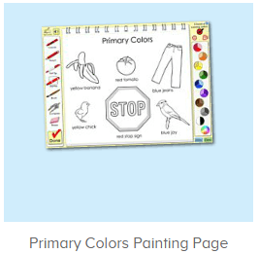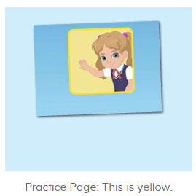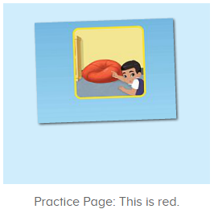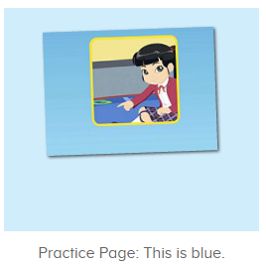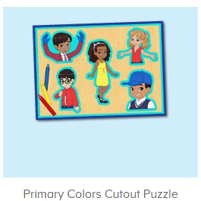
年龄段：中班下
教学目标：
- 能流利说出三种原色的名称。
- 能流利说出句子This is red/yellow/blue.并用This is...句型造句。
- 能跟唱整首并表演TPR。
- 能跟唱口语动画视频。
教具准备：1.图书词卡
使用游戏：1.Guessing game 2.TPR 3.Look and find.
教学步骤： | 备注
- 成果公布及展示：  T: Hello kids,good morning.  S:Good morning Yama.  T:First,let's praise Andy,Jason...They have finished their activities.  S:Good,good,very very good!  T:Andy,come here please, show us your activities  J:Ok.  T:Well done!(请完成家庭活动的幼生上前自主操作网站，向其他幼生展示家庭活动成果)  Everybody look,how many activities have Andy finished?  S:Four.  T:Wow,very good thank you Andy.  Coco come here, please show us your pet.  C:OK.  T:Everybody look,what is this?  S:This is my pet park.  T:Good!Coco,please introduce your pet park.  C:OK.Look,this is my pet park.This is my dog,Doggy.He is yellow.He can run fast.He likes to eat puppy food.I feed him everyday.  T:Very good,Coco.Let's praise.  T&S:Good,good,very very good! | 成果公布及展示我的宠物(单个幼生展示)
- 集体学习活动：  快乐唱吧  T:Now let's sing a song,listen and sing.(教师点击进入图1素材，请幼生跟唱整首歌曲)  S:Look at all the colors I can see.I see big red apples in the tree.I can see my yellow cat.I can see my big blue hat.Oh,look at all the colors I can see...  T:Good job!Once again.  S:Look at all the colors I can see.I see big red apples in the tree.I can see my yellow cat.I can see my big blue hat.Oh,look at all the colors I can see...  T:Now stand up and dance with me.（加上动作）  T&S:Look at all the colors I can see.I see big red apples in the tree.I can see my yellow cat.I can see my big blue hat.Oh,look at all the colors I can see...  口语动画  T:Now enjoy the video.First,listen carefully.（教师点击进入图2素材）  What can you hear?  S:Red/yellow/blue/I see red...  T:Right?Let's check.  Please listen and sing.  S:Red,red,red....  T:Nice job!Once again.  S:Red,red,red....  T:Now,boys and girls,you will have a match,are you ready?  S:Yes,we are ready.  Bs/Gs:Red,red,red....  Listen and choose  T:Pretty good!Now let's listen and choose.（教师点击进入图3素材）  Everybody listen and repeat.  Who can try?  S:Let me try.  T:Paul/Leo/Tina...please.  小小录音机  T:Now let's practice and record.（教师点击进入图4素材）  Everybody together.  S:Color/red/yellow/blue...  T:Who can try?  S:Let me try.  T:Tim/Lily/Peter...please.  T/L/P:Color/red/yellow/blue...  T:Good job!  What is this?(出示颜色图卡)  S:This is color.  T:What color is this?  S:This is red/yellow/blue.  趣味复读机  T:Nice job!Please listen and repeat.(教师依次点击进入图5-图7素材，请幼生跟读发音)  S:This is red/yellow/blue.  T:Look,what is this?  S:This is red apple/yellow banana/blue bicycle...(出示对应颜色图卡，用this is ...句型造句)  美术涂涂乐  T:Very good!Let's do some painting.  Who can try?  S:Let me try.  T:Paul/Henry...please.  Everybody listen and repeat.  S:Red/yellow/blue...  T:Well done.Everybody look,what is this?  S:This is red stop sign/yellow banana/blue jay...  拼一拼，说一说  T:Great job!It's puzzle game time!  Please listen and repeat.  S:I have a blue hat...  T:Who can try?  S:Let me try.  T:Gina/Fiona/Dora...please.  S:I have a blue hat...  T:Now look at yourself,who has a red/yellow/blue dress/shoes/shirt...?  S:I have red dress....  趣味大扫描  T:Nice job!Now let's sing again.  Listen and sing,ready go!  S:Look at all the colors I can see.I see big red apples in the tree.I can see my yellow cat.I can see my big blue hat.Oh,look at all the colors I can see...(边唱边做动作)  T:Very nice.What color is this?  S:This is red/yellow/blue.  T:Nice job!Now let's count our tickets.  Who can try?  S:Let me try.  T:Candy please.  T:How many tickets do we have today?  Let's count with ABCmouse.  S&ABCmouse:One,two,three...  T:So How many tickets do we have today?  S:We have ten tickets today.  T:Candy,how many tickets do we have today?  C:We have ten tickets today.  T:Thank you Candy.Very good! | 图1  图2  图3  图4  图5  图6  图7  图8  图9
- 家庭活动布置：
T:Now I'll show you the activities.（将已放入功课的作业界面打开）
T: Look,how many activities do you need to do?
S:....
T:Very well.Now I will show you how to do it.Please listen carefully.
Jason come here and show us how to do the activities.
Good job!Thank you Jason!
Please finish the activities and show me tomorrow,ok?
S:OK!
T:Class is over, Goodbye everyone.
S:Goodbye Yama.

