ABCmouse中班下Letters Review r-s-t&Colors,Part1课时1
新授素材内容：
- U-V-W Review Cutout Puzzle.
- Letters u-v-w Chant.
- U-V-W Matching Card.
- Colors,Part2 Animation.
- Practice Page:orange/purple/green.
- Secondary Colors pop and peek.
素材截图：
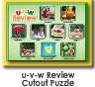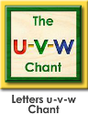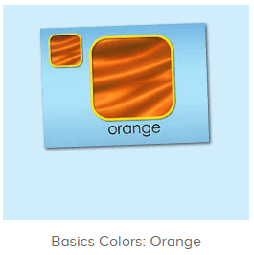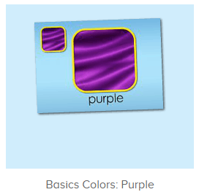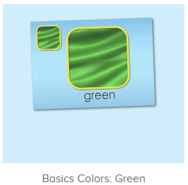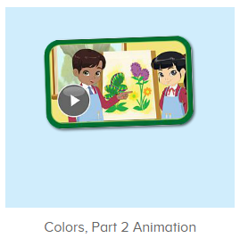
年龄段：中班下
教学目标：
- 能熟练掌握字母U,V,W的基础发音。
- 能熟练掌握对应发音的词汇词
- 能自如念唱U-V-W的所有诗歌及歌曲。
- 能掌握orange,purple,green的发音，并能从口语视频中听出关键的词汇。
教具准备：1.字母u,v,w开头的单词图卡 2.橙色、紫色、绿色的图卡
使用游戏：1.Guessing game 2.TPR 3.look and find.
教学步骤： | 备注
- 成果公布及展示：  T: Hello kids,good morning.  S:Good morning Yama.  T:First,let's praise Andy,Jason...They have finished their activities.  S:Good,good,very very good!  T:Andy,come here please, show us your activities  J:Ok.  T:Well done!(请完成家庭活动的幼生上前自主操作网站，向其他幼生展示家庭活动成果)  Everybody look,how many activities have Andy finished?  S:Four.  T:Wow,very good thank you Andy.  Now everybody look,what is this?  S:This is my tickets,my room,my avatar.  T:Good job!Coco come here, please show us your tickets.  C:OK.This is my tickets.I got many tickets from ABCmouse.I have 120 tickets.I want to be the tickets winner.I want to buy a new pet.  T:Thank you Coco.Henry come here,please show us your room.  H:OK.This is my room.I have two tables in my room.I have many toys in my room.My room is blue.It is very beautiful.I like my room very much.  T:Very good,Henry.Let's praise.  T&S:Good,good,very very good! | 成果公布及展示我的奖励票、我的化身、我的房间(单个幼生展示)
- 集体学习活动：  拼拼乐  T: Now let's play a puzzle game.Please listen and repeat.(教师点击进入图1素材，选择级别1完成拼图，请幼生仔细听跟着说）  S:Vacuum/wolf/violin...  T:Well done.Now who wants to try?（教师选择级别2/3，请幼生上前操作素材，其余幼生跟读发音）  S:Let me try.  T:Tim/Lily/Peter...please.  Everybody listen and repeat.  S:Vacuum/wolf/violin...  图卡对对碰  T:Well done!Now let's play a game.(教师点击进入图2素材，请幼生跟读发音并选择正确的图卡进行配对)  Please repeat and choose.  S:Vacuum/wheelbarrow/umbrella...  T:Good job!Who can try?  S:Let me try.  T:Tim/Lily/Peter...please.  Everybody listen and repeat.  S:Rabbit,r,snake,s...  快乐唱吧  T:Wonderful.Let's chant.First listen and no voice.（教师点击进入图3素材，请幼生先听不跟唱）  S:Letter u says "u"."u" "u" "u",umbrella, umpire, under,"u" letter u.Letter v says "v"."v" "v" "v",volcano, violin, vegetables,"v" letter v.Letter w says "w". "w" "w" "w",worm, wolf, watermelon,"w" letter w.  T:Now follow it.  S:Letter u says "u"...  T:Very nice!Now stand up,let's sing and dance.  S:Letter u says "u"...  趣味口语  T:Wonderful!Now please enjoy the video.（打开图4口语视频，请幼生只看不跟读，提示幼生找出关键词汇）  What can you hear?  S:Color,orange,purple,green,flower...  T:Right?Let's check.  Very nice.  趣味复读机  T:Now listen and repeat.（教师依次打开图5-图7素材，请幼生跟读发音）  S:Orange/purple/green.(跟读2-3遍)  T:Hear the syllables.  Now follow it.  S:Orange,o-range,o-range,orange.（可进行分组跟读2-3遍）  T:Now look,what color is it?（教师拿出三种颜色图卡依次询问）  S:Orange/purple/green.  T:Great job!Can you see orange/purple/green in the classroom?（请幼生找出教室内相对应颜色的物品）  S:Yes.  T:Show me.  Wow,terrific!  小小录音机  T:Now let's practice and record.  Everybody together.  S:Orange/purple/green.  T:Who can try?  S:Let me try.  T:Tim/Lily/Peter...please.  T/L/P:Orange/purple/green.  T:Good job!  Pop and Peek  T:Now let's pop and peek.  Who can try?  S:Let me try.  T:Tim/Lily/Peter...please.  Everybody listen and repeat.  S:Orange/purple/green...  T:What color do you see?  S:Orange/purple/green.  趣味大扫描  T:Nice job!Now let's chant again.  S:Letter u says "u"...  T:Good job!Now I will turn of the music,let's sing and dance.  S:Letter u says "u"...  T:Very good!Now look,what color is it?  S:Orange,purple,green.  T:Wonderful!Now let's count our tickets.  Who can try?  S:Let me try.  T:Candy please.  T:How many tickets do we have today?  Let's count with ABCmouse.  S&ABCmouse:One,two,three...  T:So How many tickets do we have today?  S:We have ten tickets today.  T:Candy,how many tickets do we have today?  C:We have ten tickets today.  T:Thank you Candy.Very good! | 图1：  图2：  图3：  图4：  图5  图6  图7  图8
- 家庭活动布置：
T:Now I'll show you the activities.（将已放入功课的作业界面打开）
T: Look,how many activities do you need to do?
S:...
T:Very well.Now I will show you how to do it.Please listen carefully.
Jason come here and show us how to do the activities.
Good job!Thank you Jason!
Please finish the activities and show me tomorrow,ok?
S:OK!
T:Class is over, Goodbye everyone.
S:Goodbye Yama.

