ABCmouse中班下Letters Review r-s-t&Colors,Part1课时2
新授素材内容：
- Letters u-v-w Chant.
- Colors,Part2-A Animation.
- Practice Page:orange/purple/green.
- Secondary Colors Memory Match.
- B-I-N-G-O.
素材截图：
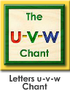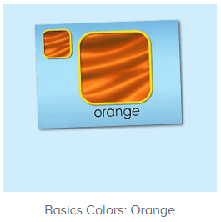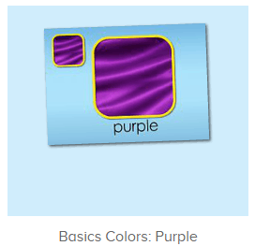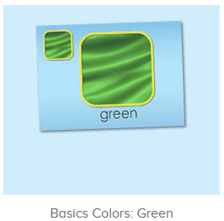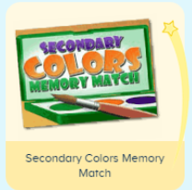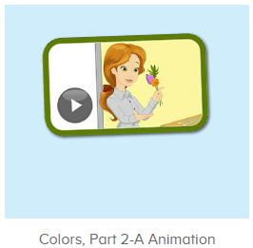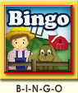
年龄段：中班下
教学目标：
- 能自如念唱U-V-W的所有诗歌及歌曲。
- 能掌握orange,purple,green的发音，并能从口语视频中听出关键的词汇。
- 能自如说出三种颜色的名称，并能找到想对应颜色的物品，会简单的描述。
- 初步认识歌曲B-I-N-G-O。
教具准备：1.橙色、紫色、绿色的图卡 2.三种想对应颜色物品的图卡或实物。
使用游戏：1.Guessing game 2.TPR 3.Look and say.
教学步骤： | 备注
- 成果公布及展示：  T: Hello kids,good morning.  S:Good morning Yama.  T:First,let's praise Andy,Jason...They have finished their activities.  S:Good,good,very very good!  T:Andy,come here please, show us your activities  J:Ok.  T:Well done!(请完成家庭活动的幼生上前自主操作网站，向其他幼生展示家庭活动成果)  Everybody look,how many activities have Andy finished?  S:Four.  T:Wow,very good thank you Andy.  Now everybody look,what is this?  S:This is my tickets,my room,my avatar.  T:Good job!Coco come here, please show us your tickets.  C:OK.This is my tickets.I got many tickets from ABCmouse.I have 120 tickets.I want to be the tickets winner.I want to buy a new pet.  T:Thank you Coco.Henry come here,please show us your room.  H:OK.This is my room.I have two tables in my room.I have many toys in my room.My room is blue.It is very beautiful.I like my room very much.  T:Very good,Henry.Let's praise.  T&S:Good,good,very very good! | 成果公布及展示我的奖励票、我的化身、我的房间(单个幼生展示)
- 集体学习活动：  快乐唱吧  T:Wonderful.Let's chant.First listen and no voice.（教师点击进入图1素材，请幼生先听不跟唱）  S:Letter u says "u"."u" "u" "u",umbrella, umpire, under,"u" letter u.Letter v says "v"."v" "v" "v",volcano, violin, vegetables,"v" letter v.Letter w says "w". "w" "w" "w",worm, wolf, watermelon,"w" letter w.  T:Now follow it.  S:Letter u says "u"...  T:Very nice!Now stand up,let's sing and dance.  S:Letter u says "u"...  趣味口语  T:Wonderful!Now please enjoy the video.（打开图2口语视频，请幼生只看不跟读，提示幼生找出关键词汇）  What can you hear?  S:Color,orange,purple,green,flower...  T:Right?Let's check.  Very nice.  Now you are the children,please listen to Miss Jones and repeat.  S:Orange,purple,green...  T:Very nice.  趣味复读机  T:Now listen and repeat.（教师依次打开图3-5素材，请幼生跟读发音）  S:Orange/purple/green.(跟读2-3遍)  T:Hear the syllables.  Now follow it.  S:Orange,o-range,o-range,orange.（可进行分组跟读2-3遍）  T:Now let's practice and record.  Everybody together.  S:Orange/purple/green.  T:Who can try?  S:Let me try.  T:Tim/Lily/Peter...please.  T/L/P:Orange/purple/green.  T:Good job!  T:Now look,what color is it?（教师拿出三种颜色图卡依次询问）  S:Orange/purple/green.  T:Great job!Can you see orange/purple/green in the classroom?（请幼生找出教室内相对应颜色的物品）  S:Yes.  T:Show me.  Susan/Lily/Lucas,what can you find in orange/purple/green?  S/L/L:A ball/flower/crayon...  T:Wow,terrific!  Now everybody look,what is this?  S:This is a flower/ball/crayon...  T:What color is the flower/ball/crayon...?  S:Orange/purple/green.  T:So this is an/a orange/purple/green flower/ball/crayon..  Let's say it together.  What is this?  T&S:This is an/a orange/purple/green flower/ball/crayon..  Let's practice  T:Now let's practice and record.（点击进入图6素材，请幼生跟读并录音）  All together.  S:Flower,orange,purple,green,yellow and blue make green.  T:Who can try?  S:Let me try.  T:Tim/Lily/Peter...please.  T/L/P:Flower,orange,purple,green,yellow and blue make green.  T:Good job!  What is this?(出示图卡)  S:This is flower.  T:What color is this?  S:Orange,purple,green.  T:How to make color green?  S:Yellow and blue make green.  T:Nice job!.  Listen and choose  T:Pretty good!Now let's listen and choose.（教师点击进入图7素材）  Everybody listen and choose.  Very good!  Now,who can try?  S:Let me try.  T:Paul/Leo/Tina...please.  图卡对对碰  T:Nice job!Now let's play a memory match game.（点击进入图8素材，请幼生跟读并进行图卡配对）  Who can try?  S:Let me try.  T:Kelly,Fiona,Gina,Dave..please.  Everybody listen and repeat.  S:Purple/orange/green/goldfish/grasshopper....  T:Terrific!  快乐唱吧  T:Now listen to the music,no voice.（点击播放图9歌曲素材）  What can you hear?  S:B-I-N-G-O.  T:Good job!Now you can follow the music.  S:B-I-N-G-O. B-I-N-G-O. B-I-N-G-O....  趣味大扫描  T:Nice job!Now let's chant again.  S:Letter u says "u"...  T:Good job!Now I will turn of the music,let's sing and dance.  S:Letter u says "u"...  T:Very good!Now look,what is this?  S:This is an/a orange/purple/green flower/ball/crayon..  T:Wonderful!Now let's count our tickets.  Who can try?  S:Let me try.  T:Candy please.  T:How many tickets do we have today?  Let's count with ABCmouse.  S&ABCmouse:One,two,three...  T:So How many tickets do we have today?  S:We have ten tickets today.  T:Candy,how many tickets do we have today?  C:We have ten tickets today.  T:Thank you Candy.Very good! | 图1：  图2：  图3  图4  图5  图6  图7  图8  图9
- 家庭活动布置：
T:Now I'll show you the activities.（将已放入功课的作业界面打开）
T: Look,how many activities do you need to do?
S:...
T:Very well.Now I will show you how to do it.Please listen carefully.
Jason come here and show us how to do the activities.
Good job!Thank you Jason!
Please finish the activities and show me tomorrow,ok?
S:OK!
T:Class is over, Goodbye everyone.
S:Goodbye Yama.

