ABCmouse中班下Letters Review r-s-t&Colors,Part1课时3
新授素材内容：
- Colors,Part2-A Animation.
- B-I-N-G-O.
- Secondary Colors Cutout Puzzle.
- Olivia's Orange World.
- Orange All Around Cutout Puzzle.
- Practice Page:I see orange.
- Color Painting:Orange.
素材截图：
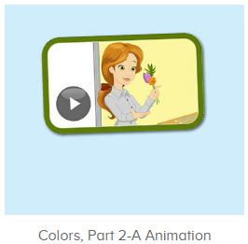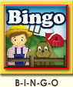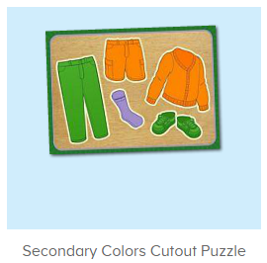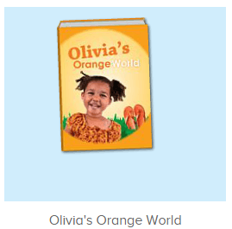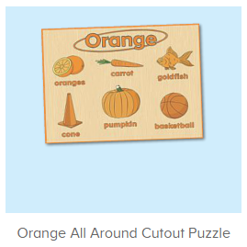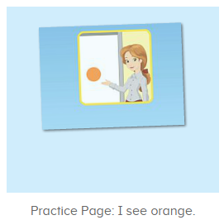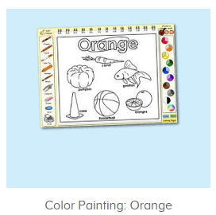
年龄段：中班下
教学目标：
- 能跟着歌曲B-I-N-G-O进行哼唱。
- 能掌握orange,purple,green的发音，并能从口语视频中听出关键的词汇。
- 能自如说出三种颜色的名称，并能找到想对应颜色的物品，会简单的描述。
- 能自如跟读图书Olivia's orange world。
- 能流利说出句子I see orange,并能套用图书词汇和拼图词汇进行造句。
教具准备：1.图书词卡
使用游戏：1.Guessing game 2.TPR 3.Look and say.
教学步骤： | 备注
- 成果公布及展示：  T: Hello kids,good morning.  S:Good morning Yama.  T:First,let's praise Andy,Jason...They have finished their activities.  S:Good,good,very very good!  T:Andy,come here please, show us your activities  J:Ok.  T:Well done!(请完成家庭活动的幼生上前自主操作网站，向其他幼生展示家庭活动成果)  Everybody look,how many activities have Andy finished?  S:Four.  T:Wow,very good thank you Andy.  Now everybody look,what is this?  S:This is my tickets,my room,my avatar.  T:Good job!Coco come here, please show us your tickets.  C:OK.This is my tickets.I got many tickets from ABCmouse.I have 120 tickets.I want to be the tickets winner.I want to buy a new pet.  T:Thank you Coco.Henry come here,please show us your room.  H:OK.This is my room.I have two tables in my room.I have many toys in my room.My room is blue.It is very beautiful.I like my room very much.  T:Very good,Henry.Let's praise.  T&S:Good,good,very very good! | 成果公布及展示我的奖励票、我的化身、我的房间(单个幼生展示)
- 集体学习活动：  快乐唱吧  T:Now listen to the music and follow it.（点击播放图1歌曲素材）  S:There was a farmer had a dog...B-I-N-G-O. B-I-N-G-O. B-I-N-G-O...  趣味口语  T:Wonderful!Now please enjoy the video and you are the children,please listen to Miss Jones and repeat.（打开图2口语视频，请幼生跟读视频中儿童部分）  S:Orange,purple,green...  T:Very nice.  拼拼乐  T:Now let's play a puzzle game.（点击进入图3素材，请幼生完成拼图且跟读发音）  Who can try?  S:Let me try.  T:Jerry/Peter/Ada..please.  Everybody listen and repeat.  S:Orange shorts/purple socks/green pants...  趣味图书  T:You are great!Now let's read a book,first,listen carefully,no voice.（打卡图4素材，请幼生先听不跟读）  What is the book's name?  S:Olivia's orange world.  T:Right?Let's check.Listen again.  So good!Now repeat it.  S:Olivia's orange world.(跟读2-3遍)  T:Very good!Let's continue.Listen and no voice.  What can you hear?  S:Orange juice/orange kitten/orange basketball/orange fish...  T:Right?Let's check.Listen again.  Wow,good job!  Now listen and repeat.  S:Olivia's orange world...orange juice,orange kitten,orange basketball...（跟读2遍）  T:Nice job!This time let's have a team match.Are you ready?  S:Yes,we are ready.  T1/T2:Orange juice,orange kitten,orange basketball...  T:Terrific!Now let's play a matching card game.  Peter,you will be the first,then come here one by one,ok?（邀请幼生一个接一个上前听音找图卡）  S:OK.  T:Now listen and repeat.  S:Orange juice,orange kitten,orange basketball...  T:Very good!This time,I want one kid to pick the card.  Who wants to try?  S:Let me try.  T:Toby,come here please.  Everybody listen and repeat,then check the cards,ok?  S:OK.  Orange juice,orange kitten,orange basketball...  T:Thank you Toby,now let's check the cards.  What is this?  S:Orange juice/orange kitten/orange basketball/orange fish...  T:Does Toby pick the right card?  S:Yes.  T:Good job,Toby.  拼拼乐  T:Puzzle time!(打开图5素材)  First,what can you see?  S:Goldfish/basketball/pumpkin/carrot...  T:Is it right?Let's check,who can try?  S:Let me try.  T:Lily/Rita/Peter...please.  Everybody listen and repeat.  S:Goldfish/basketball/pumpkin/carrot...  T:Very nice.What color are these things?  S:Orange.  T:Yes,we can see orange pumpkin...  What else can you see is orange?  S:Orange goldfish/orange cone...  T:Wonderful!  趣味复读机  T:Now let's practice the sentence.Listen and repeat.（点击进入图6素材，请幼生跟读句子）  S:I see orange.（跟读2-3遍）  T:What color do you see?  S:I see orange.  T:Good job!Now let's make sentences.  Look at the pictures,what orange things do you see?（应用图书词汇用I see orange...句型进行造句）  S:I see orange goldfish/cones/kitten...  美术涂涂乐  T:Great job!Now let's do some painting.（打开图7素材）  What can you see?  S:Cone/pumpkin...  T:You are right!  Who can try?  S:Let me try.  T:Kelly/Linda/Jerry...please.  Have you finished?  K/L/J:Yes.  T:OK.Thank you very much,go back to your seat please.  Now look,what do you see?  T&S:I see orange pumpkin/goldfish/cone...  T:Wonderful!  趣味大扫描  T:Now let's sing the song again.  S:There was a farmer had a dog...B-I-N-G-O. B-I-N-G-O. B-I-N-G-O...  T:Let's add some actions.Stand up please.  T&S:There was a farmer had a dog...B-I-N-G-O.B-I-N-G-O. B-I-N-G-O...  T:Wonderful!Now let's count our tickets.  Who can try?  S:Let me try.  T:Candy please.  T:How many tickets do we have today?  Let's count with ABCmouse.  S&ABCmouse:One,two,three...  T:So How many tickets do we have today?  S:We have ten tickets today.  T:Candy,how many tickets do we have today?  C:We have ten tickets today.  T:Thank you Candy.Very good! | 图1：  图2：  图3：  图4：  图5  图6  图7
- 家庭活动布置：
T:Now I'll show you the activities.（将已放入功课的作业界面打开）
T: Look,how many activities do you need to do?
S:...
T:Very well.Now I will show you how to do it.Please listen carefully.
Jason come here and show us how to do the activities.
Good job!Thank you Jason!
Please finish the activities and show me tomorrow,ok?
S:OK!
T:Class is over, Goodbye everyone.
S:Goodbye Yama.

