ABCmouse中班下Letters Review r-s-t&Colors,Part1课时7
新授素材内容：
- Colors,Part2-A Animation.
- B-I-N-G-O.
- Gabe's green World.
- Green All Around Cutout Puzzle.
- Practice Page:I see green.
- Color Painting:Green.
素材截图：
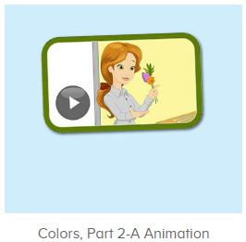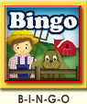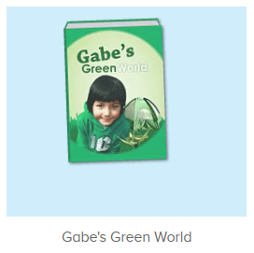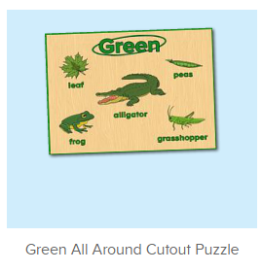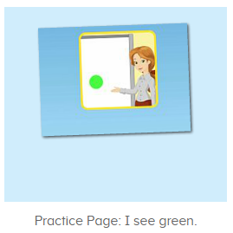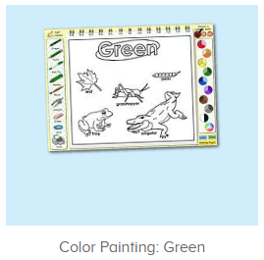
年龄段：中班下
教学目标：
- 能流利演唱整首歌曲B-I-N-G-O并表演律动。
- 能自如跟读图书Pilar's purple world。
- 能流利说出句子I see purple,并能套用图书词汇和拼图词汇进行造句。
教具准备：1.图书词卡
使用游戏：1.Guessing game 2.TPR 3.Look and say.
教学步骤： | 备注
- 成果公布及展示：  T: Hello kids,good morning.  S:Good morning Yama.  T:First,let's praise Andy,Jason...They have finished their activities.  S:Good,good,very very good!  T:Andy,come here please, show us your activities  J:Ok.  T:Well done!(请完成家庭活动的幼生上前自主操作网站，向其他幼生展示家庭活动成果)  Everybody look,how many activities have Andy finished?  S:Four.  T:Wow,very good thank you Andy.  Now everybody look,what is this?  S:This is my tickets,my room,my avatar.  T:Good job!Coco come here, please show us your tickets.  C:OK.This is my tickets.I got many tickets from ABCmouse.I have 120 tickets.I want to be the tickets winner.I want to buy a new pet.  T:Thank you Coco.Henry come here,please show us your room.  H:OK.This is my room.I have two tables in my room.I have many toys in my room.My room is blue.It is very beautiful.I like my room very much.  T:Very good,Henry.Let's praise.  T&S:Good,good,very very good! | 成果公布及展示我的奖励票、我的化身、我的房间(单个幼生展示)
- 集体学习活动：  快乐唱吧  T:Now Let's sing and dance.（点击播放图1歌曲素材）  S:There was a farmer had a dog...B-I-N-G-O. B-I-N-G-O. B-I-N-G-O...（可加入互动游戏，如接龙，分组跟唱等）  趣味口语  T:Great job!Now let's enjoy the video.（播放图2动画视频，请幼生留意视频句子并跟读儿童部分发音）  S:Orange,purple,green.  T:Now look,what color is this?  S:Green.  T:Can you find something green in the classroom?  S:Book/crayon...  趣味图书  T:You are great!Now let's read a book is all about the color green,first,listen carefully,no voice.（打卡图3素材，请幼生先听不跟读）  What is the book's name?  S:Gabe's green world.  T:Right?Let's check.Listen again.  So good!Now repeat it.  S:Gabe's green world.(跟读2-3遍)  T:Very good!Let's continue.Listen and no voice.  What can you hear?  S:Green apple/boat/frog...  T:Right?Let's check.Listen again.  Wow,good job!  Now listen and repeat.  S:Gabe's green world...green water bottle/green apple...（跟读2遍）  T:Nice job!Who is this?  S:This is Gabe.  T:What color does he like?  S:He likes the color green.  T:Great!This time let's have a team match.Are you ready?  S:Yes,we are ready.  T1/T2:Green water bottle/green apple..  T:Terrific!Now let's play a matching card game.  Peter,you will be the first,then come here one by one,ok?（邀请幼生一个接一个上前听音找图卡）  S:OK.  T:Now listen and repeat.  S:Green water bottle/green apple...  T:Very good!This time,I want one kid to pick the card.  Who wants to try?  S:Let me try.  T:Toby,come here please.  Everybody listen and repeat,then check the cards,ok?  S:OK.  Green water bottle/green apple...  T:Thank you Toby,now let's check the cards.  What is this/What are these?  S:Green water bottle/green apple...  T:Does Toby pick the right card?  S:Yes.  T:Good job,Toby.  拼拼乐  T:Puzzle time!(打开图4素材)  First,what can you see?  S:Alligator/frog...  T:Is it right?Let's check,who can try?  S:Let me try.  T:Lily/Rita/Peter...please.  Everybody listen and repeat.  S:Alligator/frog/grasshopper...  T:Very nice.What color are these things?  S:Green.  T:Yes,we can see green alligator.  What else can you see is green?  S:Green frog/green leaf...  T:Wonderful!  趣味复读机  T:Now let's practice the sentence.Listen and repeat.（点击进入图5素材，请幼生跟读句子）  S:I see green.（跟读2-3遍）  T:What color do you see?  S:I see green.  T:Good job!Now let's make sentences.  Look at the pictures,what green things do you see?（应用图书词汇用I see green...句型进行造句）  S:I see green grasshopper/green apple/green water bottle...  美术涂涂乐  T:Great job!Now let's do some painting.（打开图6素材）  T:What color do we need to color these things?  S:Green.  T:Terrific!Let's color they green.  Who can try?  S:Let me try.  T:Kelly/Linda/Jerry...please.  Have you finished?  K/L/J:Yes.  T:OK.Thank you very much,go back to your seat please.  Now look,what do you see?  T&S:I see green alligator/green leaf/green frog...  T:Wonderful!  趣味大扫描  T:Now let's sing and dance again.  S:There was a farmer had a dog...B-I-N-G-O. B-I-N-G-O. B-I-N-G-O...  T:Very good!Let's read the book again.  S:Gabe's green world...green water bottle/green apple...  T:Wonderful!Now let's count our tickets.  Who can try?  S:Let me try.  T:Candy please.  T:How many tickets do we have today?  Let's count with ABCmouse.  S&ABCmouse:One,two,three...  T:So How many tickets do we have today?  S:We have ten tickets today.  T:Candy,how many tickets do we have today?  C:We have ten tickets today.  T:Thank you Candy.Very good! | 图1：  图2：  图3：  图4：  图5  图6
- 家庭活动布置：
T:Now I'll show you the activities.（将已放入功课的作业界面打开）
T: Look,how many activities do you need to do?
S:...
T:Very well.Now I will show you how to do it.Please listen carefully.
Jason come here and show us how to do the activities.
Good job!Thank you Jason!
Please finish the activities and show me tomorrow,ok?
S:OK!
T:Class is over, Goodbye everyone.
S:Goodbye Yama.

