ABCmouse中班下Letters Review r-s-t&Colors,Part1课时4
新授素材内容：
- Colors,Part2-A Animation.
- B-I-N-G-O.
- Olivia's Orange World.
- Orange All Around Cutout Puzzle.
- Practice Page:I see orange./This is an orange flower.
- Orange Jigsaw Puzzle.
素材截图：
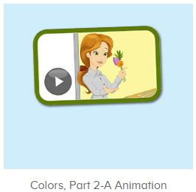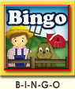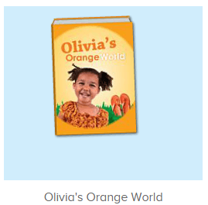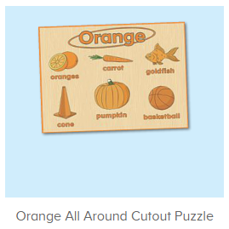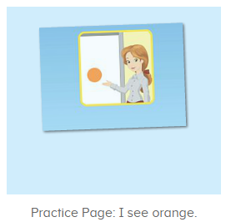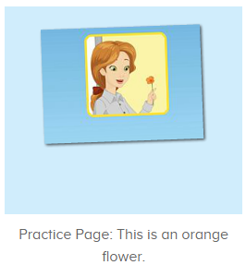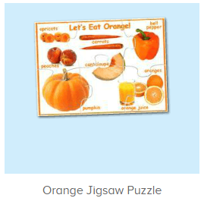
年龄段：中班下
教学目标：
- 能跟着歌曲B-I-N-G-O哼唱第一段。
- 能从口语视频中听出关键的句子。
- 能流利跟读图书Olivia's orange world并能看图说单词。
- 能流利说出句子I see orange.This is an orange flower并能套用图书词汇和拼图词汇进行造句。
教具准备：1.图书词卡
使用游戏：1.Guessing game 2.TPR 3.Look and say.
教学步骤： | 备注
- 成果公布及展示：  T: Hello kids,good morning.  S:Good morning Yama.  T:First,let's praise Andy,Jason...They have finished their activities.  S:Good,good,very very good!  T:Andy,come here please, show us your activities  J:Ok.  T:Well done!(请完成家庭活动的幼生上前自主操作网站，向其他幼生展示家庭活动成果)  Everybody look,how many activities have Andy finished?  S:Four.  T:Wow,very good thank you Andy.  Now everybody look,what is this?  S:This is my tickets,my room,my avatar.  T:Good job!Coco come here, please show us your tickets.  C:OK.This is my tickets.I got many tickets from ABCmouse.I have 120 tickets.I want to be the tickets winner.I want to buy a new pet.  T:Thank you Coco.Henry come here,please show us your room.  H:OK.This is my room.I have two tables in my room.I have many toys in my room.My room is blue.It is very beautiful.I like my room very much.  T:Very good,Henry.Let's praise.  T&S:Good,good,very very good! | 成果公布及展示我的奖励票、我的化身、我的房间(单个幼生展示)
- 集体学习活动：  快乐唱吧  T:Now listen to the music and follow it.（点击播放图1歌曲素材）  S:There was a farmer had a dog...B-I-N-G-O. B-I-N-G-O. B-I-N-G-O....  T:Good job!Now let's do the actions,follow me please.（重复第一段）  T&S:There was a farmer had a dog...B-I-N-G-O. B-I-N-G-O. B-I-N-G-O...  T:Very good!once again.  S:There was a farmer had a dog...B-I-N-G-O. B-I-N-G-O. B-I-N-G-O...  T:Boys and girls,you will have a match.Ready?  Bs/Gs:Yes,go go go!  Bs/Gs:There was a farmer had a dog...B-I-N-G-O. B-I-N-G-O. B-I-N-G-O..  趣味图书  T:You are great!Now let's read a book.  What is the name of this book?（跟读图2图书素材）  S:Olivia's orange world.  T:Who is this?  S:This is Olivia.  T:What color does she like?  S:She likes the color orange.  T:What color do you like?  S:I like the color blue/red/yellow...  T:Very good!Now let's read the book.  S:Olivia's orange world...orange juice,orange kitten,orange basketball...（跟读2遍）  T:Nice job!Look at the pictures.What is this?  S:Orange juice/orange kitten/orange basketball/orange fish...  T:Good job.  趣味复读机  T:Now let's practice the sentence.Listen and repeat.（点击进入图3素材，请幼生跟读句子）  S:I see orange.（跟读2-3遍）.  T:Good job!Now let's make sentences.  Look at the pictures,what orange things do you see?（应用图书词汇用I see orange....句型进行造句）  S:I see orange goldfish/cones/kitten....  拼拼乐  T:Puzzle time!（打开图4素材，完成拼图并应用I see...句型造句）  First,what orange things do you see?  S:I see orange pumpkin/carrots....  T:Let's finish the puzzle.Who can try?  S:Let me try.  T:Lily/Rita/Peter...please.  Everybody listen and repeat.  S:Let's eat orange.  T:Very nice.So what orange things do you see?  S:I see orange goldfish/basketball/pumpkin/carrot....  T:Wonderful.And what is your favorite orange food?  S:Pumpkin/orange....  口语动画  T:Great job!Now let's enjoy the video.（播放图5动画视频，请幼生留意视频句子）  Now look,what is this?（在This is an orange flower处暂停页面，并提问幼生）  S:Flower.  T:What color is the flower?  S:Orange.  T:So this is an...  S:This is an orange flower.  T:Listen again.(再次播放视频，请幼生重复听句子)  So,what is this?  S:This is an orange flower.  Listen and say  T:Now let's practice.Listen and repeat.（打开图6素材，请幼生练习句子）  S:This is an orange flower.(跟读2-3遍)  T:Look,what is this?(出示对应图片)  S:This is an orange flower.  T:Lily/Peter/Yolanda/Jenny...what is this?  L/P/Y/J:This is an orange flower.  拼拼乐  T:Puzzle time!（打开图7素材，完成拼图并应用This is an orange...句型造句）  Who can try?  S:Let me try.  T:Lily/Rita/Peter...please.  Everybody listen and repeat.  S:Goldfish/basketball/pumpkin/carrot....  T:Very nice.Now let's makes sentences.What is this?  S:This is an orange goldfish/basketball/pumpkin/carrot....  T:Wonderful.Look at the pictures.What is this?(出示图书图片进行造句)  S:This is an orange kitten/orange juice/orange basketball...  趣味大扫描  T:You all did a great job!Now let's sing the song again.  S:There was a farmer had a dog...B-I-N-G-O. B-I-N-G-O. B-I-N-G-O....  T:Let's add some actions.Stand up please.  T&S:There was a farmer had a dog...B-I-N-G-O.B-I-N-G-O. B-I-N-G-O....  T:Wonderful!Now let's count our tickets.  Who can try?  S:Let me try.  T:Candy please.  T:How many tickets do we have today?  Let's count with ABCmouse.  S&ABCmouse:One,two,three...  T:So How many tickets do we have today?  S:We have ten tickets today.  T:Candy,how many tickets do we have today?  C:We have ten tickets today.  T:Thank you Candy.Very good! | 图1：  图2：  图3  图4  图5  图6  图7
- 家庭活动布置：
T:Now I'll show you the activities.（将已放入功课的作业界面打开）
T: Look,how many activities do you need to do?
S:....
T:Very well.Now I will show you how to do it.Please listen carefully.
Jason come here and show us how to do the activities.
Good job!Thank you Jason!
Please finish the activities and show me tomorrow,ok?
S:OK!
T:Class is over, Goodbye everyone.
S:Goodbye Yama.

