ABCmouse中班下Letters Review r-s-t&Colors,Part1课时8
新授素材内容：
- Colors,Part2-A Animation.
- B-I-N-G-O.
- Gabe's green World.
- Green All Around Cutout Puzzle.
- Practice Page:I see green/This is a green plant.
- Green Jigsaw Puzzle.
素材截图：
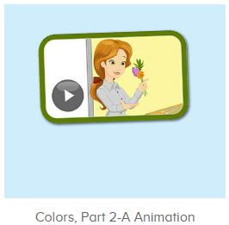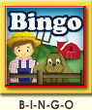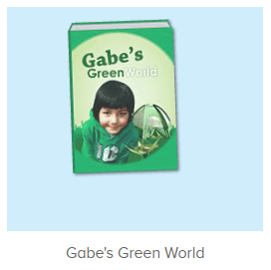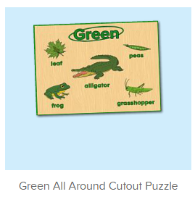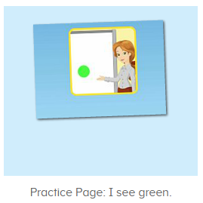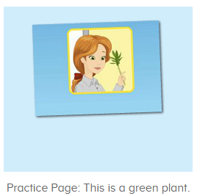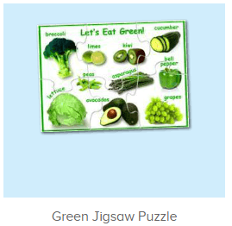
年龄段：中班下
教学目标：
- 能跟着歌曲B-I-N-G-O演唱整首歌曲并表演律动。
- 能从口语视频中听出关键的句子。
- 能流利跟读图书Gabe's green world并能看图说单词。
- 能流利说出句子I see green.This is a green plant.并能套用图书词汇和拼图词汇进行造句。
教具准备：1.图书词卡
使用游戏：1.Guessing game 2.TPR 3.Look and say.
教学步骤： | 备注
- 成果公布及展示：  T: Hello kids,good morning.  S:Good morning Yama.  T:First,let's praise Andy,Jason...They have finished their activities.  S:Good,good,very very good!  T:Andy,come here please, show us your activities  J:Ok.  T:Well done!(请完成家庭活动的幼生上前自主操作网站，向其他幼生展示家庭活动成果)  Everybody look,how many activities have Andy finished?  S:Four.  T:Wow,very good thank you Andy.  Now everybody look,what is this?  S:This is my tickets,my room,my avatar.  T:Good job!Coco come here, please show us your tickets.  C:OK.This is my tickets.I got many tickets from ABCmouse.I have 120 tickets.I want to be the tickets winner.I want to buy a new pet.  T:Thank you Coco.Henry come here,please show us your room.  H:OK.This is my room.I have two tables in my room.I have many toys in my room.My room is blue.It is very beautiful.I like my room very much.  T:Very good,Henry.Let's praise.  T&S:Good,good,very very good! | 成果公布及展示我的奖励票、我的化身、我的房间(单个幼生展示)
- 集体学习活动：  快乐唱吧  T:Now Let's sing and dance.（点击播放图1歌曲素材）  S:There was a farmer had a dog...B-I-N-G-O. B-I-N-G-O. B-I-N-G-O....（可加入互动游戏，如接龙，分组跟唱等）  趣味图书  T:You are great!Now let's read a book.  What is the name of this book?（跟读图2图书素材）  S:Gabe's green world.  T:Who is this?  S:This is Gabe.  T:What color does he like?  S:He likes the color green.  T:What color do you like?  S:I like the color blue/red/yellow...  T:Very good!Now let's read the book.  S:Gabe's green world...green water bottle/green apple...（跟读2遍）  T:Nice job!Look at the pictures.What is this?  S:Green water bottle/green apple...  T:Good job.  趣味复读机  T:Now let's practice the sentence.Listen and repeat.（点击进入图3素材，请幼生跟读句子）  S:I see green.（跟读2-3遍）  T:What color do you see?  S:I see green.  T:Good job!Now let's make sentences.  Look at the pictures,what green things do you see?（应用图书词汇用I see green....句型进行造句）  S:I see green grasshopper/green apple/green water bottle....  拼拼乐  T:Puzzle time!（打开图4素材，完成拼图并应用I see...句型造句）  First,what green things do you see?  S:I see green kiwi/grapes...  T:Good job!Let's finish the puzzle.  Who can try?  S:Let me try.  T:Lily/Rita/Peter...please.  Everybody listen and repeat.  S:Let's eat green.  T:Very nice.So what green things do you see?  S:I see green kiwi/grapes...  T:Wonderful.And what is your favorite green food?  S:Grapes/kiwi...  口语动画  T:Great job!Now let's enjoy the video.（播放图5动画视频，请幼生留意视频句子）  Now look,what is this?（在This is a green plant处暂停页面，并提问幼生）  S:Plant.  T:What color is the plant?  S:Green.  T:So this is a....  S:This is a green plant.  T:Listen again.(再次播放视频，请幼生重复听句子)  So,what is this?  S:This is a green plant.  Listen and say  T:Now let's practice.Listen and repeat.（打开图6素材，请幼生练习句子）  S:This is a green plant.(跟读2-3遍)  T:Look,what is this?(出示对应图片)  S:This is a green plant.  T:Lily/Peter/Yolanda/Jenny...what is this?  L/P/Y/J:This is a green plant.  T:Can you find green plant in the classroom?  S:Yes!  T:Good job!So what is this?  S:This is a green plant.  拼拼乐  T:Puzzle time!（打开图7素材，完成拼图并应用This is a green...句型造句）  Who can try?  S:Let me try.  T:Lily/Rita/Peter...please.  Everybody listen and repeat.  S:Alligator/beans/leaf...  T:Very nice.Now let's makes sentences.What is this?  S:This is a green alligator/leaf/frog...  T:Wonderful.Look at the pictures.What is this?(出示图书图片进行造句)  S:This is a green apple/water bottle...  趣味大扫描  T:You all did a great job!Now let's sing the song again.  S:There was a farmer had a dog...B-I-N-G-O. B-I-N-G-O. B-I-N-G-O....  T:Let's add some actions.Stand up please.  T&S:There was a farmer had a dog...B-I-N-G-O.B-I-N-G-O. B-I-N-G-O....  T:Now look at the pictures,what do you see?  S:I see green apple/water bottle...  T:Good job!What is this?  S:This is a green apple/water bottle..  T:Wonderful!Now let's count our tickets.  Who can try?  S:Let me try.  T:Candy please.  T:How many tickets do we have today?  Let's count with ABCmouse.  S&ABCmouse:One,two,three...  T:So How many tickets do we have today?  S:We have ten tickets today.  T:Candy,how many tickets do we have today?  C:We have ten tickets today.  T:Thank you Candy.Very good! | 图1：  图2：  图3  图4  图5  图6  图7
- 家庭活动布置：
T:Now I'll show you the activities.（将已放入功课的作业界面打开）
T: Look,how many activities do you need to do?
S:...
T:Very well.Now I will show you how to do it.Please listen carefully.
Jason come here and show us how to do the activities.
Good job!Thank you Jason!
Please finish the activities and show me tomorrow,ok?
S:OK!
T:Class is over, Goodbye everyone.
S:Goodbye Yama.

