ABCmouse中班下Letters Review r-s-t&Colors,Part1课时9
新授素材内容：
- Colors,Part2-B Animation.
- B-I-N-G-O.
- Yellow and red make orange.
- Red and blue make purple.
- Blue and yellow make green.
- Making Secondary Colors Cutout Puzzle.
- Secondary Colors Butterfly Catcher.
素材截图：
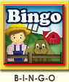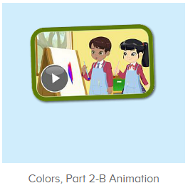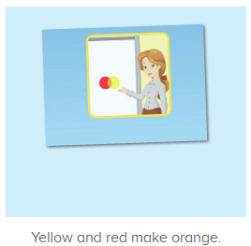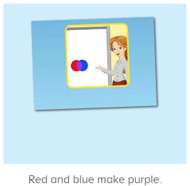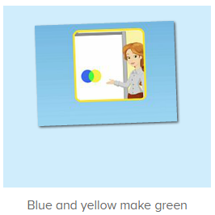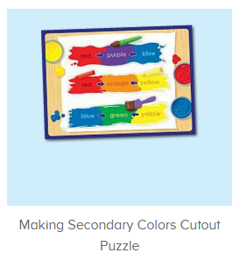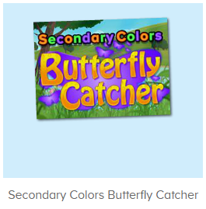
年龄段：中班下
教学目标：
- 能跟着歌曲B-I-N-G-O演唱整首歌曲并表演律动。
- 能从口语视频中听出关键的句子。
- 知道用什么颜色能调出橙色、紫色和绿色。
- 能流利说出句子Yellow and red make orange.Red and blue make purple.Blue and yellow make green.
教具准备：1.图书词卡 2.红色、蓝色、黄色颜料和色板
使用游戏：1.Guessing game 2.TPR 3.Look and say.
教学步骤： | 备注
- 成果公布及展示：  T: Hello kids,good morning.  S:Good morning Yama.  T:First,let's praise Andy,Jason...They have finished their activities.  S:Good,good,very very good!  T:Andy,come here please, show us your activities  J:Ok.  T:Well done!(请完成家庭活动的幼生上前自主操作网站，向其他幼生展示家庭活动成果)  Everybody look,how many activities have Andy finished?  S:Four.  T:Wow,very good thank you Andy.  Now everybody look,what is this?  S:This is my tickets,my room,my avatar.  T:Good job!Coco come here, please show us your tickets.  C:OK.This is my tickets.I got many tickets from ABCmouse.I have 120 tickets.I want to be the tickets winner.I want to buy a new pet.  T:Thank you Coco.Henry come here,please show us your room.  H:OK.This is my room.I have two tables in my room.I have many toys in my room.My room is blue.It is very beautiful.I like my room very much.  T:Very good,Henry.Let's praise.  T&S:Good,good,very very good! | 成果公布及展示我的奖励票、我的化身、我的房间(单个幼生展示)
- 集体学习活动：  快乐唱吧  T:Now Let's sing and dance.（点击播放图1歌曲素材）  S:There was a farmer had a dog...B-I-N-G-O. B-I-N-G-O. B-I-N-G-O...（可加入互动游戏，如接龙，分组跟唱等）  口语动画  T:Great job!Now let's enjoy the video.And tell me how to make orange,purple and green,ok?（播放图2动画视频，请幼生留意视频句子）  S:OK.  T:How to make orange?  S:Yellow/red/Yellow and red.  T:Is it right?Let's check.  Wow!Good job!How to make Green?  S:Blue and yellow..  T:Is it right?Let's check.  Wow!Good job!How to make purple?  S:Red and yellow...  T:Is it right?Let's check.  Wow!Good job!  Enjoy the video again.  Listen and say  T:Now let's practice.Listen and repeat.（打开图3-图5素材，请幼生练习句子）  S:Yellow and red make orange./Red and blue make purple./Blue and yellow make green.(跟读2-3遍)  T:How to make orange/purple/green?  S:Yellow and red make orange./Red and blue make purple./Blue and yellow make green.  T:Now look,I have some colors.（教师拿出颜料和调色板，请幼生挑出橙色、紫色和绿色）  What color is this?  S:This is yellow/red/blue.  T:Now let's make some colors.  How can we make orange/purple/green?  S:Yellow and red make orange./Red and blue make purple./Blue and yellow make green.  T:Right?Let's have a try.  Who can try?  S:Let me try.  T:Lily/Peter/Kenny..please.  Look,what colors mix together can make orange/purple/green?  S:Yellow and red make orange./Red and blue make purple./Blue and yellow make green.  T:Great job!  拼拼乐  T:Puzzle time!（打开图6素材，请幼生跟读发音）  Who can try?  S:Let me try.  T:Lily/Rita/Peter...please.  Everybody listen and repeat.  S:Yellow and red make orange./Red and blue make purple./Blue and yellow make green./Purple,orange and green.  捕蝶达人  T:You all did a great job!Now let's play a game “Butterfly Catcher”.  Who can try?  S:Let me try.  T:Gina/Fiona/Sandy...please.  Everybody listen and repeat.  S:Orange/purple/green...  趣味大扫描  T:Wonderful!Now let's sing the song again.  S:There was a farmer had a dog...B-I-N-G-O. B-I-N-G-O. B-I-N-G-O...  T:Let's add some actions.Stand up please.  T&S:There was a farmer had a dog...B-I-N-G-O.B-I-N-G-O. B-I-N-G-O...  T:What colors mix together can make orange/purple/green?  S:Yellow and red make orange./Red and blue make purple./Blue and yellow make green.  T:Wonderful!Now let's count our tickets.  Who can try?  S:Let me try.  T:Candy please.  T:How many tickets do we have today?  Let's count with ABCmouse.  S&ABCmouse:One,two,three...  T:So How many tickets do we have today?  S:We have ten tickets today.  T:Candy,how many tickets do we have today?  C:We have ten tickets today.  T:Thank you Candy.Very good! | 图1：  图2：  图3  图4  图5  图6  图7
- 家庭活动布置：
T:Now I'll show you the activities.（将已放入功课的作业界面打开）
T: Look,how many activities do you need to do?
S:...
T:Very well.Now I will show you how to do it.Please listen carefully.
Jason come here and show us how to do the activities.
Good job!Thank you Jason!
Please finish the activities and show me tomorrow,ok?
S:OK!
T:Class is over, Goodbye everyone.
S:Goodbye Yama.

