ABCmouse中班下Letters Review r-s-t&Colors,Part1课时10
新授素材内容：
- Colors,Part2-B Animation.
- B-I-N-G-O.
- Secondary Colors Cutout Puzzle.
- Making Secondary Colors Cutout Puzzle.
- Olivia's orange world.
- Gabe's green world.
- Pilar's purple world.
- Secondary Colors Painting Page.
素材截图：
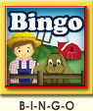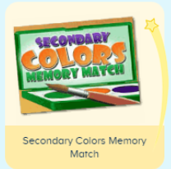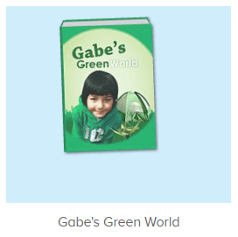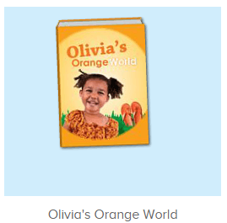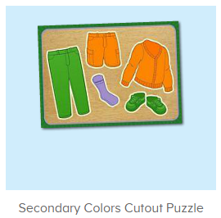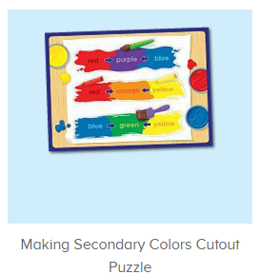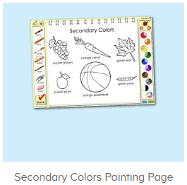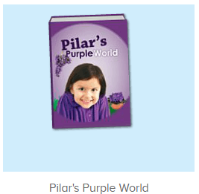
年龄段：中班下
教学目标：
- 能跟着歌曲B-I-N-G-O演唱整首歌曲并表演律动。
- 知道用什么颜色能调处橙色、紫色和绿色。
- 能流利说出句子Yellow and red make orange.Red and blue make purple.Blue and yellow make green.
- 能流利跟读三本图书，并能看图说单词。
- 能用句型I see...和This is....套用图书词汇造句。
教具准备：1.图书词卡 2.红色、蓝色、黄色颜料和色板
使用游戏：1.Guessing game 2.TPR 3.Look and say.
教学步骤： | 备注
- 成果公布及展示：  T: Hello kids,good morning.  S:Good morning Yama.  T:First,let's praise Andy,Jason...They have finished their activities.  S:Good,good,very very good!  T:Andy,come here please, show us your activities  J:Ok.  T:Well done!(请完成家庭活动的幼生上前自主操作网站，向其他幼生展示家庭活动成果)  Everybody look,how many activities have Andy finished?  S:Four.  T:Wow,very good thank you Andy.  Now everybody look,what is this?  S:This is my tickets,my room,my avatar.  T:Good job!Coco come here, please show us your tickets.  C:OK.This is my tickets.I got many tickets from ABCmouse.I have 120 tickets.I want to be the tickets winner.I want to buy a new pet.  T:Thank you Coco.Henry come here,please show us your room.  H:OK.This is my room.I have two tables in my room.I have many toys in my room.My room is blue.It is very beautiful.I like my room very much.  T:Very good,Henry.Let's praise.  T&S:Good,good,very very good! | 成果公布及展示我的奖励票、我的化身、我的房间(单个幼生展示)
- 集体学习活动：  快乐唱吧  T:Now Let's sing and dance.（点击播放图1歌曲素材）  S:There was a farmer had a dog...B-I-N-G-O. B-I-N-G-O. B-I-N-G-O....（可加入互动游戏，如接龙，分组跟唱等）  拼拼乐  T:Great job!Now let's play a puzzle game.（点击进入图3素材，请幼生完成拼图且跟读发音）  Who can try?  S:Let me try.  T:Jerry/Peter/Ada..please.  Everybody listen and repeat.  S:Orange shorts/purple socks/green pants...  T:Very good!Now tell me what do you see?  S:I see orange shorts/purple socks/green pants...  T:Very good!The next puzzle.（打开图3素材，先请幼生回忆如何能调出成色、紫色和绿色）  First,can you tell me how to make orange/purple/green?  S:Red and blue make purple./Red and yellow make orange./Blue and yellow make green.  T:Right?Let's check.  Who can try?  S:Let me try.  T:Tom/Leo/Kelly,please.  Everybody listen and repeat.  S:Red and blue make purple./Red and yellow make orange./Blue and yellow make green.  T:Wow,good job!  趣读图书  T:Now let's read a book.  What is the name of this book?（跟读图4图书素材）  S:Olivia's orange world.  T:Who is this?  S:This is Olivia.  T:What color does she like?  S:She likes the color orange.  T:What color do you like?  S:I like the color blue/red/yellow...  T:Very good!Now let's read the book.  S:Olivia's orange world...orange juice,orange kitten,orange basketball...（跟读2遍）  T:Now tell me what do you see in the book?  S:I see orange juice/orange kitten/orange basketball/orange fish...  T:Nice job!Look at the pictures.What is this?  S:This is an orange kitten/orange basketball/orange fish...  T:Terrific!  美术涂涂乐  T:Now let's do some painting.First,listen.（打开图5美术素材，根据提示图上对应的颜色，并用固定句型I see...和This is...造句）  What colors can we use to do this painting?  S:Orange/purple/green.  T:Good job!Who can try?  S:Let me try.  T:Lily/Paul/Henry...please.  Have you finished?  L/P/H:Yes!  T:Thank you!Everybody look.  What do you see?  S:I see purple grapes/orange carrot/green leaf...  T:Nice job!What is this?  S:This is an orange basketball/a purple plum/green leaf.  趣味图书  T:You are great!Now let's read a book.  What is the name of this book?（跟读图6图书素材）  S:Pilar's purple world.  T:Who is this?  S:This is Pilar.  T:What color does she like?  S:She likes the color purple.  T:What color do you like?  S:I like the color blue/red/yellow...  T:Very good!Now let's read the book.  S:Pilar's purple world....Purple sweater/purple grapes/purple flowers...（跟读2遍）  T:Now tell me what do you see in the book?  S:I see purple sweater/purple grapes/purple flowers...  T:Nice job!Look at the pictures.What is this?  S:This is a purple sweater/eggplant...  T:Good job.  图卡对对碰  T:Now let's play a memory match game.（点击进入图7素材，请幼生跟读并进行图卡配对）  Who can try?  S:Let me try.  T:Kelly,Fiona,Gina,Dave..please.  Everybody listen and repeat.  S:Purple/orange/green/goldfish/grasshopper....  T:Terrific!  趣味图书  T:The last book..  What is the name of this book?（跟读图8图书素材）  S:Gabe's green world.  T:Who is this?  S:This is Gabe.  T:What color does he like?  S:He likes the color green.  T:What color do you like?  S:I like the color blue/red/yellow...  T:Very good!Now let's read the book.  S:Gabe's green world...green water bottle/green apple...（跟读2遍）  T:Now tell me what do you see in the book?  S:I see green water bottle/green apple...  T:Nice job!Look at the pictures.What is this?  S:This is a green water bottle/green apple...  T:Good job.  趣味大扫描  T:Wonderful!Now let's sing the song again.  S:There was a farmer had a dog...B-I-N-G-O. B-I-N-G-O. B-I-N-G-O....  T:Let's add some actions.Stand up please.  T&S:There was a farmer had a dog...B-I-N-G-O.B-I-N-G-O. B-I-N-G-O....  T:What colors mix together can make orange/purple/green?  S:Yellow and red make orange./Red and blue make purple./Blue and yellow make green.  T:What is this?  S:This is an orange basket/a purple plant/a green leaf...  T:Wonderful!Now let's count our tickets.  Who can try?  S:Let me try.  T:Candy please.  T:How many tickets do we have today?  Let's count with ABCmouse.  S&ABCmouse:One,two,three...  T:So How many tickets do we have today?  S:We have ten tickets today.  T:Candy,how many tickets do we have today?  C:We have ten tickets today.  T:Thank you Candy.Very good! | 图1：  图2：  图3  图4  图5  图6  图7  图8
- 家庭活动布置：  T:Now I'll show you the activities.（将已放入功课的作业界面打开）  T: Look,how many activities do you need to do?  S:...  T:Very well.Now I will show you how to do it.Please listen carefully.  Jason come here and show us how to do the activities.  Good job!Thank you Jason!  Please finish the activities and show me tomorrow,ok?  S:OK!  T:Class is over, Goodbye everyone.  S:Goodbye Yama. | 