ABCmouse大班下词汇家族-at-课时2
复习素材内容:  1. Basics Word Family Words: cat  2. Basics Word Family Words: mat  3. Basics Word Family Words: sat | 新授素材内容:  1. Word Family Sentence Puzzle: The cat and the rat  2. The cat and the rat
素材截图:
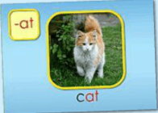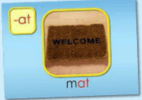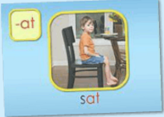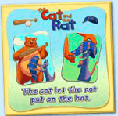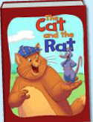
年龄段: 大班下
教学目标:
1.复习已学的3个单词。
2.复习图书前2句内容。
3.掌握第3、4、5句内容，并能表演。
教具准备: 1.3张单词卡 2.故事图片或PPT 4.The cat的头饰
使用游戏: 1.Fast reaction 2. Do and say 3. Role play
教学步骤: |  | 备注
- 成果公布及展示:
T: Hello kids.
S: Hello, teacher.
T: Jane, come here please, can you show us your activities?
J: Yes.
T: OK. Can you read these words?
T: Can you read < The cat and the rat >? （朗读已学内容）
J: Yes. I can.
T: Wow. Excellent. Can you show us your pets?
J: Yes, I have a pet, It's a yellow chick. Her name is...She can run/walk...
She is so cute. I feed /water/clean/teach my pet everyday.
T: Wow, terrific! Thank you Jane.
- 集体学习活动:  1）复习已学的3个单词。（图1~图3）  T: Kids, listen and repeat!  S: Cat, mat, sat.  T: One more time!  T: Very good!  T: Now, look and say! Who is the first one? Are you ready?  S: Yes. I am ready!  1S: Cat/mat/sat.  T: Lily, you're a little teacher!  T: Who is the first one?  L: Betty.  T: Thank you, Lily. Go back to your seat!  （游戏"快速反应"玩2-3轮即可）  2）复习《The cat and the rat》前2句内容.（图4）  T: Pretty good! Listen and repeat!  S: There was a cat who had a mat…  T: Now, Look and say!（关闭网站声音，引导S看图说句子）  S: There was a cat who had a mat…  T: Great! Stand up! Let's perform < The cat and the rat >.  T: Sit down, please! Now, I do you say. Are you ready?  S: There was a cat who had a mat…  T: Excellent! You're right!  T: Let's learn a new sentence.  3）学习《The cat and the rat》第3、4、5内容.  T: Listen, no voice!  T: What can you see/hear?  C: He sat and ate! He ate and sat! Soon the cat was very fat!  T: The cat eat more and more. So he get very…（T可以用动作提示）  S: Fat.  T: Good. Listen and repeat. （跟读第3句2-3遍）  T: Repeat again  T: Let's have a match. G1 Vs G2 Vs G3. （分3组，每组接力跟读一小段句子）  T: Are you ready?  S: Yes.  T: Follow it.  G1/G2/G3: He sat and ate!...  T: Which group is the best?  G1/G2/G3: …  T: OK. Once again.  T: Fantastic! Stand up! Let's perform these sentences.  T: Good, It's your turn!  T: Let's perform <The cat and the rat>.  T: Good job! Sit down, please!  4）上机玩句子拼图游戏2-3遍（见图5）  T: Let's play a puzzle game! First, Repeat these sentences. Are you ready?  S: The cat let the rat put on the hat.  T: Once again.  S: ...  T: Cici, please come here! You can play this puzzle.  T: Is that right?  S: Yes.  T: OK. Play again. Who wants to try?  1S: Let me try!  T: Is that right?  S: Yes.  （注：此句在后面的故事教学中会详细教学） |  | 图1:  图2:  图3:  图4:  图5:
三、家庭游戏活动布置:
T: Wow! So nice! Now look at me and I'll show you the homework.
T: You have to do one, two, three... activities. Do you know how to get a yellow star?
S: 5 times.
T: Very well. Now I will show you how to do it. Please listen and repeat.
Use the buttons, Step by step. OK?
S: OK!
T: XXX come here and show us how to do the activities.
1S:...
T: Good job! Thank you Jason! Class is over, Good bye everyone.
S: Goodbye.

