ABCmouse大班下词汇家族-at-课时8
总复习素材内容:
1. Basics Word Family Words: cat
2. Basics Word Family Words: mat
3. Basics Word Family Words: sat
4. Word Family Sentence Puzzle: The cat and the rat
5. The cat and the rat
素材截图:
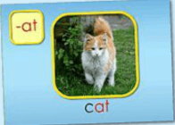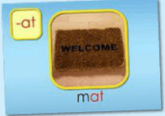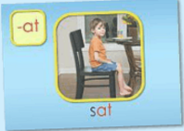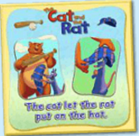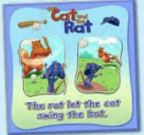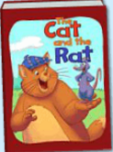
年龄段: 大班下
教学目标:
1.总复习已学单词。
2.总复习整本图书并熟练表演。
3.观看动画Flash，并给其配音。
教具准备: 1.自制的拼图碎块 2.The cat和The rat的头饰 3.自制红绿灯 4.单词卡片 5.故事图片或PPT
使用游戏: 1.Traffic light 2.Puzzle game 3.Make sentence 4.Role play
教学步骤: | 备注
- 成果公布及展示:  T: Hello kids.  S: Hello, teacher.  T: Lina, come here please, can you show us your activities?  S: Yes.  T: OK. Can you read these words?  T: Can you play this puzzle game?  T: Can you read this book?  L: Yes. I can.  T: Wow. Excellent. Can you show us your pet?  L: Yes. I can.  L: Look, I have two pigs. They can run/walk/jump...They are so cute. I feed/water/clean/teach my pigs everyday.  T: Wow, terrific! Thank you, Lina. | 注：图书展示过程中可多要几位幼生上台朗读读书。以接龙的方式进行。
二、集体学习活动:  1）复习已学过的3个单词（cat, mat, sat）（图1~3）  T: Kids, let's review "-at" family words.  Review steps:  - Follow the computer, listen and repeat.  - Game: Traffic light（线下"红绿灯"游戏）  - Complete the words: ____an (c/f/v/m/p/r/d/j) Bs vs Gs G1 Vs G2  2）操作（图4、5）拼图，并用The...let… 句型练习造句。  T: Kids, listen and repeat.  T: Can you read these sentences?  S: Yes. The rat let the cat swing the bat./ The cat let the rat put on the hat.  T: Good. Let's make sentences. "The…let...."  T: Who wants to try?  1S: Let me try! The rabbit let the cat swing the bat.  2S: The dog let the cat put on the hat. (Lisa let Lily put on the hat.)  T: Good job, kids.  T: Now, let's have a match. Who wants to try?  （每组派一个代表，挑战级别3，谁用时最短获胜）  T: Kids, tell me. Which group is the first?  S: G1...  T: Excellent! Play again.  T: Look, what's in my hand? （组织S线下拼图游戏）  S: Puzzles.  T: You're so clever. Let's have a match.  T: Are you ready?  S: Yes, we are ready!  T: Which group is the first?  S: G2...  T: Excellent! Play again.  3）复习已学图书 《The cat and the rat》（图6）  T: Now, Let's review< The cat and the rat >  Review steps:  a. Follow the computer, listen and repeat.  b. Bs read the story, Gs read the story. Bs Vs Gs  c. Look and say. （关闭网站，看PPT或图片说句子）  d. Perform the story.  e. Do and say. （看动作，猜句子内容）  T: Kids, guess, which sentence?  f. Page turning （随机翻页，翻到哪也读哪页）  T: I'll close my eyes! What's this?/What can you see?  （可请说得又快又准的S上台翻页）  g. Listen and choose the right card.  T: Kids, listen carefully! Then choose the right picture for me. OK?  h. Role play.  （以上可根据课堂实际情况选择2-3种形式复习） | 图1:  图2：  图3：  注："红绿灯"游戏玩法：借助交通灯的规则，"红灯停，绿灯行"。T出示红灯，Ss停止认读，T出示绿灯，Ss方可继续认读。  图4：  图5：  图6:
三、家庭游戏活动布置:
T: Wow! So nice! Now look at me and I'll show you the homework.
T: You have to do one, two, three... activities. Do you know how to get a yellow star?
S: 5 times
T: Very well. Now I will show you how to do it. Please listen and repeat.
Use the buttons, Step by step. OK?
S: OK!
T: XXX come here and show us how to do the activities.
1S:...
T: Good job! Thank you Jason! Class is over, Good bye everyone.
S: Goodbye.

