ABCmouse中班下字母Z课时10
复习内容：
- Simple letter story:Z.
- The sound of letter Z song.
- The letter Z chant.
- Letter Z cutout puzzle.
- The letter Z book.
- About me复习
素材截图：
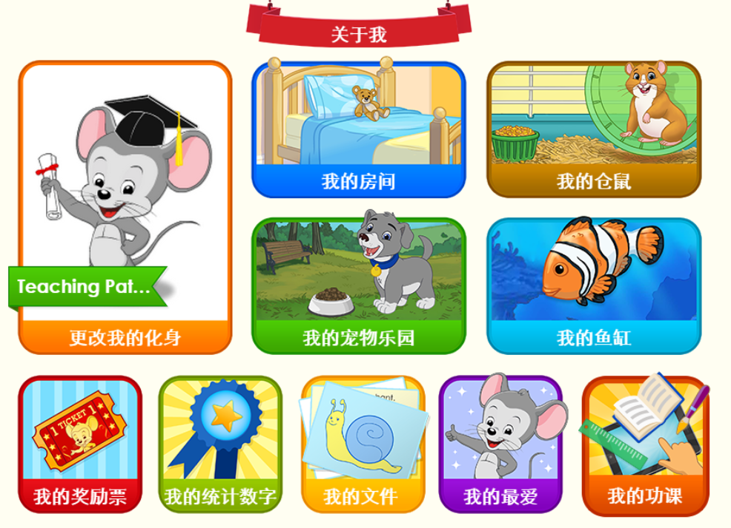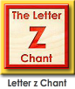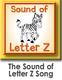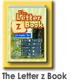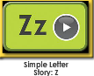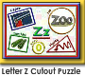
年龄段： 中班下
教学目标：
- 复习字母故事，能完整地看图说故事并表演整个字母故事。
- 复习字母歌曲和诗歌并能表演对应律动。
- 复习单词图书，并用Z is for../This is my.../I see a .../... is a number.固定句型造句。
教具准备：1.字母故事图片 2.字母故事相关头饰和图片 3.图书卡片
使用游戏：
1.Team match 2.Role play.3.TPR
教学步骤： | 备注
一、成果公布及展示  T: Hello kids,good morning.  S:Good morning Yama.  T:First,let's praise Andy,Jason...They have finished their activities.  S:Good,good,very very good!  T:Andy,come here please, show us your activities  J:Ok.  T:Well done!(请完成家庭活动的幼生上前自主操作网站，向其他幼生展示家庭活动成果)  Everybody look,how many activities have Andy finished?  S:Four.  T:Wow,very good thank you Andy.  Coco come here please,can you show us your hamster maze?  C:Yes.  T:Is this your hamster maze?  C:Yes.This is my hamster maze  T:How many hamsters do you have?  C:I have two hamsters.  T:Everybody look,how many hamsters does Coco have?  S:Coco has 2 hamsters.  T:Very good!What color are they?  S:This one is brown,that one is orange.  T:Nice job!Coco, what color are your hamsters?  C:This one is brown,that one is orange.  T:Wonderful!What is this?  C:This is a cage.  T:What are these?  T&S:These are tubes.  T:What color are the tubes?  T&S:They are blue,red and green.  T:Nice job!Coco,can you introduce your hamster maze again?This is my....  C:This is my hamster maze.I have two hamsters.This one is brown,that one is orange.This is a cage.These are tubes.They are blue,red and green.  T:So good!Everybody say it together.  C&S:This is my hamster maze.I have two hamsters.This one is brown,that one is orange.This is a cage.These are tubes.They are blue,red and green.  T:Well done!Thank you Coco,sit down please. | 公布家庭活动成果并展示我的仓鼠
二、集体学习活动：  谁是大歌星  T:Good job!Now let's sing x song/letter x chant..(复习图1-图2歌曲和单词诗歌，先跟唱再再轮流邀请几名幼生上前当小老师，带领幼生清唱并表演对应律动)  S:"z" "z" letter z..../Letter z says "z"....  T:Very good!Now who can sing?  S:Let me try.  T:Lily/Paul/Jimmy/Lucy come here,you will be the little teacher.  Everybody stand up please.  Let's sing and dance.Ready?  S:Yes,go go go!  S:"z" "z" letter z..../Letter z says "z"...  配音达人  T:Pretty good!Now let's read letter z book.（教师点击播放图3单词图书，请幼生跟读）  S:The letter z book.....  T:So good,now I will turn off the sound,let's be the little recorder.(请幼生一个接一个给图书配音，检验幼生掌握程度，遇到不会读的及时打开声音让其跟读)  Lily you will be the first then say it one by one.Are you ready?  S:Yes,we are ready.  L:The letter z book.  P:Z, “z” “z”,zebra...  Dice Game  T:Good job!Let's play a Dice game.  Who can roll the dice?  S:Let me try.  T:Susan/Paul/Kelly...please.  Look,what is it?  S:Zigzag/zebra/zero/zoo...  T:Good job!Can you use this word to make a sentence?  S:Z is for zigzag./This is my zoo./I see a zebra...  T:Great job!Let’s continue.(同理复习其他句型)  图块拼拼乐  T:Terrific!Puzzle time!Who can try?  S:Let me try.  T:Susan/Tom/Coco/Molly come here please.Everybody listen and repeat.(教师打开图4图块拼图，轮流请幼生上前操作一块，引导其他幼生跟读发音)  S:Zoo/zigzag/zucchini...  T:Terrific,thank you Susan/Tom/Coco/Molly.  看图说故事  T:Wonderful!Now let's repeat the story.(教师点击播放字母故事，请幼生跟读整个故事)  S:This is Zelda. This is Zoey.This is Zachary.They go to the zoo.They see the zebras.This zebra eats the zucchini.Oh ,no! That zebra eats the zinnia.  (跟读2-3次)  T:Let's look and say.(教师出示字母故事图片，请幼生看图说故事)  S:This is Zelda. This is Zoey.This is Zachary.They go to the zoo.They see the zebras.This zebra eats the zucchini.Oh ,no! That zebra eats the zinnia.  T:Very good!Let's perform the story,are you ready?（加上动作，边说句子边做动作进行表演）  S:Yes,we are ready.  This is Zelda. This is Zoey.This is Zachary.They go to the zoo.They see the zebras.This zebra eats the zucchini.Oh ,no! That zebra eats the zinnia.  小小表演家  T:Terrific!Let’s role play,who can try?(轮流邀请若干幼生上前充当故事角色，其他幼生说句子，表演整个字母故事)  S:Let me try.  记忆对对碰  T:Wonderful!Now let's play a memory match game.Who can try?(教师点击图6进入memory match游戏，一共可玩三轮，教师可邀请几位幼生上前操作，其他幼生跟读发音)  S:Let me try.  T:Tom/Lily/Monica/Louis/Jim please.Everybody listen and repeat.  S:Zebra/zero...  T:Good job!  ABCmouse游园会  T:You all did a good job today,let's go to "About me" to have some fun.  Everybody look,what is this?（引导整体幼生回顾已介绍过的关于我的板块）  S:This is my pet park,my tickets,my room,my avatar,my aquarium,my hamster maze.  T:Good job!who can show us your avatar/pet/room/aquarium?（邀请单个幼生作独立展示）  S:Let me try.  T:Jimmy please.  J:This is my avatar.He is a boy.He has blue eyes.He has yellow hair.His name is Jacky.  T:Wow,terrific!Thank you Jimmy.  Who can show us your tickets?  S:Let me try.  T:Coco,please.  C:This is my tickets.I have 100 tickets.I want to be the tickets winner.I want to buy a new dress.  T:Well done! | 图1  图2  图3  Dice game：骰子游戏，教师事先准备一个六面的骰子盒子，六面贴上适用于进行句型替换的图卡，教师请幼生上前抛骰子，请幼生用向上那面的单词应用固定句型造句。  图4  图5  图6  图7
三、家庭活动布置：
T:Now I'll show you the activities.（将已放入功课的作业界面打开）
T: Look,how many activities do you need to do?
S:...
T:Very well.Now I will show you how to do it.Please listen carefully.
Jason come here and show us how to do the activities.
Good job!Thank you Jason!
Please finish the activities and show me tomorrow,ok?
S:OK!
T:Class is over, goodbye everyone.
S:Goodbye Yama.

