ABCmouse中班上Number6-10&Review: O-P-Q课时2
素材内容：1. Numbers 6 to 10 Animation
2.Numbers 6 to 10,part 1 Animation
3.Practice page:Are you ready to count?
4.Practice page:One to six
5.Practice page:Counting 1 to 10
6.Practice page:These are six fingers
7.Memory match:6 to 10
8.Mirror lake fishing derby
9.Letter o-p-q chant
10. o-p-q Review Cutout puzzle
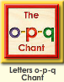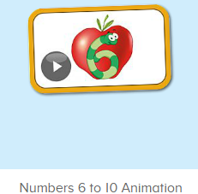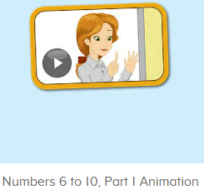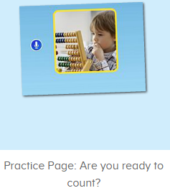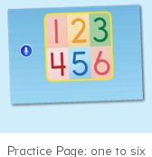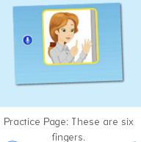
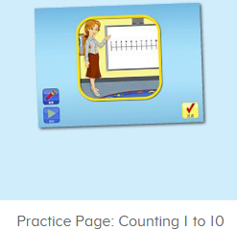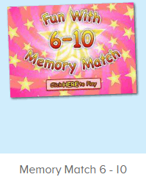
年龄段： 中班上
教学目标：1.能自如说出O-P-Q的词汇，演唱o-p-q的诗歌，并结合词汇拓展句子。
2.能理解并说出数字1-10,并能准确对应数与量。
3.能听懂动画中的句子，会应用完整的句子回答问题。
4.会结合数字自己应用Can you say/show me ...
教具准备：1.数字图片 2.o-p-q的单词及句子卡片 3.不同数量的物体图片
使用游戏：1.Guessing game 2.Role play 3.TPR 4.Fingers and times.
教学步骤： | 备注
- 成果公布及展示：  T: Hello kids. Glad to see you.  T:Hello kids.Glad to see you.  S:Glad to see you,too.  T:First,Let's praise Lisa,Molly,Jenny ... They all finished their homework.  Jason,come here please,show us your aquarium.（请一位幼生上前展示我的鱼缸）  J:This is "my aquarium"  J:There are two /three ...fish in my aquarium.  J:There is one shell/rock tunnel in my aquarium.  J:The fish/shells is/are pink/yellow/blue...  J:My tank is Fairy Tale tank.  J:I feed the fish/clean the aquarium everyday.  T:Well done.Thanks Jimmy.The next time,I'll invite you.Please,come on. | 幼生"my aquariums"部分的展示，由单个幼生结合上周的内容自己展示。
二、集体学习活动：  T:Now,It's ABCmouse time. Hello,everyone.  S:Hello, xxx  T:How are you,today?/How is the weather?  S:I am happy/so so/tired... /It's sunny/rainy/cloudy/windy....  T:I am ... I am a teacher.  S:I am ... I am a boy/girl  T:Wonderful.Let’s chant.(教师点击进入素材图1，请幼生聆听并跟唱）  S:Letter o says"o". "o" "o" "o".ostrich, ox, octopus."o" letter o.  Letter p says"p"."p" "p" "p".pig, pencil, panda."p" letter p.  Letter q says"q"."q" "q" "q".quail, quiet, quilt."q" letter q.  T:Petty good.Now,look and say.（出示字母O-P-Q的已学单词，替换诗歌中的重点词汇）  S:osprey, onager,oxpecker/plate, pizza, pear/queen, quail, question,(教师尽量选择跟之前诗歌中的词汇音节相对接近的词汇替换)  T:Let’s chant together.  S:Letter o says"o". "o" "o" "o".ostrich, ox, octopus."o" letter o.  Letter p says"p"."p" "p" "p".pig, pencil, panda."p" letter p.  Letter q says"q"."q" "q" "q".quail, quiet, quilt."q" letter q.  T:Wonderful.Let’s do the matching card game.Look,listen and say.  （进入素材图2，）  S:queen/octopus/peanuts/quail...（幼生跟读）  T:Rita/Victory...  1S:queen,q/olive,o/pear,p...（一位幼生说出对应的词汇和字母）  S:queen,q/olive,o/pear,p...（全体幼生说出对应的词汇和字母）  T:Let's look and say.What’s this letter/What’s in this picture??（教师出示图片，示例，然后结合造句）  S:It’s letter o/p/q.It’s a quail.So,Q is for quail.The quail is sleepy...  T:Well down,the next.  S:...  T:Now,let's enjoy the video. （进入素材图3，让幼生先看）  T:What do you hear?(第二遍播放，适时暂停，提问)  S&1s:I hear “fingers/1/2/3/4/5/6/7..”（单个或多个幼生说出听到的内容）  T:Very good,now,look,listen and say.（教师点击进入素材图4）  S:Are you ready to count?/1,2,3,4,5,6,6/These are six fingers./Lina,Can you say 6?/7, Sara,can you show me 7fingers?/8, Carmen,can you show me 8 fingers?/...  T:Good.Sentence by sentence.（教师播放一句，请一位幼生复述，复述完毕再请其余的幼生一起跟读一次）  1S:Are you ready to count?/1,2,3,4,5,6,6/These are six fingers./Lina,Can you say 6?/7, Sara,can you show me 7fingers?/8, Carmen,can you show me 8 fingers?/...  T:Follow ...  S:Are you ready to count?//1,2,3,4,5,6,6/These are six fingers./Lina,Can you say 6?/7, Sara,can you show me 7fingers?/8, Carmen,can you show me 8 fingers?/...  T:Petty good.Now,let's listen carefully.（进入素材图5，）  T:Lisa/Bill/Zara,What can you hear?  L/B/Z:I hear “Are you ready to count?”.  T:Let’s check.（重复播放核对，同时提示幼生跟读）  S:Are you ready to count?  T:Good.Listen,follow and do.（播放，分组起立跟读,）  G1&G2&G3:Are you/ready/to count  T:Exchange.  S:Are you/ready/to count  T:Peter/Kevin/Rose...  P/K/R:Are you/ready/to count  T:Wonderful.Together.  S:Are you ready to count?  T:Yes,Let’s count.  S:1,2,3,4,5,6...  1S:Are you ready to count?  S:Yes,Let’s count.  T:Ok,listen and say.（进入素材图6）  S:1,2,3,4,5,6  T:What’s this number?  S:It’s number 1/2/3/4/5/6  T:Good,listen,look and say.（进入素材图7）  S:1,2,3,4,5,6,7,8,9,10  T:Let’s count（带领幼生一起数数）  S:...  T:How many sticks are there?  S:There are 10 sticks.（单个，多个幼生回答）  T:How many fingers are these?（出示手指，与幼生一起）  S:1,2,3,4,5,6...  T:Yes,  S:These are ... fingers.（反复几轮，让幼生对数字都能熟练）  T:Good,let’s go ahead.How many fingers are these?（进入素材图8）  S:1,2,3,4,5,6.These are 6 fingers.  T:Right.listen again.  S:These are 6 fingers.  T:How many fingers do you have?  S:I have 10 fingers.（幼儿自己数，数完回答）  T:Let’s do memory match.look,listen and find.（进入素材图9）  S:9 violins/6keys...  T:Ken,try it.  K:...  T:How many ... Can you see?  S:I can see ...  T:The next,（哪位幼生跟读，即可上来操作）  S:...  T:memory match game.（数字和对应数量图片培训）  S:6,7,8,9.../6apples,7drums,8flowers...（看图说,说对的来拼）  T:Let’s check.Bingo.  T:Good,let’s go fishing.（进入素材图7，先听完游戏介绍）  T:Are you ready?  S:Yes.I am ready.  T:Wow,how many fishes are there?  S:1,2,3,4,5,6,7,there are 7 fishes.  T:Bob,have a try.（请1名幼生上来操作此活动，其余幼生一起数数）  S:1,2,3,go!  T:  T:Wow,how many fishes are there?  S:1,2,3,4,5,6,7,there are 7 fishes.  T:click the right one.  B:this one.  T:Thanks,go back.  T:Well done.Let's review.  S:...  T:What’s this number?  S:...  T:What are these?  S:...  T:How many ... are these/can you see/have you got?  S:...  T:Good.Let's enjoy the video.(播放素材图3，请幼生观看跟读)  T:Good.Let's count the tickets.  S:1,2,3,4...  T:How many tickets have we got?  S:...  T:All of you did a good job.（总结课堂比赛结果及孩子情况）  G1,you are the winner,G2,come on!  And,Lucy,Ken,Rita,you are wonderful | 图1:  图2:  图3：  图4：  图5：  图6：  图7：  图8：  图9：  图10：
- 家庭游戏活动布置：
T:All of you did a good job. I'll show you the homework/activities. （将已放入功课的作业界面打开）
T:Look,how many activities do you need to play?
S:Four.
T:How to get a yellow star?
S:Play 5 times
T:Very well.Now Jason, come here and show us how to do the activities.
J:...
T:Good job!Thank you Jason!
T:So ,How many activities you need to play?
S:...
T:How to play?
S:...
T:Class is over, Goodbye everyone.
S:Goodbye Teacher.

