ABCmouse中班上Number6-10&Review: O-P-Q课时3
素材内容：1.Numbers 6 to 10,part 1 Animation
2.Numbers 6 to 10,part 2 Animation
3.Numbers 6 to10 practice
4.Practice page:One to six
5.Practice page:How many apples?
6.Practice page:Six apples
7.Practice page:Seven apples
8.Numbers at the market,6 to 10
9.Egg counter
10.Letter o-p-q chant
11. o-p-q Review Cutout puzzle
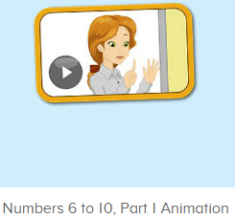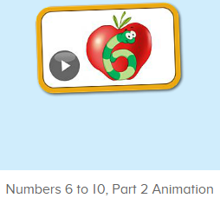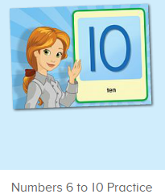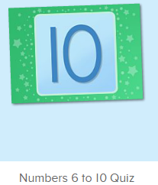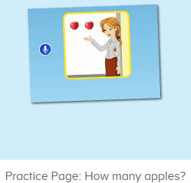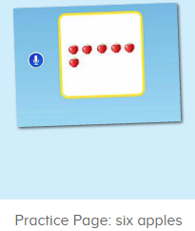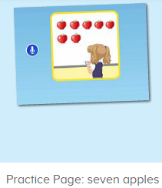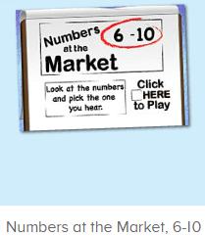
年龄段： 中班上
教学目标：1.能自如演唱o-p-q的诗歌。
2.能流畅跟读口语对话中的句子。
2.能灵活运用Can you show me/count...
3.能清楚认识1-10的数与量。
4.能说出口语动画里的全部内容。
教具准备：1.数字卡片，2.不同动物及物品数量的卡片
使用游戏：1.Guessing game 2.Role play 3.TPR 4.Fingers and times.
教学步骤： | 备注
- 成果公布及展示：  T: Hello kids. Glad to see you.  T:Hello kids.Glad to see you.  S:Glad to see you,too.  T:First,Let's praise Lisa,Molly,Jenny ... They all finished their homework.  Jason,come here please,show us your aquarium.（请一位幼生上前展示我的鱼缸）  J:This is "my aquarium"  J:There are two /three ...fish in my aquarium.  J:There is one shell/rock tunnel in my aquarium.  J:The fish/shells is/are pink/yellow/blue...  J:My tank is Fairy Tale tank.  J:I feed the fish/clean the aquarium everyday.  T:Well done.Thanks Jimmy.The next time,I'll invite you.Please,come on. | 幼生"my aquariums"部分的展示，由单个幼生结合上周的内容自己展示。
二、集体学习活动：  T:Now,It's ABCmouse time. Hello,everyone.  S:Hello, xxx  T:How are you,today?/How is the weather?  S:I am happy/so so/tired... /It's sunny/rainy/cloudy/windy....  T:I am ...I am a teacher.How about you?  S:I am ... I am a boy/girl.  T:Excellent.Let’s enjoy the video.(教师点击进入素材图1，请幼生说句子）  S:Are you ready to count?/1,2,3,4,5,6,6/These are six fingers./Lina,Can you say 6?/7, Sara,can you show me 7fingers?/8, Carmen,can you show me 8 fingers?/...  T:What’s this number?（数字图卡）  S:It’s number ...  T:How many ... are there/can you see/do you have?  S:There are .../I can see.../I have ...  T:Petty good.Now,let's go ahead.（进入素材图2，）Listen and say.  （教师播放素材，请幼生跟着说，从整体到单个）  T:Lisa,/Peter/Henry ...Follow it.  L/P/H:Nico,Can you come here?/Yes./Today, we are going to paint apples./This is 1 apple./Can you paint 4 more apples, please?  T:Say it together.  S:Nico,Can you come here?/Yes./Today, we are going to paint apples./This is 1 apple./Can you paint 4 more apples, please?  T:Well done.Who can come here?  S:I can.  T:So,Let’s say.  S:Lily/Jerry,can you come here?  L/J:Yes.  T:And,this one.  S:Paint.  T:Who can paint the apples?  S:I can.  T:Let’s say.  S:Lily/Jerry,can you paint the apples?  T:Look,what is this?What can it do?  S:It’s a dog,It can run.  T:Really?Let’s ask the dog.  S:Dog,dog,can you run?  D:Yes,I can.  T:Now,ask your friend?  1S&1S:Can you .../Yes.I can./No,I can’t.  T:Good.Let’s follow.One by one.（再一次暂停跟读，实时提问）  S:Nico,Can you come here?/Yes./Today, we are going to paint apples./This is 1 apple./Can you paint 4 more apples, please?  T:How many apples are there?  S:There are ...  T:Good,Let's continue.Look and say.（进入素材图3，让幼生先看动画）  S:7,What number is this?What is this?/You say ...（播放练习素材，教师引导幼生问，单个幼生回答，以此类推）  1S:It’s7/8/9/10/paint/apples/Here are 6 apples.  T:Very good.The next.Listen and find.（进入素材图4，让幼生找对应的数字）  T:Where is 7.6.8.9.../Choose ...（平台声音）  S:Here is 7,6,8,9...  T:What’s this number?/Show me number ...  S:It’s ...  T:Nice.Look and say.（进入素材图5,教师请单个幼生说句子，挑选3-5名轮流跟着说即可）  L:How many apples?  S:There are 2 apples.  T:And this one?（出示不同数量的物体图片）  S:How many bananas/peaches...  1S:There are ...  T:Look and say.G1&G2（进入素材图6-7,教师引导幼生自主问答）  G1:How many apples are there？  G2:There are ... apples.  T:Exchange.  T:Nice.Choosing game.（进入素材图8）  S:Pick 8/7/9/10（幼生根据声音跟读，说的快的上来点 ）.  T:Ken.Have a try.  T:Good job.Let's chant（进入素材图9）  S:Letter o says"o". "o" "o" "o".ostrich, ox, octopus."o" letter o.  Letter p says"p"."p" "p" "p".pig, pencil, panda."p" letter p.  Letter q says"q"."q" "q" "q".quail, quiet, quilt."q" letter q.  T:Game time.（进入素材图10，幼生说出来，并做动作）  S:...  T:Excellent.Let’s review.（拿出单词及数字图卡）  T:Who is this?/What can ... do?/What is this number?/How many ....  S:This is .../... Can come here/paint.../It’s 6,7,8,9/There are ...  T:Let’s check.（重复播放素材图2，并请幼生跟读）  S:...  T:Good.Let's count the tickets.  S:1,2,3,4...  T:How many tickets have we got?  S:...  T:All of you did a good job.（总结课堂比赛结果及孩子情况）  G1,you are the winner,G2,come on!  And,Lucy,Ken,Rita,you are wonderful | 图1:  图2：  图3：  图4：  图5：  图6：  图7：  图8：  图9:  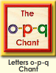  图10:  
- 家庭游戏活动布置：
T:All of you did a good job. I'll show you the homework/activities. （将已放入功课的作业界面打开）
T:Look,how many activities do you need to play?
S:Four.
T:How to get a yellow star?
S:Play 5 times
T:Very well.Now Jason, come here and show us how to do the activities.
J:...
T:Good job!Thank you Jason!
T:So ,How many activities you need to play?
S:...
T:How to play?
S:...
T:Class is over, Goodbye everyone.
S:Goodbye Teacher.

