ABCmouse中班上Number6-10&Review: O-P-Q课时5
素材内容：1.Numbers 6 to 10 Animation
2.Numbers 6 to10 practice
3.Counting 1 to 10 at the zoo
4.Egg counter
5.Counting 1 to 10 with Lizzy
6.Twinkle,Twinkle,little star
7.The Letter O book
8.The Letter P book
9.The Letter Q book
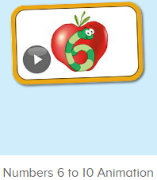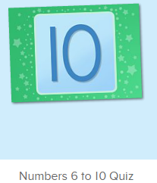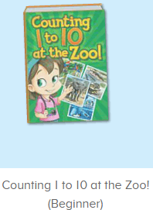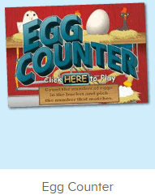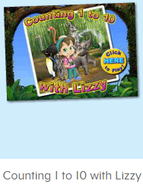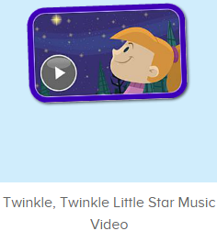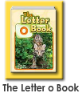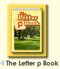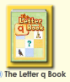
年龄段： 中班上
教学目标：1.能自如认读应用o-p-q的图书内容。
2.能流畅跟读口语对话中的句子。
2.能灵活运用Can you show me/count...
3.能清楚认识1-10的数与量。
4.能说出口语动画里的全部内容。
5.能认读应用数字图书中的全部内容
教具准备：1.数字卡片，2.不同动物及物品数量的卡片
使用游戏：1.Guessing game 2.Role play 3.TPR 4.Fingers and times.
教学步骤： | 备注
- 成果公布及展示：  T: Hello kids. Glad to see you.  T:Hello kids.Glad to see you.  S:Glad to see you,too.  T:First,Let's praise Lisa,Molly,Jenny ... They all finished their homework.  Jason,come here please,show us your aquarium.（请一位幼生上前展示我的鱼缸）  J:This is "my aquarium"  J:There are two/three ...fish in my aquarium.  J:There is one shell/rock tunnel in my aquarium.  J:The fish/shells is/are pink/yellow/blue...  J:My tank is Fairy Tale tank.  J:I feed the fish/clean the aquarium everyday.  T:Well done.Thanks Jimmy.The next time,I'll invite you.Please,come on. | 幼生"my aquariums"部分的展示，由单个幼生结合上周的内容自己展示。
二、集体学习活动：  T:Now,It's ABCmouse time. Hello,everyone.  S:Hello, xxx  T:How are you,today?/How is the weather?  S:I am happy/so so/tired... /It's sunny/rainy/cloudy/windy....  T:I am ...I am a teacher.How about you?  S:I am ... I am a boy/girl.  T:Excellent.Let’s enjoy the video.(教师点击进入素材图1，请幼生说句子）  Look,Listen and say.  （教师播放素材，请幼生跟着说，从整体到单个）  S:Nico,Can you come here?/Yes./Today, we are going to paint apples./This is 1 apple./Can you paint 4 more apples, please?...  T:Well done.Who can come here?/Who can paint the apples?/What number is this?What is this?...  S:I can.../It’s number .../It’s...  T:Now,ask your friend?  1S&1S:Can you .../How many ...  Yes.I can./No,I can’t./There are ...  T:Very good.Listen and find.（进入素材图2，让幼生找对应的数字）  T:Where is 7.6.8.9.../Choose ...（平台声音）  S:Here is 7,6,8,9...  T:What’s this number?/Show me number ...  S:It’s ...  T:Good,Let's continue.Look and say.（进入素材图3，让幼生先看图书抢答，如果遇到幼生不会的，则放出声音大家一起说）  S:Count 1 to10 at the zoo...  T:What number is this?What can you see?/How many... ?（教师根据页面内容提问,幼生单个回答，集体回答）  1S:It’s7/8/9/10/I can see .../There are ...  T:Very good.Lina,can you count the lions/monkeys/...  1S:Yes.1.2.3.4.5...  T:Wow,let’s continue.  S:...  T:This time.one by one.（播放图书，单个幼生站起来接龙说）  S:...  T:Excellent,Egg counter time.Look ,listen and count（进入素材图4,教师引导幼生自主问答）  T:Who can count?  G:I can.1.2.3.4.5...  T:Choose the right number.  S:This one is number ...（2-3轮）  T:Nice.let’s go ahead.Listen and find.（进入素材图5,先说出来的上来找动物，其余幼生一起跟着数）  S:Can you find...  T:Lily,please  L:1,2,3,4,5,6.I can see ...  T:The next,Ken.（一位幼生数数，其余幼生仔细听跟着说，以此类推）  K:1,2,3,4,5,6,7.I can see ...  T:Good job.Let's enjoy the song.（进入素材图6，幼生站起来一起动）  T:Show me your hands,let’s do the action.（第二遍，边听边做动作）  S:...（幼生跟着教师一起做动作）  T:This time,listen and repeat.（播放视频，幼生聆听,逐句跟读）  S:Twinkle,Twinkle Little Star. How I wonder what you are.  Up above the word so high, like a diamond in the sky.  Twinkle,Twinkle Little Star. How I wonder what you are.  Twinkle,Twinkle Little Star. How I wonder what you are.  Twinkle,Twinkle all the night,Sharing with us all your light.  Twinkle,Twinkle Little Star. How I wonder what you are.  T:Excellent,again.（每跟读完一句及时表扬幼生，可以是单个或多个）  S: ...  T:Music chair.（教师播放音乐，部分幼生跟着唱，部分幼生上来参与游戏，音乐停了，没找到椅子的幼生唱出前一句，唱对了，集体跟唱，该幼生回到座位，从下面选一位幼生补上，反复3-5轮）  T:Henry.Sing it ,please.  H: How I wonder what you are.  S: How I wonder what you are.  T:Ok,go back.Minnie,come on.Let’s continue.  T:Let’s read the book.Who can try?（打开图书图7-9，关闭声音，幼生自主朗读）  S:I can try.  T:Gs, say it together.  Gs:The letter O book...  T:Excellent.The next,Bs.  Bs:The letter P book...  T:Well down.This time.One by one.（最后一本书，从左至右站起来接龙读）  S:The letter Q book...（每位幼生站起来读，并做对应动作）  T:What’s this letter?/What sound does letter ...make?/Say three words for letter .../Make a sentence with ...  S:...（单个和多个幼生抢答）  T:Excellent.Let’s review.（拿出单词及数字图卡）  T:Who is this?/What can ... do?/What is this number?/How many ....  S:This is .../... Can come here/paint.../It’s 6,7,8,9/There are ...  T:Let’s check.（重复播放素材图3，并请幼生跟读）  S:...  T:Good.Let's count the tickets.  S:1,2,3,4...  T:How many tickets have we got?  S:...  T:All of you did a good job.（总结课堂比赛结果及孩子情况）  G1,you are the winner,G2,come on!  And,Lucy,Ken,Rita,you are wonderful | 图1:  图2：  图3：  图4：  图5：  图6：  图7：  图8：  图9:
- 家庭游戏活动布置：
T:All of you did a good job. I'll show you the homework/activities. （将已放入功课的作业界面打开）
T:Look,how many activities do you need to play?
S:Four.
T:How to get a yellow star?
S:Play 5 times
T:Very well.Now Jason, come here and show us how to do the activities.
J:...
T:Good job!Thank you Jason!
T:So ,How many activities you need to play?
S:...
T:How to play?
S:...
T:Class is over, Goodbye everyone.
S:Goodbye Teacher.

