ABCmouse中班上Number6-10&Review: O-P-Q课时6
素材内容：1.Numbers 6 to 10 Animation
2.Counting 1 to 10 at the zoo
3.Mirror lake fishing derby
4.How many apples?
5.There are ten apples
6.Twinkle,Twinkle,little star
7.6-10 Memory match
8.Letters O-P-Q Chant
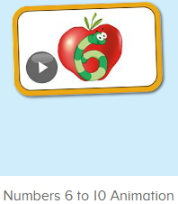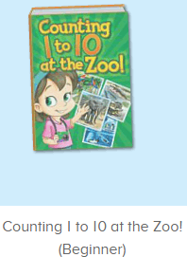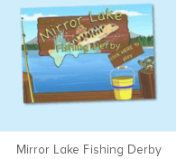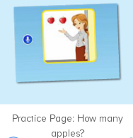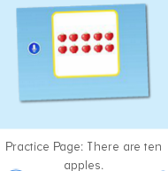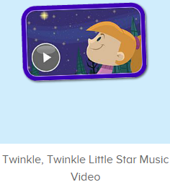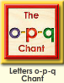
年龄段： 中班上
教学目标：1.能流畅应用口语动画中的数字及关键句式How many...
2.能结合口语中的句子内容对数字图书进行看图说话
3.能清晰跟唱歌曲Twinkle,twinkle,little star
3.能清楚认识1-10的数与量。
4.能应用替换词汇诗歌中的关键词句。
5.能认读应用数字图书中的全部内容
教具准备：1.数字卡片，2.不同动物及物品数量的卡片
使用游戏：1.Guessing game 2.Role play 3.TPR 4.Fast reaction 5.Dragon 6.Mic game
教学步骤： | 备注
- 成果公布及展示：  T: Hello kids. Glad to see you.  T:Hello kids.Glad to see you.  S:Glad to see you,too.  T:First,Let's praise Lisa,Molly,Jenny ... They all finished their homework.  Jason,come here please,show us your aquarium.（请一位幼生上前展示我的鱼缸）  J:This is "my aquarium"  J:There are two/three ...fish in my aquarium.  J:There is one shell/rock tunnel in my aquarium.  J:The fish/shells is/are pink/yellow/blue...  J:My tank is Fairy Tale tank.  J:I feed the fish/clean the aquarium everyday.  T:Well done.Thanks Jimmy.The next time,I'll invite you.Please,come on. | 幼生"my aquariums"部分的展示，由单个幼生结合上周的内容自己展示。
二、集体学习活动：  T:Now,It's ABCmouse time. Hello,everyone.  S:Hello, xxx  T:How are you,today?/How is the weather?  S:I am happy/so so/tired... /It's sunny/rainy/cloudy/windy....  T:I am ...I am a teacher.How about you?  S:I am ... I am a boy/girl.  T:Excellent.Let’s enjoy the video.(教师点击进入素材图1，请幼生说句子）  Look,Listen and say.  （教师播放素材，请幼生跟着说，从整体到单个接龙）  S:Nico,Can you come here?/Yes./Today, we are going to paint apples./This is 1 apple./Can you paint 4 more apples, please?...  T:Good,Let's continue.Look and say.（进入素材图2，关闭声音，让幼生看图说话）  S:Count 1 to10 at the zoo...  T:What is the name of this picture?/What number is this?/What can you see?/How many... ?/What color are the ...（教师根据页面内容提问,幼生单个回答，集体回答）  1S:It’s7/8/9/10/I can see .../There are ...  T:Very good.Lina,can you count the lions/monkeys/...  1S:Yes.1.2.3.4.5...  T:Wow,let’s continue.  S:...  T:This time.one by one.（播放图书，暂停翻页，单个幼生站起来接龙说，教师可适当肢体动作提示）  S:This is number .../Look,there are ...lions./They are brown/big.../The lion can ...  T:Excellent,Mirror lake fishing derby.Let’s play.（进入素材图3,教师引导幼生自主问答）  T:Who can count?  G:I can.1.2.3.4.5...  T:How many fishes are there?（第一次教室提问，第二次A组提问，B组回答，以此类推）  S:There are ten.  T:Choose the right number.  S:This one is number ...（2-3轮）  T:Nice.let’s go ahead.Listen and say.（进入素材图4,先听2-3遍，再根据问题回答）  T:Let’s count.  S:1,2,there are 2 apples.  T:How many apples are there now?（播放平台的声音，并拿出不同数量苹果的图片）  S:1,2,3,4,5,6,7...there are 2/3/4/5/6/7 apples.（单个或多个幼生回答2-3轮）  T:This time,let’s repeat.（2-3次）  S:How many apples are there now?  T:Well done.Dragon game.I point, you say.（把幼生根据句子内容分为4组，How many,apples,are there,now）  S:How many/apples/are there/now.（幼生根据教师的提示站起来说内容）  T:Good,together.  S:How many apples are there now?  T:How about this one?（出示其余数量不同的物品，并加一个问号）  S:How many tigers/elephants are there now?  T:Wonderful.How many apples are there,now?Let’s listen.（进入素材图5，）  S:There are ten apples.  T:How many apples are there,now?  1s:There are ten apples.  T:Mark,come here,you are the teacher.  M:How many ... are there,now?（根据图片提问）  S:There are ...（回答的好的上来继续提问）  T:Ken,have a try.  K:How many ... are there,now?（根据图片提问）  S:..  T:Let’s do the memory match.How many ... are there?（进入素材图6，能回答出来的上来操作活动）  S:There are ...  T:Grace, try it.  G:..（边操作，边跟读）  T:Good job.Let's enjoy the song.Stand up.Show me your hands,let’s do the action.（进入素材图7，幼生站起来一起跟唱并做动作动）  S:...（幼生跟着教师一起做动作）  T:This time,listen and repeat.（播放视频，幼生聆听,逐句跟读）  S:Twinkle,Twinkle Little Star. How I wonder what you are.  Up above the world so high, like a diamond in the sky.  Twinkle,Twinkle Little Star. How I wonder what you are.  Twinkle,Twinkle Little Star. How I wonder what you are.  Twinkle,Twinkle all the night,Sharing with us all your light.  Twinkle,Twinkle Little Star. How I wonder what you are.  T:Excellent,look.What is this?（解析关键字词）  S:Little star,diamond,sky,night,light ...  T:So nice,fast reaction.（教师把关键字词图片贴在白板上，或用动作表示,幼生根据提示说出关键词，教师表扬说的准确的幼生。）  S:Little star,diamond,sky,night,light ...  T:Perfect,this time,sing together.  S:...  T:This time,when you hear “little star”,close your mouth.（教师给与关键字词，幼生听到则不唱，其余跟唱）  S:Twinkle,Twinkle xxx. How I wonder what you are...  T:Good,this time,mic-phone game.（教师拿出麦克风，麦克风指向哪，哪里的幼儿唱，指向平台，则幼儿不说话，指向单个幼儿，单个幼儿唱）  S:Twinkle,Twinkle Little Star. How I wonder what you are...  T:Together.（集体带动作唱）  S: Twinkle,Twinkle...  T:Excellent.Let’s chant.Letters o-p-q Chant  S:Letter o says"o". "o" "o" "o".  ostrich, ox, octopus. "o" letter o.  Letter p says"p". "p" "p" "p".  pig, pencil, panda. "p" letter p.  Letter q says"q". "q" "q" "q".  quail, quiet, quilt. "q" letter q.  T:What’s this letter?/What sound does letter ...make?/Say three words for letter .../Make a sentence with ...  S:..（单个和多个幼生抢答）  T:Let’s make a new chant.（幼生看教师的动作替换关键词汇,涂黄部分可替换）  S:Letter o says"o". "o" "o" "o".  ostrich, ox, octopus. "o" letter o.  Letter p says"p". "p" "p" "p".  pig, pencil, panda. "p" letter p.  Letter q says"q". "q" "q" "q".  quail, quiet, quilt. "q" letter q.  T:Excellent.Let’s review.（拿出单词及数字图卡）  T:Who is this?/What can ... do?/What is this number?/How many ....  S:This is .../... Can come here/paint.../It’s 6,7,8,9/There are ...  T:Let’s sing and dance.（播放素材图7，幼生一起唱跳表演）  S:...  T:Good.Let's count the tickets.  S:1,2,3,4...  T:How many tickets have we got?  S:...  T:All of you did a good job.（总结课堂比赛结果及孩子情况）  G1,you are the winner,G2,come on!  And,Lucy,Ken,Rita,you are wonderful | 图1:  图2：  图3：  图4：  图5：  图6：  图7：  图8：
- 家庭游戏活动布置：
T:All of you did a good job. I'll show you the homework/activities. （将已放入功课的作业界面打开）
T:Look,how many activities do you need to play?
S:Four.
T:How to get a yellow star?
S:Play 5 times
T:Very well.Now Jason, come here and show us how to do the activities.
J:...
T:Good job!Thank you Jason!
T:So ,How many activities you need to play?
S:...
T:How to play?
S:...
T:Class is over, Goodbye everyone.
S:Goodbye Teacher.

