ABCmouse中班上Number6-10&Review: O-P-Q课时7
素材内容：1.Twinkle,Twinkle,little star
2.Counting 1 to 10 at the zoo
3.Counting 1 to 10 with Lizzy
4.Number wheel
5.Classroom number line 1-10
6.Simple letter story:O
7.Dot to dot 1-10 butterfly
8.Numbers at the zoo
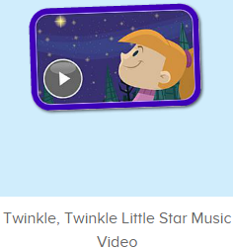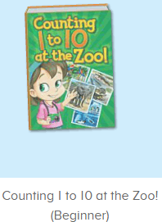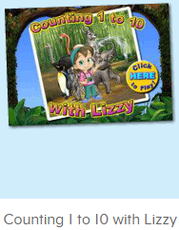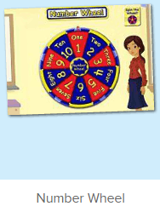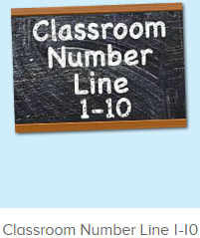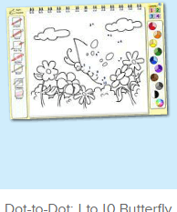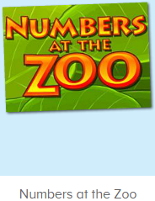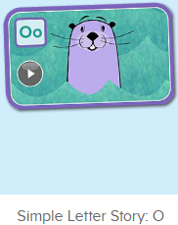
年龄段： 中班上
教学目标：1.能自如演唱歌曲Twinkle,twinkle,little star
2.能结合口语中的句子内容对数字图书进行看图说话
3.能应用表演字母故事O
3.能清楚认识1-10的数与量。
4.能应用替换词汇诗歌中的关键词句。
5.能认读应用数字图书中的全部内容
教具准备：1.数字卡片，2.不同动物及物品数量的卡片
使用游戏：1.Guessing game 2.Role play 3.TPR 4.Fast reaction 5.Dragon 6.Mic game
教学步骤： | 备注
- 成果公布及展示：  T: Hello kids. Glad to see you.  T:Hello kids.Glad to see you.  S:Glad to see you,too.  T:First,Let's praise Lisa,Molly,Jenny ... They all finished their homework.  Jason,come here please,show us your aquarium.（请一位幼生上前展示我的鱼缸）  J:This is "my aquarium"  J:There are two/three ...fish in my aquarium.  J:There is one shell/rock tunnel in my aquarium.  J:The fish/shells is/are pink/yellow/blue...  J:My tank is Fairy Tale tank.  J:I feed the fish/clean the aquarium everyday.  T:Well done.Thanks Jimmy.The next time,I'll invite you.Please,come on. | 幼生"my aquariums"部分的展示，由单个幼生结合上周的内容自己展示。
二、集体学习活动：  T:Now,It's ABCmouse time. Hello,everyone.  S:Hello, xxx  T:How are you,today?/How is the weather?  S:I am happy/so so/tired... /It's sunny/rainy/cloudy/windy....  T:I am ...I am a teacher.How about you?  S:I am ... I am a boy/girl.  T:Excellent.Let’s sing and dance.(教师点击进入素材图1，请幼生一起唱跳表演）  S:Twinkle,Twinkle Little Star. How I wonder what you are...  T:Now,please,look and say.  S:Little star/sky/diamond...  T:Good,sing it by yourselves.  S:...  T:G1,sing it ,G2, do the action.（一轮后，再交换）  G1&G2:...  T:Good,Let's continue.Look and say.（进入素材图2，关闭声音，让幼生看图说话）  S:Count 1 to10 at the zoo...  T:What is the name of this picture?/What number is this?/What can you see?/How many... ?/What color are the ...（教师根据页面内容提问,幼生单个回答，集体回答）  1S:It’s7/8/9/10/I can see .../There are ...  T:Very good.Lina,can you count the lions/monkeys/...  1S:Yes.1.2.3.4.5...  T:Wow,let’s continue.  S:...  T:This time.one by one.（播放图书，暂停翻页，单个幼生站起来接龙说）  S:This is number .../Look,there are ...lions./They are brown/big.../The lion can ...  T:Nice.let’s go ahead.Look and find.（进入素材图3,先说出来的上来找动物，其余幼生一起跟着数）  S:Can you find...  T:Lily,please  L:1,2,3,4,5,6.I can see ...  T:The next,Ken.（一位幼生数数，其余幼生仔细听跟着说，以此类推）  K:1,2,3,4,5,6,7.I can see ...  T:Nice.let’s spin the wheel.（进入素材图4,先请幼生把转盘上的数字说一遍，再进行游戏）  T:What’s this number?/Make a sentence with number 2/3/4/5...  S:It’s number .../There are ... apples./I can see ... birds.  T:Ok,let’s play.  S:Spin the wheel.（幼生一起说，选取一位上来转转盘）  1S:It’s number.../There are ....（幼生转完以后，再结合转到的数字说句子）  T:Well done.continue.  S:...  T:Classroom number line.who can try?（播放素材图5）  S:I can try.（抽3个数字请幼生点击，其余幼生跟读，请一名幼生结合跟读内容造句，会造句的再来点3个数字。以此类推2-3轮）  S:3,3 tents/6, 6 violins/8,8 peanuts.  1s:There are 8 peanuts.  T:Henry,try it.  H:5,5 balls/7, 7 dresses/9,9 keys.  S:5,5 balls/7, 7 dresses/9,9 keys.  T:Let’s paint the picture.What can you see in the picture?（播放素材图6）  S:I can see ...（单个幼生回答）  T:Good,let’s line the numbers.Ready go.  S:1,2,3,4,5,6,7,8,9,10  T:Wow,what is this?  S:It’s a butterfly.  T:Let’s color it.What color do you like?  S:I like red/yellow/blue...  T:Color it please.  1S:...  T:OK,what can you see in the picture?/What color is the ...  1s:I can see .../The ... is red/black...（集体和分组描述2-3轮）  T:Numbers in the zoo.listen and say.（播放素材图7）  S:Choose number 6.  T:Left or right?（给予幼生示意左右的意思）  S:left  T:Good.The next.  1S:Choose number 9,right.（单个幼生回答，至游戏结束）  T:Story time.Look,who/what is this? /What can you see in this picture?/Where are Oscar and Oliver?/What do they like?/What does the ... like?Do they like olives?/What color is the ...（播放素材图8）  S:...（单个幼生回答，不会的再整体引导回答）  T:Good job.Let's perform the story.  S:Simple letter story:O,This is...  T:Pick game. Group 1 and group 2,pick and say. （第一组抽卡片，给第二组说句子，第二组答出来后抽一张卡片请第一组说句子）  G1&G2:This is Oscar./Oscar is Oliver's brother...  T:Let's play matching game. Look and find the picture.（教师做动作,把故事图片放在一边，请幼生根据看到的找出对应的图片，并说出句子）  T:Who can? Sherry...  S:...  T:Wow, Let's review.（从第一幅图到最后一幅图，来一轮全体巩固）  S:...  T:Best performer.Mike,Joanna,Margret,Owen...（请幼生上来自己表演故事）  S:Simple letter story:O...  T:You did a very good job.Let's praise...  T:Excellent.Let’s review.（拿出单词及数字图卡）  T:Who is this?/What can ... do?/What is this number?/How many ....  S:This is .../... Can come here/paint.../It’s 6,7,8,9/There are ...  T:Let’s sing and dance.（幼生一起唱跳表演歌曲）  S:...  T:Good.Let's count the tickets.  S:1,2,3,4...  T:How many tickets have we got?  S:...  T:All of you did a good job.（总结课堂比赛结果及孩子情况）  G1,you are the winner,G2,come on!  And,Lucy,Ken,Rita,you are wonderful | 图1:  图2：  图3：  图4：  图5：  图6：  图7：  图8：
- 家庭游戏活动布置：
T:All of you did a good job. I'll show you the homework/activities. （将已放入功课的作业界面打开）
T:Look,how many activities do you need to play?
S:Four.
T:How to get a yellow star?
S:Play 5 times
T:Very well.Now Jason, come here and show us how to do the activities.
J:...
T:Good job!Thank you Jason!
T:So ,How many activities you need to play?
S:...
T:How to play?
S:...
T:Class is over, Goodbye everyone.
S:Goodbye Teacher.

