ABCmouse中班上Number6-10&Review: O-P-Q课时4
素材内容：1.Numbers 6 to 10,part 1 Animation
2.Numbers 6 to 10,part 2 Animation
3.Numbers 6 to10 practice
4.Practice page:nine apples
5.Practice page:ten apples
6.Number wheels
7.Twinkle,Twinkle,little star
8.The Letter O book
9.The Letter P book
10.The Letter Q book
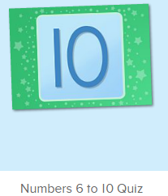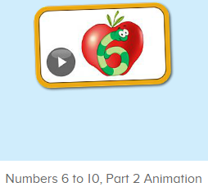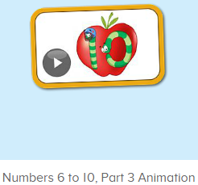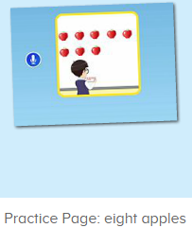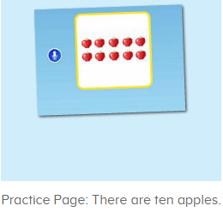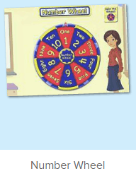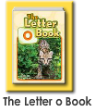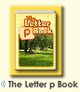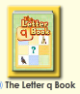
年龄段： 中班上
教学目标：1.能自如认读应用o-p-q的图书内容。
2.能流畅跟读口语对话中的句子。
2.能灵活运用Can you show me/count...
3.能清楚认识1-10的数与量。
4.能说出口语动画里的全部内容。
教具准备：1.数字卡片，2.不同动物及物品数量的卡片
使用游戏：1.Guessing game 2.Role play 3.TPR 4.Fingers and times.
教学步骤： | 备注
- 成果公布及展示：  T: Hello kids. Glad to see you.  T:Hello kids.Glad to see you.  S:Glad to see you,too.  T:First,Let's praise Lisa,Molly,Jenny ... They all finished their homework.  Jason,come here please,show us your aquarium.（请一位幼生上前展示我的鱼缸）  J:This is "my aquarium"  J:There are two /three ...fish in my aquarium.  J:There is one shell/rock tunnel in my aquarium.  J:The fish/shells is/are pink/yellow/blue...  J:My tank is Fairy Tale tank.  J:I feed the fish/clean the aquarium everyday.  T:Well done.Thanks Jimmy.The next time,I'll invite you.Please,come on. | 幼生"my aquariums"部分的展示，由单个幼生结合上周的内容自己展示。
二、集体学习活动：  T:Now,It's ABCmouse time. Hello,everyone.  S:Hello, xxx  T:How are you,today?/How is the weather?  S:I am happy/so so/tired... /It's sunny/rainy/cloudy/windy....  T:I am ...I am a teacher.How about you?  S:I am ... I am a boy/girl.  T:Very good.Listen and find.（进入素材图1，让幼生找对应的数字）  T:Where is 7.6.8.9.../Choose ...（平台声音）  S:Here is 7,6,8,9...  T:What’s this number?/Show me number ...  S:It’s ...  T:Excellent.Let’s enjoy the video.(教师点击进入素材图2，请幼生说句子）  Listen and say.  （教师播放素材，请幼生跟着说，从整体到单个）  T:Say it together.  S:Nico,Can you come here?/Yes./Today, we are going to paint apples./This is 1 apple./Can you paint 4 more apples, please?  T:Well done.Who can come here?/Who can paint the apples?/  S:I can...  T:Now,ask your friend?  1S&1S:Can you .../Yes.I can./No,I can’t.  T:How many apples are there?  S:There are ...  T:Good,Let's continue.Look and say.（进入素材图3，让幼生先看动画）  S:8,now,there are 8apples on the whiteboard...  T:What number is this?What is this?/You say ...（播放练习素材，教师引导幼生问，单个幼生回答，以此类推）  1S:It’s7/8/9/10/paint/apples/There are 10 apples.  T:Very good.Sharp ears.（教师播放平台，最快听到的抢答）  S:Lina,can you paint 1 more apple...  T:Who can paint 1 more apple?  S:Lina/Raj...  T:Say the whole sentence.  S:Lina/Raj can paint 1 more apple.  T:How many apples are there?（单个和多个幼生回答）  S:There are ... apples.  T:What’s this number?/Show me number ...（数字卡片）  S:It’s ...  T:Nice.Let’s continue（继续播放动画）  S:Excellent,/let’s practice one more time./Nico, can you help me count the apples?...  （教师请单个幼生说句子，挑选3-5名轮流跟着说即可）  T:Excellent,Look and say.G1&G2（进入素材图4-5,教师引导幼生自主问答）  G1:How many apples are there？  G2:There are ... apples.  T:Exchange.  T:Nice.Number wheel.Who can spin the wheel?（进入素材图6）  S:8/7/9/10...（幼生根据看转盘说数字，说的快的上来点击转盘 ）.  T:Ken.Have a try.Listen carefully.（一位幼生转，其余幼生仔细听）  S:...  T:What’s this number?  K:  T:Make a sentence with “8”.  S:...（单个和多个幼生造句练习）  T:Good job.Let's enjoy a song.（进入素材图7，幼生仔细听）  S:...  T:Show me your hands,let’s do the action.（第二遍，边听边做动作）  S:...（幼生跟着教师一起做动作）  T:This time,listen carefully and tell me what you can hear?（播放视频，幼生聆听，教师适当动作提示）  S:..  T:What can you hear?  S:I can hear ...（单个幼生回答，其余幼生跟着一起说）  T:Good.Let’s check.（再核对一次，教师走近幼生，适时表扬与鼓励）  T:Wow,follow it.  S:...  T:Let’s read the book.Who can try?（打开图书，关闭声音，幼生自主朗读）  S:I can try.  T:Gs, say it together.  Gs:The letter O book...  T:Excellent.The next,Bs.  Bs:The letter P book...  T:Well down.This time.One by one.（最后一本书，从左至右站起来接龙读）  S:The letter Q book...（每位幼生站起来读，并做对应动作）  T:Excellent.Let’s review.（拿出单词及数字图卡）  T:Who is this?/What can ... do?/What is this number?/How many ....  S:This is .../... Can come here/paint.../It’s 6,7,8,9/There are ...  T:Let’s check.（重复播放素材图3，并请幼生跟读）  S:...  T:Good.Let's count the tickets.  S:1,2,3,4...  T:How many tickets have we got?  S:...  T:All of you did a good job.（总结课堂比赛结果及孩子情况）  G1,you are the winner,G2,come on!  And,Lucy,Ken,Rita,you are wonderful | 图1:  图2：  图3：  图4：  图5：  图6：  图7：  图8：  图9:  图10:
- 家庭游戏活动布置：
T:All of you did a good job. I'll show you the homework/activities. （将已放入功课的作业界面打开）
T:Look,how many activities do you need to play?
S:Four.
T:How to get a yellow star?
S:Play 5 times
T:Very well.Now Jason, come here and show us how to do the activities.
J:...
T:Good job!Thank you Jason!
T:So ,How many activities you need to play?
S:...
T:How to play?
S:...
T:Class is over, Goodbye everyone.
S:Goodbye Teacher.

