ABCmouse中班上Number6-10&Review: O-P-Q课时10
素材内容：1.Twinkle,Twinkle,little star
2.Counting 1 to 10 with Lizzy
3.Numbers 6 to 10 Animation
4.Egg counter
5.Simple letter story:o,p,q
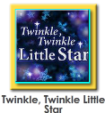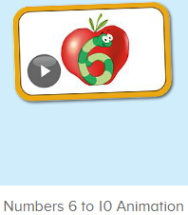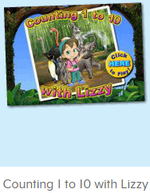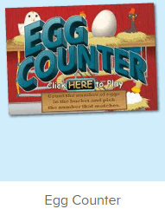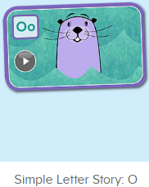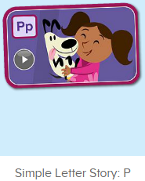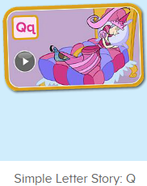
年龄段： 中班上
教学目标：1.能自如演唱歌曲Twinkle,twinkle,little star
2.能结合口语中的句子内容对数字图书进行看图说话
3.能应用表演字母故事o-p-q
3.能清楚认识1-10的数与量。
4.能应用替换词汇诗歌中的关键词句。
5.能认读应用数字图书中的全部内容
教具准备：1.数字卡片 2.不同动物及物品数量的卡片 3.故事图片 4.歌曲及故事关键词图片
使用游戏：1.Guessing game 2.Role play 3.TPR 4.Fast reaction 5.Dragon 6.Hide and seek
教学步骤： | 备注
- 成果公布及展示：  T: Hello kids. Glad to see you.  T:Hello kids.Glad to see you.  S:Glad to see you,too.  T:First,Let's praise Lisa,Molly,Jenny ... They all finished their homework.  Jason,come here please,show us your aquarium.（请一位幼生上前展示我的鱼缸）  J:This is "my aquarium"  J:There are two/three ...fish in my aquarium.  J:There is one shell/rock tunnel in my aquarium.  J:The fish/shells is/are pink/yellow/blue...  J:My tank is Fairy Tale tank.  J:I feed the fish/clean the aquarium everyday.  T:Well done.Thanks Jimmy.The next time,I'll invite you.Please,come on. | 幼生"my aquariums"部分的展示，由单个幼生结合上周的内容自己展示。
二、集体学习活动：  T:Now,It's ABCmouse time. Hello,everyone.  S:Hello, xxx  T:How are you,today?/How is the weather?  S:I am happy/so so/tired... /It's sunny/rainy/cloudy/windy....  T:I am ...I am a teacher.How about you?  S:I am ... I am a boy/girl.  T:Excellent.Let’s sing and dance.(教师点击进入素材图1，请幼生一起唱跳表演）  S:Twinkle,Twinkle Little Star. How I wonder what you are...  T:Now,please,look and say.  S:Little star/sky/diamond...（单个幼生和多个幼生都有）  T:Good,sing it by yourselves.  S:...  T:G1,sing it ,G2, do the action.（一轮后，再交换）  G1&G2:...  T:Excellent.Let’s enjoy the video.(教师点击进入素材图2，教师播放素材，请幼生先看图说话，再跟着说，从整体到单个接龙）  T:What can you see?/Who is this?/what color is this?  S:I can see .../This is Miss Jones/It’s ...（单个或多个幼生回答）  T:Good,let’s repeat.（教师挑选单个幼生说）  1S:Nico,Can you come here?/Yes./Today, we are going to paint apples./This is 1 apple./Can you paint 4 more apples, please?...  T:What’s the next?（适时暂停，请幼生抢答说出下一句）  1S:...  T:Nice.let’s go ahead.Listen and find.（进入素材图3,先说出来的上来找动物，其余幼生一起跟着数）  S:Can you find...  T:Lily,please  L:1,2,3,4,5,6.I can see ...  T:The next,Ken.（一位幼生数数，其余幼生仔细听跟着说，以此类推）  K:1,2,3,4,5,6,7.I can see ...  T:Hide and seek.First,look and say  S:5 monkeys/9impalas...  T:What’s missing?（此游戏进行2轮左右）  S:4 lions .  T:Who can find 4lions?  S:I can find 4 lions.  T:Lucy,can you find 4 lions?  L:Yes,I can.  T:Go and find,please.The others say the sentences 5 times.  S:Can you find 4 lions?  L:Wow, it’s here.  T:Excellent,Egg counter time.Look ,listen and count（进入素材图4,教师引导幼生自主问答）  T:Who can count?  G:I can.1.2.3.4.5...  T:Choose the right number.  S:This one is number ...（2-3轮）  T:Story time.Look,who/what is this? /What can you see in this picture?/What color is the ...?/ Do you like the ...（拿出字母故事关键内容图片）  S:...  T:Find 4words for letter o/p/q from the story.  S:Oscar/Oliver/octopus/otter （请单个幼生先说，再全体说）  Perter/Pearl/pet/puppy  Queen/Quince/quail/quilt  T:Very good.Picture talking time.  G1&G2:...（轮流随机看图说话，看哪组的幼生说得多）  T:Let's play matching game. Look,say and match the picture.（教师把故事图片放在一起，三个故事混放，请幼生挑选图片，并说出对应的句子，放到对应的位置，说出内容并找出对应的图片）  T:Who can? Sherry/Peter...  Sh:This is ...  S:...  T:Wow, Let's review.（从第一幅图到最后一幅图，来一轮全体巩固）  S:...  T:Let's perform the story. Simple letter story O/P/Q. Bs&GsReady! go（音量调小，从头开始放，男生一句，女生一句，带动作表演）  S:..  T:You did a very good job.Let's praise...  T:Best performer,Who can try?（请一组幼生上来表演故事，其余评分）  S:I can try.  T:Peter,Zoe...  S:Simple letter story:O/P/Q  T:Good job.Let's perform the story.（角色扮演，上道具，把幼生分为3组，每组表演一个故事）  S:Simple letter story:Q,This is...  T:Excellent.Let’s review.（拿出单词及数字图卡）  T:Who is this?/What can ... do?/What is this number?/How many ....  S:This is .../... Can come here/paint.../It’s 6,7,8,9/There are ...  T:Let’s sing and dance.（幼生一起唱跳表演歌曲）  S:...  T:Good.Let's count the tickets.  S:1,2,3,4...  T:How many tickets have we got?  S:...  T:All of you did a good job.（总结课堂比赛结果及孩子情况）  G1,you are the winner,G2,come on!  And,Lucy,Ken,Rita,you are wonderful | 图1:  图2：  图3：  图4：  图5-7：
- 家庭游戏活动布置：
T:All of you did a good job. I'll show you the homework/activities. （将已放入功课的作业界面打开）
T:Look,how many activities do you need to play?
S:Four.
T:How to get a yellow star?
S:Play 5 times
T:Very well.Now Jason, come here and show us how to do the activities.
J:...
T:Good job!Thank you Jason!
T:So ,How many activities you need to play?
S:...
T:How to play?
S:...
T:Class is over, Goodbye everyone.
S:Goodbye Teacher.

