ABCmouse中班下Letters Reviews X-Y-Z&One and more课时1
复习素材内容：  - The x-y-z Chant.  - X-y-z Review Cutout Puzzle.  - X-y-z Matching Card Game. | 新授素材内容：  - One and More，Part1 Animation.  - Practice Page:How many spots?  - Practice page:Toby has one blue spot.  - Practice page:Toby has three blue spots.
素材截图：
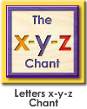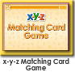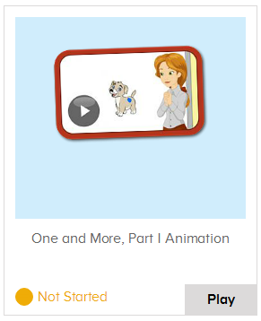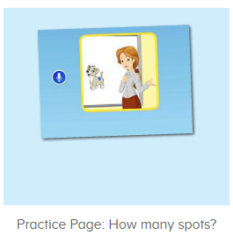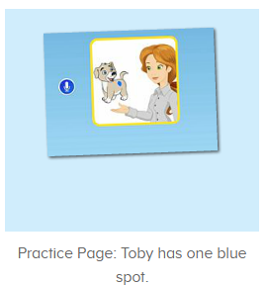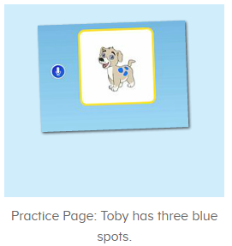
年龄段： 中班下
教学目标：
- 能熟练掌握字母x,y,z的基础发音。
- 能熟练掌握对应发音的词汇词
- 能自如念唱x-y-z的诗歌。
- 能听出口语视频中的关键词或句子。
- 能流利跟读How many spots does Toby have?Toby has one blue spot.Toby has three blue spots.
教具准备：1.x,y,z单词及字母图卡 2.口语句子图卡
使用游戏：1.Guessing game 2.TPR 3.I do you say
教学步骤： |  | 备注
- 成果公布及展示：  T: Hello kids,good morning.  S:Good morning Yama.  T:First,let's praise Andy,Jason...They have finished their activities.  S:Good,good,very very good!  T:Andy,come here please, show us your activities  J:Ok.  T:Well done!(请完成家庭活动的幼生上前自主操作网站，向其他幼生展示家庭活动成果)  Everybody look,how many activities have Andy finished?  S:Four.  T:Wow,very good thank you Andy.  Now everybody look,what is this?  S:This is my aquarium,my hamster maze.  T:Good job!Coco come here, please show us your hamster maze.  C:OK.This is my hamster maze.I have two hamsters.This one is brown,that one is orange.They like to run and sleep.I feed them everyday.They are so cute.  T:Thank you Coco.Henry come here,please show us your aquarium.  H:OK.This is my aquarium.I have three fish.This one is yellow,this one is blue,that one is orange.My aquarium background is space.I clean my aquarium everyday.I love it very much.  T:Very good,Henry.Let's praise.  T&S:Good,good,very very good! |  | 成果公布及展示我的鱼缸、我的仓鼠(单个幼生展示）
- 集体学习活动：  快乐唱吧  T:Wonderful.Now let's chant.First listen and no voice.（教师点击进入图1素材，请幼生先听不跟唱）  This time,listen and repeat.  S:Letter x says "x"."x" "x" "x"fox, box, six."x" letter x.Letter y says "y". "y" "y" "y".yo-yo, yogurt, yarn."y" letter y.Letter z says "z."z" "z" "z".zebra, zipper, zero. "z" letter z.  T:Very nice!Now stand up,let's sing and dance.  S:Letter x says "x"...  拼拼乐  T: Now let's play a puzzle game.Please listen and repeat.(教师点击进入图2素材，选择级别1完成拼图，请幼生仔细听跟着说）  S:Yak/fox/zipper...  T:Well done.Now who wants to try?（教师选择级别2/3，请幼生上前操作素材，其余幼生跟读发音）  S:Let me try.  T:Tim/Lily/Peter...please.  Everybody listen and repeat.  S:Yak/fox/zipper...  图卡对对碰  T:Well done!Now let's play a game.(教师点击进入图3素材，请幼生跟读发音并选择正确的图卡进行配对)  Please repeat and choose.  S:Fox/yo-yo/x/y....  T:Good job!Who can try?  S:Let me try.  T:Tim/Lily/Peter...please.  Everybody listen and repeat.  S:Fox/yo-yo/x/y....  趣味口语动画  T:Now let’s enjoy the video,please listen and no voice.（播放图4口语动画视频，请幼生认真听不跟读，教师可在关键词、句中暂停，询问幼生问题）  Who is this?(在介绍Toby的地方停下询问幼生问题)  S:Toby.  T:Good job!So say hello to Toby.  S:Hello,Toby.  T:Nice job!Let’s continue.  What can you hear?  S:One blue spot.  T:Right?Let’s check,listen again.  Terrific!  趣味复读机  T:Now let’s practice.(打开图5素材，先请幼生听不跟读)  First,listen and no voice.  What can you hear?  S:Toby/spot...  T:Let’s check,listen again.(播放2-3遍)  Good job!  Now listen and repeat.  S:How many spots does Toby have?（跟读2-3遍）  T:Now boys/girls,stand up,listen and repeat.  Bs/Gs:How many spots does Toby have?  T:Good job!Now look,how many spots does Toby have?(教师出示图6素材图卡，导入学习)  S:One.  T:Right?Let’s check.Listen and no voice.(点击图6素材，请幼生先听不跟读)  Now repeat it.  S:Toby has one blue spot.(跟读2-3遍)  T:Now boys/girls,stand up,listen and repeat.  Bs/Gs:Toby has one blue spot.  T:So how many spots does Toby have?  S:Toby has one blue spot.  T:Now you will ask and I will answer,ok?  S:Ok.  How many spots does Toby have?  T:Toby has one blue spot.  Very good,once again.  How many spots does Toby have?/Toby has one blue spot.  S:Toby has one blue spot./How many spots does Toby have?  T:Now boys/girls,you ask,and girls.boys,you answer,ok?  S:OK.  Bs/Gs:How many spots does Toby have?/Toby has one blue spot.  Gs/Bs:Toby has one blue spot./How many spots does Toby have?  T:Wow,you did a great job!  Now listen carefully.how many spots does Toby have?(教师点击播放图7素材，请幼生听并回答问题)  How many spots does Toby have?  S:Toby has three blue spots.  T:Right?Let’s check,listen and repeat.  S:Toby has three blue spots.(跟读2-3遍)  T:Now boys/girls,stand up,listen and repeat.  Bs/Gs:Toby has three blue spots.  T:Good job!  你问我答  T:Now let’s make the conversation.  First,I ask,you answer,ok?  S:Ok.  T:How many spots does Toby have?  S:Toby has one/three blue spot/s.  T:Nice!It’s your turn.  S:How many spots does Toby have?  T:Toby has one/three blue spot/s.  Very good!  Now boys/girls,you ask,and girls/boys,you answer,ok?  S:OK.  Bs/Gs:How many spots does Toby have?/Toby has one/three blue spot/s.  Gs/Bs:/Toby has one/three blue spot/s./How many spots does Toby have?  T:Wonderful!Now who can try?  S:Let mt try.  T:Peter/Lily/Kelly/Molly,please.  P/K/L/M:How many spots does Toby have?/Toby has one/three blue spot/s.  趣味大扫描-单词连连看  T:Wonderful.Let's review.  Listen and repeat.（点击图1,5,6,7请幼生跟读复习）  S:Letter x says "x"."x" "x" "x"fox, box, six."x" letter x.Letter y says "y". "y" "y" "y".yo-yo, yogurt, yarn."y" letter y.Letter z says "z."z" "z" "z".zebra, zipper, zero. "z" letter z.  How many spots does Toby have?/Toby has one/three blue spot/s.  T:Very good!Now let’s count our tickets.  Who can try?  S:Let me try.  T:Candy please.  T:How many tickets do we have today?  Let's count with ABCmouse.  S&ABCmouse:One,two,three......  T:So How many tickets do we have today?  S:We have ten tickets today.  T:Candy,how many tickets do we have today?  C:We have ten tickets today.  T:Thank you Candy.Very good! |  | 图1：  图2：  图3：  图4：  图5：  图6：  图7：
- 家庭活动布置：
T:Wow!So nice!Now I'll show you the activities.（将已放入功课的作业界面打开）
T: Look,how many activities do you need to do?
S:...
T:Very well.Now I will show you how to do it.Please listen carefully.
Jason come here and show us how to do the activities.
Good job!Thank you Jason!
Please finish the activities and show me tomorrow,ok?
S:OK!
T:Class is over, Goodbye everyone.
S:Goodbye Yama.

