ABCmouse中班下Letters Reviews X-Y-Z&One and more课时3
复习素材内容：.  - .Practice Page:Toby has four red spots.  - Practice page:Toby has five red spots.  - Practice page:Toby has six red spots. | 新授素材内容：  - Practice Page:Toby has seven green spots.  - Practice page:Toby has eight red spots.  - Practice page:Toby has nine purple spots.  - Practice page:Toby has ten orange spots.  - Sing the Alphabet Music Video.  - One and More,Part 3 Animation.
素材截图：
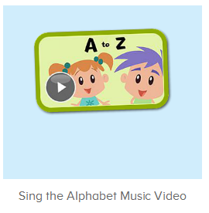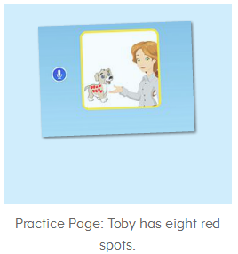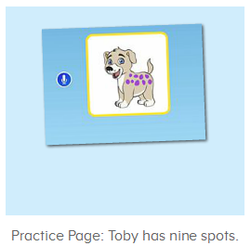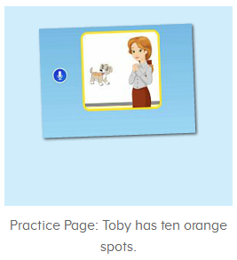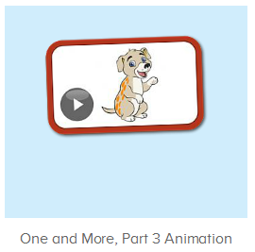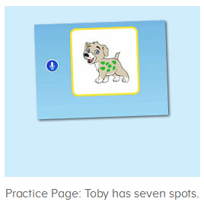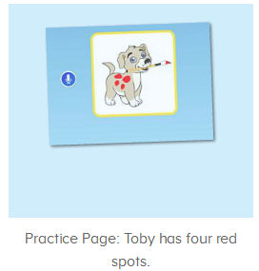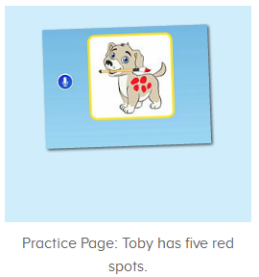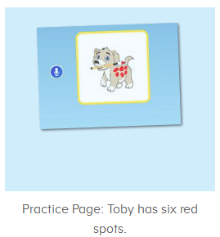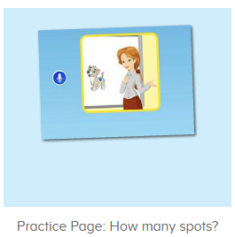
年龄段： 中班下
教学目标：
- 能听出歌曲Sing the Alphabet第一段中包含的字母和单词，能跟着节奏哼唱第一段。
- 能听出口语视频中的关键词或句子。
- 能流利跟读How many spots does Toby have?Toby has one blue spot.Toby has three blue spots.Toby has four red spots.Toby has five red spots.Toby has six red spots.Toby has seven green spots.Toby has eight red spots.Toby has nine purple spots.Toby has ten orange spots.并进行对话。
- 能用...has...句子造句。
教具准备：1.口语句子图卡
使用游戏：1.Guessing game 2.TPR 3.I do you say
教学步骤： |  | 备注
- 成果公布及展示：  T: Hello kids,good morning.  S:Good morning Yama.  T:First,let's praise Andy,Jason...They have finished their activities.  S:Good,good,very very good!  T:Andy,come here please, show us your activities  J:Ok.  T:Well done!(请完成家庭活动的幼生上前自主操作网站，向其他幼生展示家庭活动成果)  Everybody look,how many activities have Andy finished?  S:Four.  T:Wow,very good thank you Andy.  Now everybody look,what is this?  S:This is my aquarium,my hamster maze.  T:Good job!Coco come here, please show us your hamster maze.  C:OK.This is my hamster maze.I have two hamsters.This one is brown,that one is orange.They like to run and sleep.I feed them everyday.They are so cute.  T:Thank you Coco.Henry come here,please show us your aquarium.  H:OK.This is my aquarium.I have three fish.This one is yellow,this one is blue,that one is orange.My aquarium background is space.I clean my aquarium everyday.I love it very much.  T:Very good,Henry.Let's praise.  T&S:Good,good,very very good! |  | 成果公布及展示我的鱼缸、我的仓鼠(单个幼生展示）
- 集体学习活动：  快乐唱吧  T:Now let’s sing the Alphabet song.First,listen and no voice.（播放图1歌曲素材，请幼生注意听，不跟唱，可只播放第一段)  This time,let’s listen and repeat.  S:...a is for apple,and b is for ball...(跟唱2-3遍)  T:Very good!Now stand up,let’s sing and dance.  S:...a is for apple,and b is for ball...(跟唱2-3遍)  T:Great job!Now let’s have a match,ok?(加入分组跟唱)  S:OK.  T1/T2/T3:...A is for apple.B is for ball...  T:Wonderful!Now stand up,let’s sing and dance.（加入律动）  S:...a is for apple,and b is for ball...(跟唱2-3遍)  温故知新  T:Wonderful.Now let's listen and repeat.（教师点击进入图2-图5素材，请幼生跟读）  S:Toby has four/five/six red spots.  趣味口语动画  T:You are so great!Now let’s enjoy the video,please listen and no voice.（播放图5口语动画视频，请幼生认真听不跟读，教师可在关键词、句中暂停，询问幼生问题）  How many spots does Toby have?  S:Toby has seven green spots./Toby has eight red spots./Toby has nine purple spots./Toby has ten orange spots.  T:Is it right?Let’s check/Listen careful!  趣味复读机  T:very good.Now let’s practice.(打开图6-图:9素材，先请幼生听不跟读)  First,listen and no voice.  Now listen and repeat.  S:Toby has seven green spots./Toby has eight red spots./Toby has nine purple spots./Toby has ten orange spots(跟读2-3遍)  T:Now boys/girls,stand up,listen and repeat.  Bs/Gs:Toby has four/five/six red spots.  T:So how many spots does Toby have?（指着平台画面询问幼生）  S:Toby has seven green spots./Toby has eight red spots./Toby has nine purple spots./Toby has ten orange spots  T:Lily/Peter/Leo...,look,how many spots does Toby have?  L/P/L:Toby has seven green spots./Toby has eight red spots./Toby has nine purple spots./Toby has ten orange spots.  你问我答  T:Now let’s make the conversation.ok?  S:Ok.  T:How many spots does Toby have?（指着平台画面询问幼生）  S:Toby has seven green spots./Toby has eight red spots./Toby has nine purple spots./Toby has ten orange spots.  T:Nice!It’s your turn.  S:How many spots does Toby have?  T:Toby has seven green spots./Toby has eight red spots./Toby has nine purple spots./Toby has ten orange spots.  Very good!  Now boys/girls,you ask,and girls/boys,you answer,ok?  S:OK.  Bs/Gs:How many spots does Toby have?/Toby has seven green spots./Toby has eight red spots./Toby has nine purple spots./Toby has ten orange spots.  Gs/Bs:Toby has seven green spots./Toby has eight red spots./Toby has nine purple spots./Toby has ten orange spots./How many spots does Toby have?  T:Wonderful!Now who can try?  S:Let mt try.  T:Peter/Lily/Kelly/Molly,please.  P/K/L/M:How many spots does Toby have?/Toby has seven green spots./Toby has eight red spots./Toby has nine purple spots./Toby has ten orange spots.  趣味大扫描  T:Wonderful.Let's review.  Listen and repeat.（点击图2-9请幼生跟读复习）  S:Toby has four/five/six red spots...  T:Now look at the pictures.Kelly/Molly/Louise...come here,you will ask and they will answer,ok?(准备图卡，请几位幼生上前当小老师，提问问题，其余幼生回答)  K/M/L:Ok.  How many spots does Toby have?  S:Toby has one/three/four/five/six blue/red spots.//Toby has seven green spots./Toby has eight red spots./Toby has nine purple spots./Toby has ten orange spots.  T:Very good!Thank you Kelly/Molly/Louise.  Now let’s sing and dance.  S:...a is for apple,and b is for ball...  T:Well done!Now let’s count our tickets.  Who can try?  S:Let me try.  T:Candy please.  T:How many tickets do we have today?  Let's count with ABCmouse.  S&ABCmouse:One,two,three...  T:So How many tickets do we have today?  S:We have ten tickets today.  T:Candy,how many tickets do we have today?  C:We have ten tickets today.  T:Thank you Candy.Very good! |  | 图1：  图2：  图3：  图4：  图5：  图6：  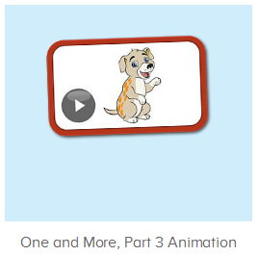  图7：  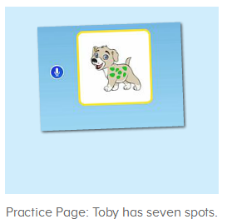  图8：  图9：  图10：
- 家庭活动布置：
T:Wow!So nice!Now I'll show you the activities.（将已放入功课的界面打开）
T: Look,how many activities do you need to do?
S:...
T:Very well.Now I will show you how to do it.Please listen carefully.
Jason come here and show us how to do the activities.
Good job!Thank you Jason!
Please finish the activities and show me tomorrow,ok?
S:OK!
T:Class is over, Goodbye everyone.
S:Goodbye Yama.

