ABCmouse中班下Letters Reviews X-Y-Z&One and more课时4
复习素材内容：.  - Practice Page:Toby has seven green spots.  - Practice page:Toby has eight red spots.  - Practice page:Toby has nine purple spots.  - Practice page:Toby has ten orange spots. | 新授素材内容：  - Sing the Alphabet Music Video.  - One and More,Part 3 Animation.  - One and More Practice.  - One and More Quiz.  - How Many?  - How Many?Cutout Puzzle.
素材截图：
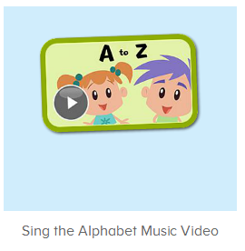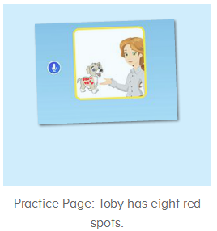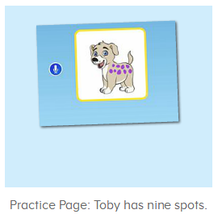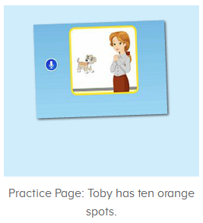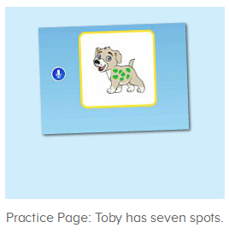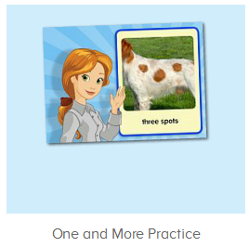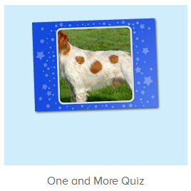
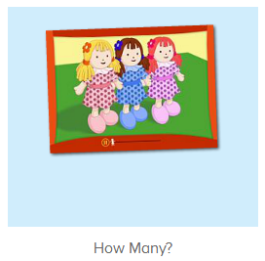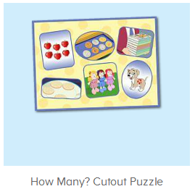
年龄段： 中班下
教学目标：
- 能跟唱歌曲Sing the Alphabet第一段，能听出第二段包含的字母及代表的单词，能跟着哼唱第二、三段I is for...,...sing the letters along with me。
- 能流利跟读Toby has seven green spots.Toby has eight red spots.Toby has nine purple spots.Toby has ten orange spots.并进行对话。
- 能流利跟读How Many视频内容，并能用How many和相关词汇回答问题。
教具准备：1.口语句子图卡
使用游戏：1.Guessing game 2.TPR 3.I do you say
教学步骤： |  | 备注
- 成果公布及展示：  T: Hello kids,good morning.  S:Good morning Yama.  T:First,let's praise Andy,Jason...They have finished their activities.  S:Good,good,very very good!  T:Andy,come here please, show us your activities  J:Ok.  T:Well done!(请完成家庭活动的幼生上前自主操作网站，向其他幼生展示家庭活动成果)  Everybody look,how many activities have Andy finished?  S:Four.  T:Wow,very good thank you Andy.  Now everybody look,what is this?  S:This is my aquarium,my hamster maze.  T:Good job!Coco come here, please show us your hamster maze.  C:OK.This is my hamster maze.I have two hamsters.This one is brown,that one is orange.They like to run and sleep.I feed them everyday.They are so cute.  T:Thank you Coco.Henry come here,please show us your aquarium.  H:OK.This is my aquarium.I have three fish.This one is yellow,this one is blue,that one is orange.My aquarium background is space.I clean my aquarium everyday.I love it very much.  T:Very good,Henry.Let's praise.  T&S:Good,good,very very good! |  | 成果公布及展示我的鱼缸、我的仓鼠(单个幼生展示）
- 集体学习活动：  快乐唱吧  T:Now let’s sing the Alphabet song.（播放图1歌曲素材，请跟唱)  S:...a is for apple,and b is for ball...(跟唱2-3遍)  T:Very good!Now stand up,let’s sing and dance.  S:...a is for apple,and b is for ball...(跟唱2-3遍)  T:Great job!Now,listen and no voice.(接着播放第二段，请幼生先听不跟唱)  What can you hear?  S:I/J...  T:Right?Let’s check,listen again.  Very nice!Now listen and repeat.  S:I is for....  T:Let’s sing it sentence by sentence.  S:I is for...  T:Good job!Once again.  S:I is for...  T:Try again.  S:I is for....  T:This time let’s add some actions.  S:I is for....(带动作跟唱2-3遍)  温故知新  T:Wonderful.Now let's listen and repeat.（教师点击进入图2-图5素材，请幼生跟读）  S:Toby has seven green spots./Toby has eight red spots./Toby has nine purple spots./Toby has ten orange spots.  你问我答  T:Now let’s make the conversation.ok?  S:Ok.  T:How many spots does Toby have?（出示图卡询问幼生）  S:Toby has seven green spots./Toby has eight red spots./Toby has nine purple spots./Toby has ten orange spots.  T:Nice!It’s your turn.  S:How many spots does Toby have?  T:Toby has seven green spots./Toby has eight red spots./Toby has nine purple spots./Toby has ten orange spots.  Very good!  Now boys/girls,you ask,and girls/boys,you answer,ok?  S:OK.  Bs/Gs:How many spots does Toby have?/Toby has seven green spots./Toby has eight red spots./Toby has nine purple spots./Toby has ten orange spots.  Gs/Bs:Toby has seven green spots./Toby has eight red spots./Toby has nine purple spots./Toby has ten orange spots./How many spots does Toby have?  T:Wonderful!Now who can try?  S:Let mt try.  T:Peter/Lily/Kelly/Molly,please.  P/K/L/M:How many spots does Toby have?/Toby has seven green spots./Toby has eight red spots./Toby has nine purple spots./Toby has ten orange spots.  Listen and record  T:Wonderful.Now let's listen and repeat.（教师点击进入图6素材，请幼生跟读）  S:Count/one spot/three spots/five spots...（跟读2-3遍）  T:Let’s listen and record.  S:Count/one spot/three spots/five spots...  T:Good job!Now let’s play a choosing game.(打开图7素材，请于幼生跟读并轮流请幼生操作平台选择正确答案)  Please repeat and choose.  Who can try?  S:Let me try.  T:Sam/Peter/Kitty...please.  Everybody,listen and repeat,ok?  S:OK.  Choose count/Where is one spot?/three spots...?  T:Right?  S:Yes.  口语Video  T:Wonderful!Now let’s enjoy a video,please listen and no voice.(打开图8素材，请幼生只听不跟读)  What can you hear?  S:Apples/cookies/spots...  T:Right?Listen again.  When you hear apples/cookies/spots...please clap your hands.ok?  S:OK.  T:Very nice,this time let’s listen and repeat.  S:How many/six apples...(跟读2-3遍，可加入分组跟读游戏)  T:Look,how many apples/coins...?（一句一句暂停跟读并提问检测）  S:Six apples/seven coins...  拼拼乐  T:Nice job!Let’s play a puzzle game.（打开图9素材，选择级别1，教师操作，请幼生跟读）  First listen and repeat.  S:Six apples/seven coins...  T:Look,what are these?These are...  S:These are apples/coins...  T:Who wants to try?  S:Let me try.  T:Susan/Kitty/Billy...please.  Everybody listen and repeat,ok?  S:OK.  Six apples/seven coins...  你问我答  T:Great job!Now let’s make a conversation.  Look,how many apples/coins...?There are...  T&S:There are six apples/seven coins...  T:Good job!Once again.  How many apples/coins..?  S:There are six apples/seven coins...  T:Terrific!Now boys/girls,you will be the teacher,ok?  BS/GS:Ok.  Bs/Gs:How many apples/coins..?  Bs/Gs:There are six apples/seven coins...  T:Very good!Now who wants to be the little teacher?  S:Let me try.  T:Paul/Gina/Harry..please.  P/G/H:How many apples/coins...?  S:There are six apples/seven coins...  趣味大扫描  T:Wonderful.Let's review.  Listen and repeat.（点击图6请幼生跟读复习）  S:Count/one spot...  T:Very good! Now let’s sing the song again.  S:Let’s learn the...a is for apple,and b is for ball...Please sing the letters along with me.  T:Well done!Now let’s count our tickets.  Who can try?  S:Let me try.  T:Candy please.  T:How many tickets do we have today?  Let's count with ABCmouse.  S&ABCmouse:One,two,three...  T:So How many tickets do we have today?  S:We have ten tickets today.  T:Candy,how many tickets do we have today?  C:We have ten tickets today.  T:Thank you Candy.Very good! |  | 图1：  图2：  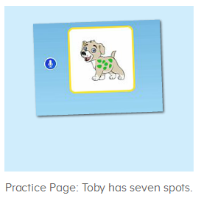  图3：  图4：  图5：  图6：  图7：  图8：  图9：
- 家庭活动布置：
T:Wow!So nice!Now I'll show you the activities.（将已放入功课的界面打开）
T: Look,how many activities do you need to do?
S:...
T:Very well.Now I will show you how to do it.Please listen carefully.
Jason come here and show us how to do the activities.
Good job!Thank you Jason!
Please finish the activities and show me tomorrow,ok?
S:OK!
T:Class is over, Goodbye everyone.
S:Goodbye Yama.

