ABCmouse中班下Letters Reviews X-Y-Z&One and more课时6
复习素材内容：.  - Practice Page:She has three dolls.  - Practice Page:He has five robots.  - How Many Do You Have?  - How Many?Cutout Puzzle. | 新授素材内容：  - Sing the Alphabet Music Video.  - How Many?Part2 Animation.  - Practice Page:How many airplanes?.  - Practice Page:He has one airplane.  - Practice Page:He has seven airplanes.
素材截图：
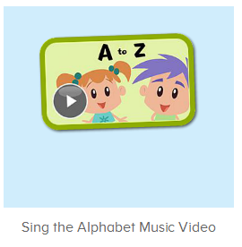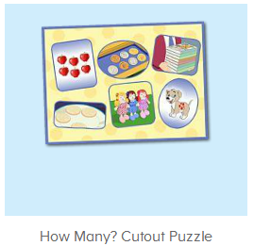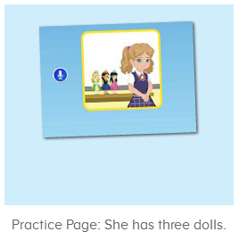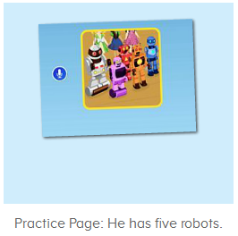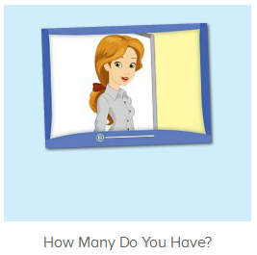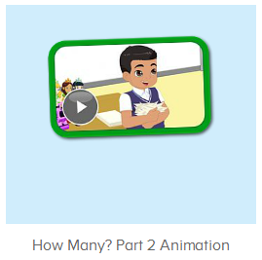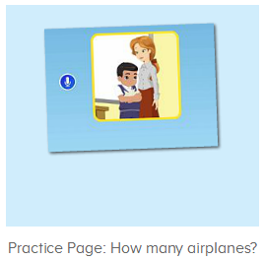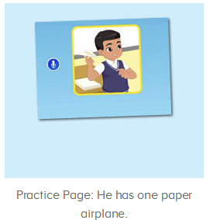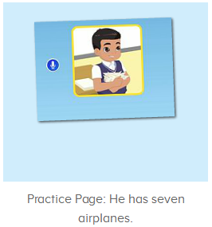
年龄段： 中班下
教学目标：
- 能跟唱歌曲Sing the Alphabet第一、二、三段并加上动作表演。
- 能听出歌曲第四段包含的字母及单词，能跟着哼唱。
- 能听出口语视频中的关键词、句。
- 能流利跟读How many airplanes?He has one airplane.He has seven airplanes.
- 能用How many?cutout puzzle 的词组编对话。
教具准备：1.口语句子图卡
使用游戏：1.Guessing game 2.TPR 3.I do you say
教学步骤： |  | 备注
- 成果公布及展示：  T: Hello kids,good morning.  S:Good morning Yama.  T:First,let's praise Andy,Jason...They have finished their activities.  S:Good,good,very very good!  T:Andy,come here please, show us your activities  J:Ok.  T:Well done!(请完成家庭活动的幼生上前自主操作网站，向其他幼生展示家庭活动成果)  Everybody look,how many activities have Andy finished?  S:Four.  T:Wow,very good thank you Andy.  Now everybody look,what is this?  S:This is my aquarium,my hamster maze.  T:Good job!Coco come here, please show us your hamster maze.  C:OK.This is my hamster maze.I have two hamsters.This one is brown,that one is orange.They like to run and sleep.I feed them everyday.They are so cute.  T:Thank you Coco.Henry come here,please show us your aquarium.  H:OK.This is my aquarium.I have three fish.This one is yellow,this one is blue,that one is orange.My aquarium background is space.I clean my aquarium everyday.I love it very much.  T:Very good,Henry.Let's praise.  T&S:Good,good,very very good! |  | 成果公布及展示我的鱼缸、我的仓鼠(单个幼生展示）
- 集体学习活动：  快乐唱吧  T:Now let’s sing the Alphabet song.（播放图1歌曲素材，请跟唱第一到三段)  S:Let’s sing the alphabet song.A is for apple,and b is for ball...along with me.(跟唱2-3遍)  T:Very good!Now stand up,let’s sing and dance.  S:Let’s sing the alphabet song.A is for apple,and b is for ball...along with me.(带动作跟唱2-3遍)  T:Nice job!Now listen and no voice.(继续播放第四段)  What can you hear?  S:I can hear Q/S  T:Right?Listen again.  Wow,very good!  This time,when you hear letter Q/S...please clap your hands,ok?  S:OK.  T:Very nice!Now listen and repeat.  S:Q is for quiet,and R is for rose(跟唱2-3遍)  T:Good job!Now let’s sing it sentence by sentence.  S:Q is for quiet,and R is for rose..  T:Now stand up,let’s add some actions.(加上动作跟唱2-3遍)  S:Q is for quiet,and R is for rose...  温故知新  T:Wonderful.Now let's listen and repeat.（教师点击进入图2-图4素材，请幼生跟读）  S:How many do you have?/How many dolls do you have?../She has three dolls./He has five robot.  T:Lily/Peter..come here please,now look,how many apples/ coins/books... does Lily/Peter have?  S:She/He has six apples/coins/books...  T:Good!Now look at the pictures,how many books/apples/coins...do you have?(教师准备一些图卡，请幼生用I have...句型造句)  S:I have eight/nine/two...books/apples/coins...  T:Wonderful!Who can be the little teacher?  S:Let me try.  T:Tom/Kelly..please.  T/K:How books/apples/coins...do you have?  S:I have eight/nine/two...books/apples/coins...  T:Very good!  口语Video  T:Great job!Now let’s enjoy the video.(打开图5素材，请幼生只听不跟读并回答教师问题)  Listen carefully,ok?  S:OK.  T:What can you hear?  S:Paper/airplane/one...  T:Wow,great,let’s check,listen carefully.  Very nice.  Watch again.What are these?(教师停到关键句子画面询问幼生)  S:These are paper.  T:What is this?  S:Paper airplane  T:How many paper airplanes does he have?  S:One/seven...  Let’s Practice  T:Good job!Now let’s do some practice..（打开图6-7，请幼生跟读练习）  First listen and no voice.（先请幼生只听不跟读2-3遍）  Now listen and repeat.  S:How many paper airplane does he have?/He has one/seven airplane(s)(跟读2-3遍)  T:Now let’s have a match.Boys and girls,are you ready?  S:Yes,we are ready.  Bs/Gs:How many paper airplanes does he have?/He has one/seven airplane(s).  T:Great job!Who can try?  S:Let me try.  T:Sam/Peter/Yuki...please.  S/P/Y:How many paper airplanes does he have?/He has one/seven airplane(s).  T:Very good!  你问我答  T:Now let’s make a conversation.First,let’s make some paper airplanes.（教师准备一些纸，带着幼生一起折纸飞机）  Have you finished?  S:Yes.  T:What is this?  S:Paper airplane.  T:Good job!How many paper airplanes do you have?  S:One/two...  T:Lily/Peter/Kelly...come here please.  Everybody look,how many paper airplanes does she/he have?  S:She/He has one/two...paper airplane(s).  T:Good job!  拼拼乐  T:Now let’s play a puzzle game.  Who can try?  S:Let me try.  T:Yolanda,please.  Everybody,listen and repeat.  S:Six apples/three dolls...  T:Now look and answer.  How many apples/dolls...do you have?  S:I have six/three.. apples/dolls...  T:Very good!Lily/Sam...come here please.  Choose a puzzle.  Now look,how many cookies/coins does she/he have?  S:She/He has five/seven...cookies/coins...  趣味大扫描  T:Wonderful.Let's review.  Listen and repeat.  S:How many paper airplane does he have?/He has one/seven airplane(s)  T:Very good! Now let’s sing the song again.（跟唱第一到四段）  S:Let’s learn the alphabet a to z...a is for apple,and b is for ball...Please sing the letters along with me.（跟唱2-3遍）  T:Well done!Now let’s count our tickets.  Who can try?  S:Let me try.  T:Candy please.  T:How many tickets do we have today?  Let's count with ABCmouse.  S&ABCmouse:One,two,three..  T:So How many tickets do we have today?  S:We have ten tickets today.  T:Candy,how many tickets do we have today?  C:We have ten tickets today.  T:Thank you Candy.Very good! |  | 图1：  图2：  图3：  图4：  图5：  图6：  图7：  图8：
- 家庭活动布置：
T:Wow!So nice!Now I'll show you the activities.（将已放入功课的界面打开）
T: Look,how many activities do you need to do?
S:...
T:Very well.Now I will show you how to do it.Please listen carefully.
Jason come here and show us how to do the activities.
Good job!Thank you Jason!
Please finish the activities and show me tomorrow,ok?
S:OK!
T:Class is over, Goodbye everyone.
S:Goodbye Yama.

