ABCmouse中班下Letters Reviews X-Y-Z&One and more课时7
复习素材内容：.  - Practice Page:How many airplanes?.  - Practice Page:He has one airplane.  - Practice Page:He has seven airplanes. | 新授素材内容：  - Sing the Alphabet Music Video.  - How Many?Part3 Animation.  - Practice Page:How many coins?  - Practice Page:She has ten coins.  - How Many Are There?
素材截图：
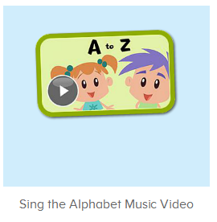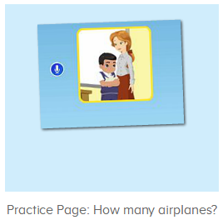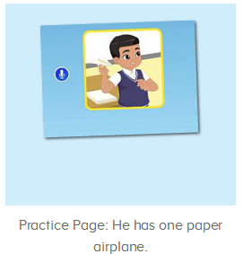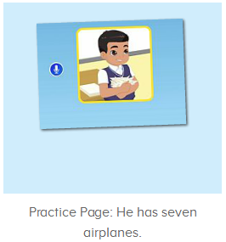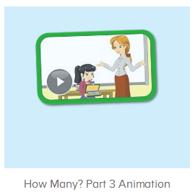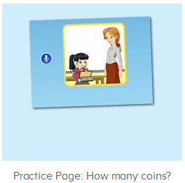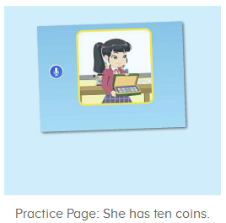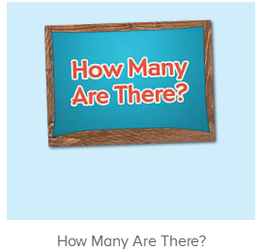
年龄段： 中班下
教学目标：
- 能跟唱歌曲Sing the Alphabet第一、二、三、四段并加上动作表演。
- 能听出口语视频中的关键词、句。
- 能流利跟读How many coins?She has ten coins.
- 能跟读视频How Many Are There?
教具准备：1.口语句子图卡
使用游戏：1.Guessing game 2.TPR 3.I do you say
教学步骤： |  | 备注
- 成果公布及展示：  T: Hello kids,good morning.  S:Good morning Yama.  T:First,let's praise Andy,Jason...They have finished their activities.  S:Good,good,very very good!  T:Andy,come here please, show us your activities  J:Ok.  T:Well done!(请完成家庭活动的幼生上前自主操作网站，向其他幼生展示家庭活动成果)  Everybody look,how many activities have Andy finished?  S:Four.  T:Wow,very good thank you Andy.  Now everybody look,what is this?  S:This is my aquarium,my hamster maze.  T:Good job!Coco come here, please show us your hamster maze.  C:OK.This is my hamster maze.I have two hamsters.This one is brown,that one is orange.They like to run and sleep.I feed them everyday.They are so cute.  T:Thank you Coco.Henry come here,please show us your aquarium.  H:OK.This is my aquarium.I have three fish.This one is yellow,this one is blue,that one is orange.My aquarium background is space.I clean my aquarium everyday.I love it very much.  T:Very good,Henry.Let's praise.  T&S:Good,good,very very good! |  | 成果公布及展示我的鱼缸、我的仓鼠(单个幼生展示）
- 集体学习活动：  快乐唱吧  T:Now let’s sing the Alphabet song.（播放图1歌曲素材，请跟唱第一到四段)  S:Let’s sing the alphabet song.A is for apple,and b is for ball...along with me..W is for water,and ox ends in X!(跟唱2-3遍)  T:Very good!Now stand up,let’s sing and dance.  S:Let’s sing the alphabet song. A is for apple,and b is for ball...along with me..W is for water,and ox ends in X!(带动作跟唱2-3遍)  温故知新  T:Wonderful.Now let's listen and repeat.（教师点击进入图2-图4素材，请幼生跟读）  S:How many paper airplane does he have?/He has one/seven airplane(s)  T:Now let’s have a match.Boys and girls,are you ready?  S:Yes,we are ready.  Bs/Gs:How many paper airplanes does he have?/He has one/seven airplane(s).  T:Great job!Who can try?  S:Let me try.  T:Sam/Peter/Yuki...please.  S/P/Y:How many paper airplanes does he have?/He has one/seven airplane(s).  T:Very good!  口语Video  T:Great job!Now let’s enjoy the video.(打开图5素材，请幼生只听不跟读并回答教师问题)  Listen carefully,ok?  S:OK.  T:What can you hear?  S:Coins/one/five/robot...  T:Wow,great,let’s check,listen carefully.  Very nice.  Watch again.What are these?(教师停到关键句子画面询问幼生)  S:These are coins.  T:How many coins does Lina have?  S:She has ten coins.  Let’s Practice  T:Good job!Now let’s do some practice..（打开图6-7，请幼生跟读练习）  First listen and no voice.（先请幼生只听不跟读2-3遍）  Now listen and repeat.  S:How many coins does she have?/She has ten coins.(跟读2-3遍)  T:Now let’s have a match.Boys and girls,are you ready?  S:Yes,we are ready.  Bs/Gs:How many coins does she have?/She has ten coins.  T:Great job!Who can try?  S:Let me try.  T:Sam/Peter/Yuki...please.  S/P/Y:How many coins does she have?/She has ten coins.  T:Very good!Do you have coins?  S:Yes,I have.  T:How many coins do you have?  S:I have  T:Ken/Leo..how many coins do you have?  L/L:I have three/four coins.  你问我答  T:Now let’s make a conversation.First,look here,how many coins?  S:Ten coins.  T:Tom/Gina... come here,please.  I will give you five coins.  Now please make a conversation.  How many coins does she/he have?  S:She/He has five coins.  T:Good job!Who wants to be the teacher?  S:Let me try.  T:Peter/Harry..please.  P/H:How many coins does he/she have?  S:She/He has five coins.  口语Video  T:Great job!Now let’s enjoy the video.（打开图9素材，请幼生只听不跟读）  Please listen carefully.  What can you hear?  S:How many are there?/eggs/baby birds...  T:Right?Let’s check,listen again.  Good job!What else can you hear?  S:Flowers  T:OK.Let’s check again.Listen carefully.  Nice job!Now let’s repeat sentence by sentence.  S:How many are there?/How many eggs are in the bird nest?/There are three eggs in the bird nest.（每句重复跟读2-3遍）  T:Look,where are the eggs?They are in the...  S:They are in the bird nest.  T:Very good!How many eggs are there in the bird nest?  S:There are three eggs in the bird nest.  T:Wonderful,repeat again.  S:How many eggs are in the bird nest?/There are three eggs in the bird nest.  T:Good job!Let’s continue.  S:How many baby birds are in the bird’s home?/There are two birds in the bird’s home.（每句重复跟读2-3遍）  T:Where are the baby birds?  S:They are in the bird’s home.  T:How many baby birds are in the bird’s home?  S:There are two birds in the bird’s home.  T:Good job!Let’s continue.  Look and say  T:Very good!Let’s repeat again.  S:How many are there?/How many eggs are in the bird nest?/There are three eggs in the bird nest...  T:Now let’s look and say.（关小音量，请幼生看图说句子）  S:How many are there?/How many eggs are in the bird nest?/There are three eggs in the bird nest...  T:Nice job!Now let’s have a match,boys and girls,are you ready?  S:Yes,we are ready.  S:How many are there?  Bs/Gs:/How many eggs are in the bird nest?/There are three eggs in the bird nest...  趣味大扫描  T:Wonderful.Let's review.  Listen and repeat.  S:How many coins does she have?/She has ten coins.  T:Very good! Now let’s sing the song again.（跟唱第一到四段）  S:Let’s learn the alphabet song. is for apple,and b is for ball...Please sing the letters along with me.（跟唱2-3遍）  T:Well done!Now let’s count our tickets.  Who can try?  S:Let me try.  T:Candy please.  T:How many tickets do we have today?  Let's count with ABCmouse.  S&ABCmouse:One,two,three..  T:So How many tickets do we have today?  S:We have ten tickets today.  T:Candy,how many tickets do we have today?  C:We have ten tickets today.  T:Thank you Candy.Very good! |  | 图1：  图2：  图3：  图4：  图5：  图6：  图7：  图9：
- 家庭活动布置：
T:Wow!So nice!Now I'll show you the activities.（将已放入功课的界面打开）
T: Look,how many activities do you need to do?
S:...
T:Very well.Now I will show you how to do it.Please listen carefully.
Jason come here and show us how to do the activities.
Good job!Thank you Jason!
Please finish the activities and show me tomorrow,ok?
S:OK!
T:Class is over, Goodbye everyone.
S:Goodbye Yama.

