ABCmouse中班下Letters Reviews X-Y-Z&One and more课时8
复习素材内容：.  - Practice Page:How many coins?  - Practice Page:She has ten coins.  - How Many Are There? | 新授素材内容：  - Sing the Alphabet Music Video.  - How Many Do You Have?
素材截图：
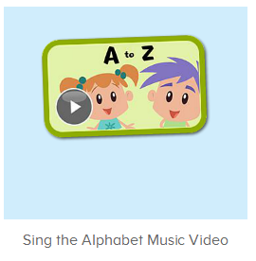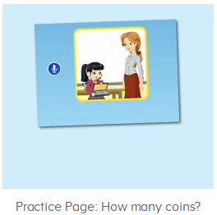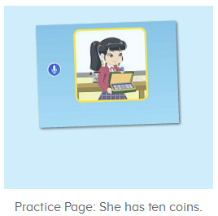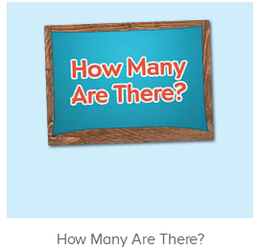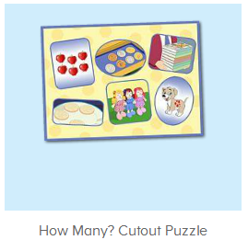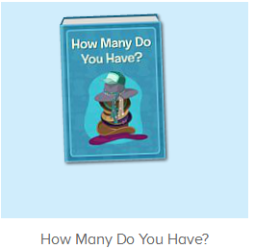
年龄段： 中班下
教学目标：
- 能跟唱歌曲Sing the Alphabet第一、二、三、四段并加上动作表演，能跟着哼唱最后一段。
- 能跟读图书1-15页，理解more..than和the most的用法。
- 能流利跟读How many coins?She has ten coins.
- 能跟读视频How Many Are There?
教具准备：1.口语句子图卡
使用游戏：1.Guessing game 2.TPR 3.I do you say
教学步骤： |  | 备注
- 成果公布及展示：  T: Hello kids,good morning.  S:Good morning Yama.  T:First,let's praise Andy,Jason...They have finished their activities.  S:Good,good,very very good!  T:Andy,come here please, show us your activities  J:Ok.  T:Well done!(请完成家庭活动的幼生上前自主操作网站，向其他幼生展示家庭活动成果)  Everybody look,how many activities have Andy finished?  S:Four.  T:Wow,very good thank you Andy.  Now everybody look,what is this?  S:This is my aquarium,my hamster maze.  T:Good job!Coco come here, please show us your hamster maze.  C:OK.This is my hamster maze.I have two hamsters.This one is brown,that one is orange.They like to run and sleep.I feed them everyday.They are so cute.  T:Thank you Coco.Henry come here,please show us your aquarium.  H:OK.This is my aquarium.I have three fish.This one is yellow,this one is blue,that one is orange.My aquarium background is space.I clean my aquarium everyday.I love it very much.  T:Very good,Henry.Let's praise.  T&S:Good,good,very very good! |  | 成果公布及展示我的鱼缸、我的仓鼠(单个幼生展示）
- 集体学习活动：  快乐唱吧  T:Now let’s sing the Alphabet song.（播放图1歌曲素材，请跟唱第一到四段)  S:Let’s sing thea is for apple,and b is for ballalong with me..W is for water,and ox ends in X!(跟唱2-3遍)  T:Very good!Now stand up,let’s sing and dance.  S:Let’s sing thea is for apple,and b is for ballalong with me..W is for water,and ox ends in X!(带动作跟唱2-3遍)  T:Very nice!Now let’s listen and no voice.（单独播放最后一段2-3遍）  Now follow it.  S:Let's learn the alphabet from A to Z!.the alphabet with you!（跟唱最后一段2-3遍）  T:Let’s add some actions.  S:Let's learn the alphabet from A to Z!.the alphabet with you!（带动作跟唱最后一段2-3遍）  T:You did a great job!Let’s sing the song together.  S:Let’s sing the alphabet with you!（跟唱整首歌曲2遍）  温故知新  T:Wonderful.Now let's listen and repeat.（教师点击进入图2-图4素材，请幼生跟读）  Bs/Gs:How many coins does she have?/She has ten coins.、How many are there?/How many eggs are in the bird nest?/There are three eggs in the bird nest...  T:Great job!Who can try?  S:Let me try.  T:Sam/Peter/Yuki...please.  S/P/Y:How many coins does she have?/She has ten coins.  T:Very good!Let’s repeat again.(重复跟读图4素材)  S:How many are there?/How many eggs are in the bird nest?/There are three eggs in the bird nest...  T:Now let’s look and say.（关小音量，请幼生看图说句子）  S:How many are there?/How many eggs are in the bird nest?/There are three eggs in the bird nest...  T:Nice job!Now let’s have a match,boys and girls,are you ready?  S:Yes,we are ready.  S:How many are there?  Bs/Gs:/How many eggs are in the bird nest?/There are three eggs in the bird nest...  趣读图书  T:Great job!Now let’s read a book,please listen and no voice.（教师打开图5素材，请幼生仔细听不跟读，先整体播放图书）  Listen again.(播放1-15页)  T:What is the book’s name?（第二遍播放完图书名字暂停，询问幼生问题）  S:How many do you have?  T:Nice job!Let’s continue.(播放至15页停止，询问幼生问题)  Now please tell me,what can you hear?  S:apples/four apples  T:Very good!Now listen and repeat.（跟读1-15页）  S:How many do you have?/Raj has three apples/Sara has.  T:How many apples does Raj/Sara have?  S:Raj/Sara has three/four apples.  T:Right?Let’s check,listen and repeat.  S:Raj has three apples./Sara has four apples.  T:Good job!Continue.  S:Sara has more apples than Raj.(跟读2-3遍)  T:Raj has three apples.Sara has four apples.So Sara has more apples than Raj.  Peter and Lily come here,please.  I will give Peter two coins and Lily three coins.  Now who has more coins?  T&S:Lily has more coins than Peter.  T:Good job!Again.  S:Lily has more coins than Peter.  T:Leo and Gina come here,please.  Leo has four coins,and Gina has two coins.  Who has more coins?  S:Leo has more coins than Gina.  T:Very good!Let’s repeat the book again.  S:How many do you have?/Raj has./Raj has ten cookies.(跟读到第13页暂停)  T:How many cookies does Nico/Li Na/Raj have?  S:Nico/Li Na/Raj has five/eight/ten cookies.  T:Very good!Who has more cookies?Nico or Li Na?  S:Li Na hs more cookies than Nico.  T:Good!Who has more cookies?Li Na or Raj?  S:Raj has more cookies than Li Na.  T:Very good!So who has the most cookies?Nico, Li Na or Raj?  S:  T:Listen and tell me.(跟读第15页)  S:Raj has the most cookies.(跟读2-3遍)  T:So who has the most cookies?  S:Raj has the most cookies.  比一比，说一说  T:Now let’s repeat the book again.  S:How many do you have?/Raj has three apples/Sara has.（跟读至13页）  T:Very good!Look,what are these?（教师事先准备一些硬币或铅笔或较为容易准备的教具）  S:Coins/pencils...  T:How many coins do I have?  S:Ten coins/pencils...  T:Kelly,Leo,Dora,come here please.  Kelly,I will give you two coins/pencils.  Dora,I will give you five coins/pencils.  Leo,I will give you three coins/pencils.  Now,everybody look,how many coins/pencils doe Kelly/Dora/Leo have?  S:Kelly/Dora/Leo has two/five/three coins/pencils.  T:Who has more coins/pencils?Kelly or Dora?  S:Dora has more coins/pencils than Kelly.  T:Who has more coins/pencils?Leo or Dora?  S:Dora has more coins/pencils than Leo.  T:So who has the most coins/pencils?Kelly,Dora or Leo?  S:Dora has the most Coin/pencils.  T:Very good!Who wants to try?  S:Let me try.  T:Susan,Wendy and Fiona,please.（替换幼生，重复练习2-3遍）  趣味大扫描  T:Wonderful.Let's review.  Listen and repeat.（跟读整本图书）  S:How many do you have?/Raj has three apples/Sara has.  T:Very good! Now let’s sing the song again.（跟唱整首歌曲）  S:Let’s sing the alphabet with you!（跟唱2遍）  T:Let’s sing and dance,stand up please.  Follow the music.  S:Let’s sing the alphabet with you!（跟唱2遍）  T:Well done!Now let’s count our tickets.  Who can try?  S:Let me try.  T:Candy please.  T:How many tickets do we have today?  Let's count with ABCmouse.  S&ABCmouse:One,two,three..  T:So How many tickets do we have today?  S:We have ten tickets today.  T:Candy,how many tickets do we have today?  C:We have ten tickets today.  T:Thank you Candy.Very good! |  | 图1：  图2：  图3：  图4：  图5：
- 家庭活动布置：
T:Wow!So nice!Now I'll show you the activities.（将已放入功课的界面打开）
T: Look,how many activities do you need to do?
S:...
T:Very well.Now I will show you how to do it.Please listen carefully.
Jason come here and show us how to do the activities.
Good job!Thank you Jason!
Please finish the activities and show me tomorrow,ok?
S:OK!
T:Class is over, Goodbye everyone.
S:Goodbye Yama.

