ABCmouse中班下Letters Reviews X-Y-Z&One and more课时10
复习素材内容：.
- Sing the Alphabet Music Video.
- How Many?Practice.
- How Many?Quiz.
- How Many Do You Have?
- One and More Practice.
- One and More Quiz.
- How Many Are There?
- Egg Counter.
- How Many Do You Have?
素材截图：
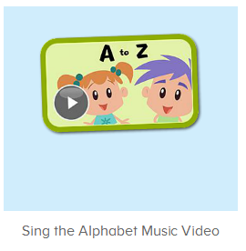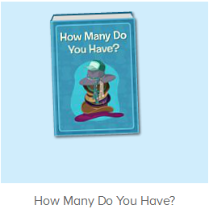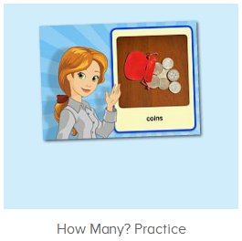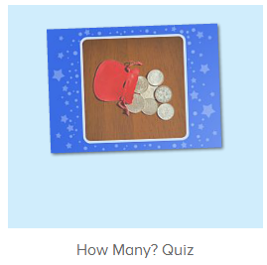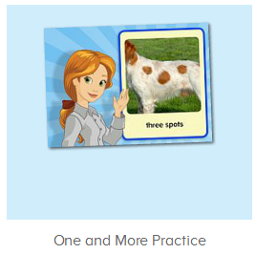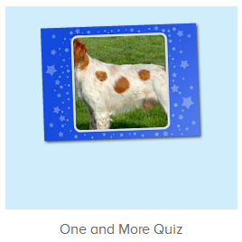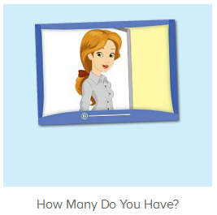
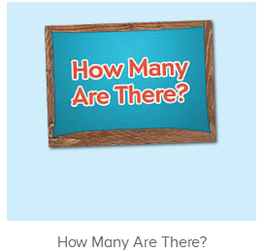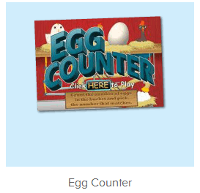
年龄段： 中班下
教学目标：
- 能跟唱歌曲Sing the Alphabet并能表演动作。
- 能跟读图书How Many Do You Have?能理解more ..than..和the most的用法。
- 能流利跟读One and More Practice和How Many Practice。
- 能跟读视频How Many Are There?和How Many Do You Have?
教具准备：1.口语句子图卡
使用游戏：1.Guessing game 2.TPR 3.I do you say
教学步骤： | 备注
- 成果公布及展示：  T: Hello kids,good morning.  S:Good morning Yama.  T:First,let's praise Andy,Jason...They have finished their activities.  S:Good,good,very very good!  T:Andy,come here please, show us your activities.  J:Ok.  T:Well done!(请完成家庭活动的幼生上前自主操作网站，向其他幼生展示家庭活动成果)  Everybody look,how many activities have Andy finished?  S:Four.  T:Wow,very good thank you Andy.  Now everybody look,what is this?  S:This is my aquarium,my hamster maze.  T:Good job!Coco come here, please show us your hamster maze.  C:OK.This is my hamster maze.I have two hamsters.This one is brown,that one is orange.They like to run and sleep.I feed them everyday.They are so cute.  T:Thank you Coco.Henry come here,please show us your aquarium.  H:OK.This is my aquarium.I have three fish.This one is yellow,this one is blue,that one is orange.My aquarium background is space.I clean my aquarium everyday.I love it very much.  T:Very good,Henry.Let's praise.  T&S:Good,good,very very good! | 成果公布及展示我的鱼缸、我的仓鼠(单个幼生展示）
- 集体学习活动：  快乐唱吧  T:Now let’s sing the Alphabet song.（播放图1歌曲素材，请跟唱第一到四段)  S:Let's learn the alphabet from A to Z!.the alphabet with you!（跟唱最后一段2-3遍）  T:Let’s add some actions.  S:Let's learn the alphabet from A to Z!.the alphabet with you!（带动作跟唱最后一段2-3遍）  T:You did a great job!Let’s sing the song together.  S:Let’s sing the alphabet with you!（跟唱整首歌曲2遍）  口语Video  T:Wonderful.Now let’s enjoy the video.  Please watch carefully.（打开图2素材，请幼生认真看不跟读）  What can you hear/see?  S:Dolls/robots...  T:How many dolls/robots/... Does Sara/Ken...have?  S:She/He has three/four..dolls/robots/...  T:Very good!Let’s watch again.  Let’s practice  T:Now let’s practice.（打开图3素材，请幼生跟读和录音）  Listen and repeat.  S:Coins/dolls/(每个发音点击跟读2-3遍)  T:Good job!Let’s record our voice.  Are you ready?  S:Yes,we are ready.  Coins/dolls/...  T:Nice,let’s hear your voice.  Wow,so good!  Who can try?  S:Let me try.  T:Lena/Harry...please.  L/H:Coins/dolls/...  T:Let’s hear Lena’s/Harry’s...voice.  Is it nice?  S:Yes.  T:Very good!Now let’s listen and choose.(打开图4素材，请幼生听音选择)  Who can try?  S:Let me try.  T:Coco/Anna/Joey,please.  Everybody listen and repeat.  S:Where are the coins?/dolls...?  口语Video  T:Very good!Now let’s read it by teams,boys and girls,are you ready?（打开图5素材，分组跟读，教师出示相关指令手势引导幼生跟读）  S:Yes,we are ready.  How many do you have?/How many dolls do you have?...  Bs/Gs:I have three dolls./I have .  T:Nice job!Let’s repeat again.  S:How many do you have?/How many dolls do you have?/I have...  T:Very good!Now let’s be the little recorders,are you ready?  S:Yes,we are ready.  How many do you have?/How many dolls do you have?/I have...  T:Good!Now look at the pictures,how many books/apples/coins...do you have?(教师准备一些图卡，请幼生用I have...句型造句)  S:I have eight/nine/two...books/apples/coins...  T:Wonderful!Who can be the little teacher?  S:Let me try.  T:Tom/Kelly..please.  T/K:How books/apples/coins...do you have?  S:I have eight/nine/two...books/apples/coins...  T:Very good!  趣读图书  T:Great job!Now let’s read a book,please listen and repeat.（教师打开图6素材，请幼生仔细听跟着说）  S:How many do you have?/Raj has three apples/Sara has.  T:What is the book’s name?  S:How many do you have?  T:How many apples does Raj/Sara have?  S:Raj/Sara has three/four apples.  T:Who has more apples?  S:Sara has more apples than Raj.  T:Very good!How many cookies does Nico/Li Na/Raj have?  S:Nico/Li Na/Raj has five/eight/ten cookies.  T:Very good!Who has more cookies?Nico or Li Na?  S:Li Na hs more cookies than Nico.  T:Good!Who has more cookies?Li Na or Raj?  S:Raj has more cookies than Li Na.  T:Very good!So who has the most cookies?Nico, Li Na or Raj?  S:Raj has the most cookies.  T:How many red/blue spots does Toby have?  S:Toby has six/nine red spots.  T:Does Toby have more blue spots or red spots?  S:Toby has more blue spots than red spots.  T: How many dolls/robots does Sara have?  S:Sara has three/five dolls/robots.  T:Does Sara has more dolls or robots?  S:Sara has more robots than dolls.  T:How many hats does Sara/Carmen/Nico have?  S:Sara/Carmen/Nico has  T:Who has the most hats?  S:Nico has the most hats.  T:Very good!Let’s repeat the book again.  S:How many do you have?/Raj has three apples/Sara has.  T:Very good!Let’s have a match.Boys and girls,are you ready?  S:Yes,we are ready.  Bs/Gs:How many do you have?/Raj has three apples/Sara has.  Look and say  T:Very good!Let’s repeat the video.（打开图7素材，请幼生跟读）  S:How many are there?/How many eggs are in the bird nest?/There are three eggs in the bird nest...  T:Now let’s look and say.（关小音量，请幼生看图说句子）  S:How many are there?/How many eggs are in the bird nest?/There are three eggs in the bird nest...  T:Nice job!Now let’s have a match,boys and girls,are you ready?  S:Yes,we are ready.  S:How many are there?  Bs/Gs:/How many eggs are in the bird nest?/There are three eggs in the bird nest...  Game Time  T:Very good!Now let’s play a game-Egg counter.（打开图8素材）  Who can try?  S:Let me try.  T:Tom/Kelly/Gina...please.  Everybody,look and count.  How many eggs do you see?  S:Three/six  T:Tom/Kelly/Gina...please.  趣味大扫描  T:Wonderful.Let's review.  Listen and repeat.（跟读整本图书）  S:How many do you have?/Raj has three apples/Sara has.  T:Very good! Now let’s sing the song again.（跟唱整首歌曲）  S:Let’s sing the alphabet with you!（跟唱2遍）  T:Let’s sing and dance,stand up please.  Follow the music.  S:Let’s sing the alphabet with you!（跟唱2遍）  T:Well done!Now let’s count our tickets.  Who can try?  S:Let me try.  T:Candy please.  T:How many tickets do we have today?  Let's count with ABCmouse.  S&ABCmouse:One,two,three..  T:So How many tickets do we have today?  S:We have ten tickets today.  T:Candy,how many tickets do we have today?  C:We have ten tickets today.  T:Thank you Candy.Very good! | 图1：  图2：  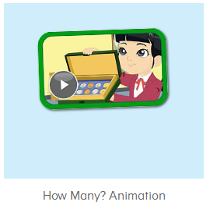  图3：  图4：  图5：  图6：  图7：  图8：
- 家庭活动布置：
T:Wow!So nice!Now I'll show you the activities.（将已放入功课的界面打开）
T: Look,how many activities do you need to do?
S:...
T:Very well.Now I will show you how to do it.Please listen carefully.
Jason come here and show us how to do the activities.
Good job!Thank you Jason!
Please finish the activities and show me tomorrow,ok?
S:OK!
T:Class is over, Goodbye everyone.
S:Goodbye Yama.

