ABCmouse中班下Letters Reviews X-Y-Z&One and more课时5
复习素材内容：.  - How Many?  - How Many?Cutout Puzzle. | 新授素材内容：  - Sing the Alphabet Music Video.  - How Many?Part1 Animation.  - Practice Page:She has three dolls.  - Practice Page:He has five robots.  - How Many Do You Have?
素材截图：
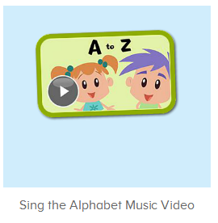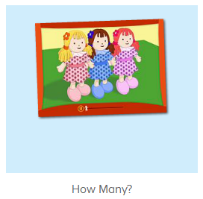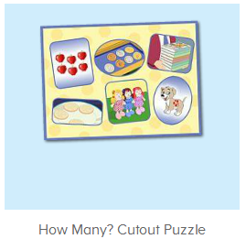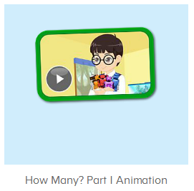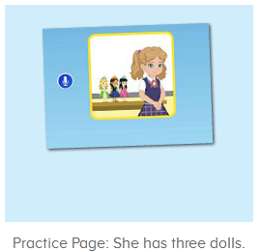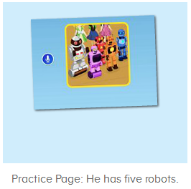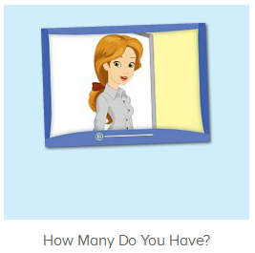
年龄段： 中班下
教学目标：
- 能跟唱歌曲Sing the Alphabet第一、二、三段并加上动作表演。
- 能听出口语视频中的关键词、句。
- 能流利跟读She has three dolls.He has five robots.并能用she/he has...句型回答教师问题。
- 能用How many do you have?I have...做简短对话。
教具准备：1.口语句子图卡
使用游戏：1.Guessing game 2.TPR 3.I do you say
教学步骤： |  | 备注
- 成果公布及展示：  T: Hello kids,good morning.  S:Good morning Yama.  T:First,let's praise Andy,Jason...They have finished their activities.  S:Good,good,very very good!  T:Andy,come here please, show us your activities  J:Ok.  T:Well done!(请完成家庭活动的幼生上前自主操作网站，向其他幼生展示家庭活动成果)  Everybody look,how many activities have Andy finished?  S:Four.  T:Wow,very good thank you Andy.  Now everybody look,what is this?  S:This is my aquarium,my hamster maze.  T:Good job!Coco come here, please show us your hamster maze.  C:OK.This is my hamster maze.I have two hamsters.This one is brown,that one is orange.They like to run and sleep.I feed them everyday.They are so cute.  T:Thank you Coco.Henry come here,please show us your aquarium.  H:OK.This is my aquarium.I have three fish.This one is yellow,this one is blue,that one is orange.My aquarium background is space.I clean my aquarium everyday.I love it very much.  T:Very good,Henry.Let's praise.  T&S:Good,good,very very good! |  | 成果公布及展示我的鱼缸、我的仓鼠(单个幼生展示）
- 集体学习活动：  快乐唱吧  T:Now let’s sing the Alphabet song.（播放图1歌曲素材，请跟唱第一到三段)  S:Let’s sing the alphabet song.A is for apple,and b is for ball...along with me.(跟唱2-3遍)  T:Very good!Now stand up,let’s sing and dance.  S:Let’s sing the alphabet song.A is for apple,and b is for ball...along with me.(带动作跟唱2-3遍)  温故知新  T:Wonderful.Now let's listen and repeat.（教师点击进入图2-图3素材，请幼生跟读及操作）  S:How many/six apples.  T:Who wants to try?  S:Let me try.  T:Susan/Kitty/Billy...please.  Everybody listen and repeat,ok?  S:OK.  Six apples/seven coins...  你问我答  T:Great job!Now let’s make a conversation.  Look,how many apples/coins...?There are...  T&S:There are six apples/seven coins  T:Good job!Once again.  How many apples/coins..?  S:There are six apples/seven coins  T:Terrific!Now boys/girls,you will be the teacher,ok?  BS/GS:Ok.  Bs/Gs:How many apples/coins..?  Bs/Gs:There are six apples/seven coins  T:Very good!Now who wants to be the little teacher?  S:Let me try.  T:Paul/Gina/Harry..please.  P/G/H:How many apples/coins...?  S:There are six apples/seven coins  口语Video  T:Great job!Now let’s enjoy the video.(打开图4素材，请幼生只听不跟读并回答教师问题)  Listen carefully,ok?  S:OK.  T:What can you hear?  S:Dolls/coins  T:Wow,great,let’s check,listen carefully.  Very nice.  Watch again.How many dolls does she/he have?(教师停到关键句子画面询问幼生)  S:Three dolls/five robots  Let’s Practice  T:Very good!Now let’s do some practice.（打开图5-6，请幼生跟读练习）  First listen and no voice.（先请幼生只听不跟读2-3遍）  Now listen and repeat.  S:She has three dolls./He has five robots.(跟读2-3遍)  T:Now let’s have a match.Boys and girls,are you ready?  S:Yes,we are ready.  Bs/Gs:She has three dolls./He has five robots.  T:Great job!Who can try?  S:Let me try.  T:Sam/Peter/Yuki...please.  S/P/Y:She has three dolls./He has five robots.  T:Very good!Lily/Peter..come here please,now look,how many apples/ coins/books... does Lily/Peter have?（教师准备一些水果的图卡，引导幼生应用She/He has造句）  S:She/He has six apples/coins/books...  口语Video  T:Wonderful!Now please enjoy the video and then tell me what you can hear,ok?（打开图7素材，请幼生只听不跟读）  S:OK.  T:What can you hear?  S:I can hear cookies/how many/dolls...  T:Wow,is it right?Let’s check,listen again.（再次核对时若遇到幼生有回答正确的内容请教师给予及时的鼓励）  Great job!Now let’s listen and repeat.  S:How many do you have?/How many dolls do you have?/I have.(可先一句一句暂停跟读)  T:Very good!Now let’s read it by teams,boys and girls,are you ready?（分组跟读，教师出示相关指令手势引导幼生跟读）  S:Yes,we are ready.  How many do you have?/How many dolls do you have?...  Bs/Gs:I have three dolls./I have .  T:Nice job!Let’s repeat again.  S:How many do you have?/How many dolls do you have?/I have...  T:Very good!Now let’s be the little recorders,are you ready?  S:Yes,we are ready.  How many do you have?/How many dolls do you have?/I have...  T:Good!Now look at the pictures,how many books/apples/coins...do you have?(教师准备一些图卡，请幼生用I have...句型造句)  S:I have eight/nine/two...books/apples/coins...  T:Wonderful!Who can be the little teacher?  S:Let me try.  T:Tom/Kelly..please.  T/K:How books/apples/coins...do you have?  S:I have eight/nine/two...books/apples/coins...  T:Very good!  趣味大扫描  T:Wonderful.Let's review.  Look at the pictures,how many dolls/robots does she/he have?  S:She/He has three/five dolls/robots.  T:Very good! Now let’s sing the song again.（带动作唱）  S:Let’s learn thea is for apple,and b is for ball...Please sing the letters along with me.  T:Well done!Now let’s count our tickets.  Who can try?  S:Let me try.  T:Candy please.  T:How many tickets do we have today?  Let's count with ABCmouse.  S&ABCmouse:One,two,three..  T:So How many tickets do we have today?  S:We have ten tickets today.  T:Candy,how many tickets do we have today?  C:We have ten tickets today.  T:Thank you Candy.Very good! |  | 图1：  图2：  图3：  图4：  图5：  图6：  图7：
- 家庭活动布置：
T:Wow!So nice!Now I'll show you the activities.（将已放入功课的界面打开）
T: Look,how many activities do you need to do?
S:...
T:Very well.Now I will show you how to do it.Please listen carefully.
Jason come here and show us how to do the activities.
Good job!Thank you Jason!
Please finish the activities and show me tomorrow,ok?
S:OK!
T:Class is over, Goodbye everyone.
S:Goodbye Yama.

