ABCmouse大班下词汇家族-ip-课时8
总复习素材内容:
1. Basics Word Family Words: dip
2. Basics Word Family Words: sip
3. Basics Word Family Words: rip
4. Word Family Sentence Puzzle: The Big Sip
5. The Big Sip
素材截图:
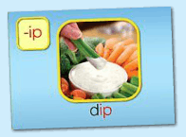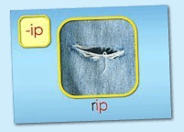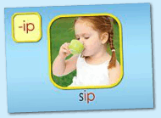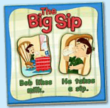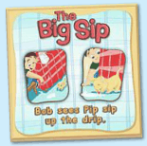
年龄段: 大班下
教学目标:
1.总复习已学单词。
2.总复习整本图书并熟练表演。
教具准备: 1.字母小卡片 2..故事图片或PPT 3.自制的拼图碎块
使用游戏: 1.Fast Game 2.Puzzle game 3.Make sentence 4.Role play
教学步骤: | 备注
- 成果公布及展示:  T: Hello kids.  S: Hello, teacher.  T: XXX, come here please, can you show us your activities?  S: Yes.  T: OK. Can you read these words?  T: Can you play this puzzle game?  T: Can you read this book?  L: Yes. I can.  T: Wow. Excellent. Can you show us your aquarium?  S:OK.Look,this is my aquarium. The background of my aquarium is space.I have one clown fish and two butterfly fish. The butterfly fish cost me 100 tickets.My fish like to hide behind the plants.I feed my fish everyday.  T: Terrific! Thank you, XXX. | 注：图书展示过程中可多要几位幼生上台朗读读书。以接龙的方式进行。
二、集体学习活动:  1）复习已学过的3个单词（dip,sip,rip）（图1~3）  T: Kids, let's review "-ip" family words.  Review steps:  - Follow the computer, listen and repeat.  - Game: Bomb Game  - Complete the words: __ ip (r/l/d/l/s) Boys vs Girls  2）操作（图4、5）拼图，并用...like…/ ...see...句型练习造句。  T: Kids, listen and repeat.  T: Can you read these sentences?  S: Yes. Bob likes milk. He takes a sip.Bob sees Pip sip up the drip.  T: Good. Let's make sentences. "…like.... ... takes..."  T: Who wants to try?  S: Let me try! Amy like juice.She takes a sip.  T: Good job, XXX.  T:Let's make sentences. "…see..."  S: Let me try! I see a black cat .  T: Look, what's in my hand? （组织S线下拼图游戏）  S: Puzzles.  T: You're so clever. Let's have a match.  T: Are you ready?  S: Yes, we are ready!  T: Which group is the first?  S: G2...  T: Excellent! Play again.  3）复习已学图书 《The Big Sip》（图6）  T: Now, Let's review< The Big Sip >  Review steps:  a. Follow the computer, listen and repeat.  b. Boys read the story, Girls read the story. Boys team vs Girls team.  c. Look and say. （看PPT或图片说句子）  d. Perform the story. Little teacher.  e. Do and say. （看动作，猜句子内容）  f. Fast Game. （快速翻页，快速朗读）  g. Listen and choose the right card.  T: Kids, listen carefully! Then choose the right picture for me. OK?  h. Role play.  （以上可根据课堂实际情况选择2-3种形式复习）  4）复习本节课所学内容及课堂情况总结  T: Let's review these words.（T展示单词卡）  S: Z-ip/D-ip/R-ip/L-ip/S-ip.  T: Wonderful! This week we study the <The Big Sip>,please Perform the story for your parent. | 图1:  图2:  图3：  图4：  图5：  图6：
三、家庭游戏活动布置:
T: Wow!So nice!Now look at me ,you have to do one, two,three... activities.
T: XXX come here and show us how to do the activities.
S:...
T: Good job!Thank you XXX!Class is over, Good bye everyone.
S: Goodbye.

