ABCmouse大班下词汇家族-un-课时8
复习素材内容:
1. Basics Word Family Words: fun
2. Basics Word Family Words: run
3. Basics Word Family Words: sun
4. Word Family Puzzle: To Run Is Fun 1-2
5. To Run Is Fun
素材截图:
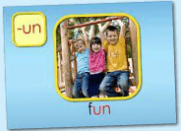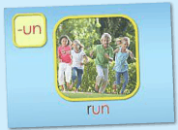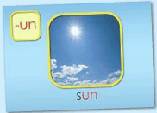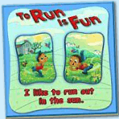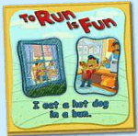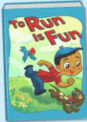
年龄段: 大班下
教学目标:
- 总复习已学单词。
- .总复习整本图书并熟练表演。
教具准备: 1.字母小卡片 2..故事图片或PPT 3.自制的拼图碎块
使用游戏: 1.Fast Game 2.Puzzle game 3.Make sentence 4.Role play
教学步骤: | 备注
- 成果公布及展示:
T: Hello kids.
S: Hello, teacher.
T: XXX, come here please, can you show us your activities?
S: Yes.
T: OK. Can you read these words?
T: Can you play this puzzle game?
T: Can you read < To Run Is Fun>?（朗读已学内容）
S: Yes. I can.
T: Excellent. Can you show us your hamster maze?
S: OK.This is my hamster maze. I have two hamsters.
T: Please introduce your hamster maze.
S: Let me show you my hamster maze.I have two hamsters.This one is brown,that one is black. Her/his name is Andy/Amy. These are tubes and cages.I build a beautiful home for my hamsters.They like to travel through the tubes very much.
T: Wow,terrific!Thank you XXX.
二、集体学习活动:  1）复习已学过的3个单词（fun/run/sun）（图1~3）  T: Kids, let's review "-un" family words.  Review steps:  - Follow the computer, listen and repeat.  - Game: Bomb Game  - Complete the words: __ un(f/r/s) Boys vs Girls  2）操作（图4、5）拼图，并用”I like...” “I eat...in....”句型练习造句。  T: Can you read these words?  S: ...  T: Can you read these sentences?  S: Yes. I like to run out in the sun.  S: I eat a hot dog in a bun.  T: Good. Let's use “I like...”make sentences.  T: Who wants to try?  S: Let me try! I like lily./I like to run./I like to eat watermelon....  T: Good job, XXX.  T: Let's use”I eat...in...”make sentences.  S: Let me try! I eat apple in the house./I eat ice-cream in the park./I eat rice in the classroom...  T: Look, what's in my hand? （组织S线下拼图游戏）  S: Puzzles.  T: You're so clever. Let's have a match.  T: Are you ready?  S: Yes, we are ready!  T: Which group is the first?  S: G2...  T: Excellent! Play again.  - 复习《To Run Is Fun》内容.（图6）  T: Now, Let's review< To Run Is Fun>.  Review steps:  a. Follow the computer, listen and repeat.  b. Boys read the story, Girls read the story. Boys team vs Girls team.  c. Look and say. （看PPT或图片说句子）  d. Perform the story. Little teacher.  e. Do and say. （看动作，猜句子内容）  f. Fast Game. （快速翻页，快速朗读）  g. Listen and choose the right card.  T: Kids, listen carefully! Then choose the right picture for me. OK?  h. Role play.  （以上可根据课堂实际情况选择2-3种形式复习）  4）复习本节课所学内容及课堂情况总结  T: Let's review these words.（T展示单词卡）  S: f-un ,fun.s-un,sun. r-un,run.  S: water gun,hamburger bun,hair bun  T: Wonderful! This week we study the < To Run Is Fun>,please Perform the story for your parent. | 图1:  图2:  图3：  图4：  图5：  图6：
三、家庭游戏活动布置:
T: Wow!So nice!Now look at me ,you have to do one, two,three... activities.
T: XXX come here and show us how to do the activities.
S:...
T: Good job!Thank you XXX!Class is over, Good bye everyone.
S: Goodbye.

