更多发音ow-Lesson 2教学参考教案
复习素材内容:  - More English Sounds:/ow/ as in owl  - More English Sounds:/ow/ as in house  - More English Sounds:/ow/ as in mouse  - More English Sounds Chant: owl | 新授素材内容:  - More English Sounds Sentence Chant:owl  - Sentence Puzzle:/ow/ as in owl  - Painting Page,/ow/:Cow  - Farm Maze:/ow/as in owl  - More English Sounds Word Video:owl  - More English Sounds Sentence Video:owl
素材截图:
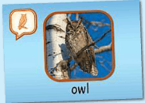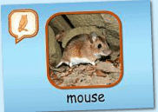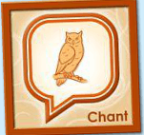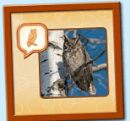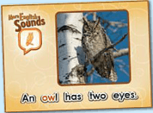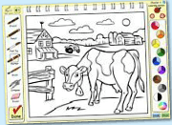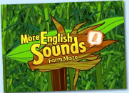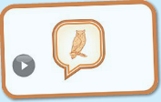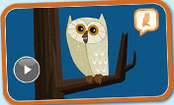
年龄段: 大班上
教学目标:
- 复习更多发音/ow/的基础发音，能熟练认读词汇并会表演对应的TPR。
- 熟悉诗歌旋律，能试着自行跟唱。
- 活用句型...has...
教具准备: 1.3张单词卡 2.故事图片或PPT
使用游戏: 1.Who is the fast 2.Hammer Game 3. A little teacher 4.Guessing game
教学步骤: |  | 备注
- 成果公布及展示:
T: Good morning everyone.
S: Good morning, teacher.
T: What is the weather today?
S: Today is sunny day.
T: OK.Who can show us your activities?
S: I can.
T: XXX, come here please. Can you read these words?
T: Can you sing this chant? （朗读已学内容）
S: Yes.
T: Wow. Excellent. Can you show us your aquarium?
S:OK.Look,this is my aquarium. The background of my aquarium is space.I have one clown fish and two butterfly fish. The butterfly fish cost me 100 tickets.My fish like to hide behind the plants.I feed my fish everyday.
T: Wow, terrific! Thank you XXX.
- 集体学习活动:  1）复习已学的3个单词。（图1~图3）  T: Everyone, listen and repeat!  S: owl/house/mouse.  T: One more time!  S: owl/house/mouse.  T: Very good!  T: Now let`s play a game.I want to see who is the first one? Are you ready?  S: Yes. I am ready!  S: owl/house/mouse.  T: Good job. Now I invite my good friend, Mr. Hammer.  T: I say the words you hit the flashcard. Do you understand?  S: Understand!（游戏“锤子游戏”玩3-4轮即可）  2）复习已学过的诗歌（图4）。  T: Kids. Have a rest. Listen, no voice.  T: Once again.  T: Sing with the radio. Are you ready?  S: Hear the sound...  T: Wonderful, one more time.  T: Good. Let's play a game. "Guessing game". Are you ready?  Radio: "Hear the sound of "ow"".  T: Guess, the next sentence is ...  S: "Hear the sound of "ow"".  T: Good. Go on.  ...  T: Wow, terrific! Now, guess for 2 sentences/4 sentences. OK?  （猜歌曲游戏，先让幼生猜一句，然后再逐步增加至两句，三句，四句）  T: Good, can you sing this chant? （教师将网站声音调小，幼生跟着网站一起唱）  S: Yes. We can sing.  T: Let's do the action. Stand up, follow me.  T: Once again.  T: Now, it's your turn. Come on, kids.  T: very good. Let's chant.（清唱加做动作）  T: Let's have a match. Bs Vs Gs.  T: Who wins?  3) 新授"owl"的句型诗歌.（图5）  T: Listen a chant.  T: Listen again.(3-4遍)  T: Tell me, what can you hear?  S: Hear the sound of "ow"...  T: Good, listen again.  T: Sing this chant. OK.  T: Very good. Sing it again.  T: Listen, kids, guess, the next sentence is...  S: "Hear the sound of "ow" ".  T: Right? Let's check.  T: Yes. You're right. OK. Continue. Listen and guess, are you ready?  ...  T: Can you find a new sentence in the chant?  S: An owl has two eyes.  T: Right? Let's check.  T: Yes. You're right.（教师拉动播放条，移到即将新授的句子，让幼生再听一次，加深印象）  4) 教师打开此句对应的句型拼图（图6），学习并掌握此句。  T: Look and listen carefully.  T: Listen again.  T: OK, read after these words one by one.  S: An/ owl/ has/ two/ eyes.  T: Read again.  S: An owl has two eyes.  T: Let's play this puzzle.  T: Here?  S: Yes/No.  T: Play again.  T: Who wants to try?  S: Let me try!  T: Is that right?  T: You did a good job!  T: Look at this picture, what's this?  S: An owl.  T:So...（教师做动作，提示幼生看图说句子）  S: An owl has two eyes.  T: Good, How about this?（教师拿出其他的卡片造句，用...has...）  S:A dog/cat/bird has two eyes.....（鼓励幼生多用已学的内容造句）  S:An owl has a mouth/nose  5）上机玩涂色游戏 （图7）  T: Let's do some painting! listen and repeat.  S: cow-/ow/ as in cow.  T: Who wants to be a “little artist”?  1S: Let me try!  T: OK, you please.  T: Can you tell me what's in the picture?  S: cow.  T: What color do you want to paint?  S: Black/Blue/Pink...  T: OK, who wants to try?  2S: Let me try!（请4-5位S上台参加比赛）  T: Do you know, who get “a little artist”?  T: XXX!  T: Congratulation! XXX!  6) 进入配对游戏素材，巩固发音。（见图8）  T: Let`s play game.Follow the sound /ow/.Who want to try?  S: ...(游戏2-3轮)  T: Now change to the super challenge level.  S: ...(游戏2-3轮)  7）复习More English Sounds Word Video:owl和Sentence Video:owl巩固诗歌和句子。（见图9-10）  T: Kids, let's do the action. Stand up.  T: Once again.  T: Now,Team1 come here.  T: Well done. Team 2 let's chant.（清唱加做动作）  8）复习本节课所学内容及课堂情况总结  T: Let's review this sentence.  S: An owl has two eyes  T: Wonderful! This class is fun fun fun! How many tickets do you have? |  | 图1:  图2:  图3:  图4:  图5:  图6:  图7:  图8:  图9-10:
三、家庭游戏活动布置:
T: Wow!So nice!Now look at me ,you have to do one, two,three... activities.
T: XXX come here and show us how to do the activities.
S:...
T: Good job!Thank you XXX!Class is over, Good bye everyone.
S: Goodbye.

