ABCmouse大班上更多发音/uh/-课时2
复习素材内容：  1. More English Sounds:/uh/ as in banana  2. More English Sounds:/uh/ as in camera  3. More English Sounds:/uh/ as in seven  4. More English Sounds:/uh/ as in camel  5. More English Sounds chant: banana | 新授素材内容：  - More English Sounds Sentence chant:banana  - Sentence puzzle:/uh/ as in banana  - Painting Page,/uh/:Rocket  - Hungry Tortoise:/uh/ as in banana  - More English Sounds Word Video:banana
素材截图：
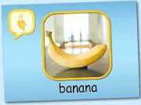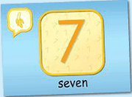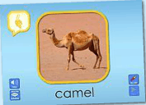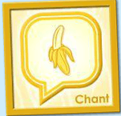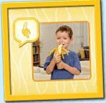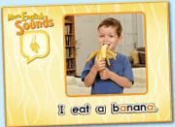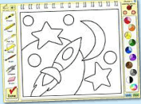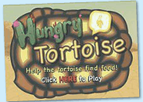
年龄段： 大班上
教学目标：
1.复习更多发音/uh/的基础发音，能熟练认读词汇并会表演对应的TPR。
2.熟悉诗歌旋律，能试着自行跟唱。
3.活用句型：I eat...
教具准备：1.对应的单词卡
使用游戏：1.Flash cards 2.Passing game 3.Make sentence
教学步骤： |  | 备注
- 成果公布及展示：
T: Hello kids.
S: Hello, teacher.
T: Jessie can you show us your activities?
J: Yes.
T: Can you read these words?
T: Can you play this puzzle game?
J: Yes,I can.
T: Wow. Excellent. Please show us your aquarium,OK?
J: Look, This is my aquarium. I have three...fish.These fish are so cute.
These fish cost me 500 tickets. These fish like to hide behind the plants.
T: Wow,terrific!Thank you Jessie.
- 集体学习活动：  1）先复习上节课已学过的4个发音词汇.(图1~图4)  T: Let's review these words. Read this word one by one.  T: Are you ready?  S: Yes. I am ready.  S: Banana,camera,seven,camel.  T: Pretty good. Once again.  S:Banana,camera,seven,camel.  T: Let's "flash cards."  T: Are you ready?  S: Yes, I am ready.  S: Banana,camera,seven,camel.  T: Is that right? Let's check.  T: Yes, you're right! Read after the computer.  S: Banana,camera,seven,camel.  T: Excellent.  - 从已复习的发音词汇过度到幼生本堂课需掌握的单词诗歌.（图5）。  T: Kids. Have a rest. Listen, no voice.  T: Once again.  T: What can you hear?  S: Hear the sound of "uh", banana,camel,camera.  T: Good! Now, sing with the radio. Are you ready?  S: Hear the sound...  T: Wonderful, one more time.  T: Good. Let's play a game. "passing game". Are you ready?  Radio: "Hear the sound of "uh""... （网站在播放一句或几句后暂停并引导台下S接唱）  1S: "Hear the sound of "uh"".  2S: "uh" "uh" "uh"  3S: banana,camel,camera.  ...  T: Wow, terrific! One more time,OK?  T: Good, let's do the action. Stand up, follow me.  T: Once again.  T: Now, it's your turn. Come on, kids.  T: Very good. Let's chant.（清唱加做动作）  T: Let's have a match. Bs Vs Gs.  T: Who wins?  ...  - 新授"banana"的句型诗歌(见图6)  T: Listen a chant.  T: Listen again.  T: Tell me, what can you hear?  S: Hear the sound of "uh", I eat a banana.  T: Good, listen again.  T: Sing this chant. OK.  T: Very good. Sing it again.  T: Can you find a new sentence in the chant?  S: I eat a banana.  T: Right? Let's check.  T: Yes. You're right.（T重新播放有句子的那一段，让S多听加深印象）  - 教师打开此句对应的句型拼图（图7），学习并掌握此句。  T: Look and listen carefully.  T: Listen again.  T: OK, read after these words one by one.  S: I /eat /a /banana.  T: Read again.  S: I /eat /a /banana.  T: Who can play this puzzle?  1S: Let me try!  T: Do you like to eat banana?  S: Yes. I do.  T: OK, Look at me.I eat a banana.  T: I give some fruit for you ,please use ”I eat ...”make sentence.  1S: OK. I eat a apple.  T: So good. Next one.  2S:. I eat a pear.  3S: I eat an orange.  - 幼生掌握句子后，再次回到chant，把诗歌和句子再次巩固复习一次。  T: Kids, can you sing this "banana" chant?  S: Yes.  T: OK. Sing it together.  T: Very good.  T: Now, let's do the action. Stand up, follow me.  T: Once again.  T: Now, it's your turn. Come on, kids.  T: Well done. Let's chant.（清唱加做动作）  T: Let's have a match. Bs Vs Gs.  T: Who wins?  ...  6) 上机玩涂色游戏.（图8）  T: Let's do some painting! Listen and repeat.(点击喇叭跟读标题2-3遍)  S: ...  T: Who wants to be a “little artist”?  S: Let me try!  T: OK, you please.  S: ...  T: OK, who wants to try?  S: Let me try!（请4-5位S上台参加比赛）  T: Do you know, who get “a little artist”?  T: XXX!  T: Congratulation! XXX!  7) 进入配对游戏素材，巩固发音.（图9）  T: Let`s play game.Follow the sound /uh/.Who want to try?  S: ...(游戏2-3轮)  T: Now change to the super challenge level.  S: ...(游戏2-3轮)  T: Next game.  8) 看动画，复习诗歌.（图10）  T: Kids, stand up  S: Yes.  T: Sing it together.  S: ...  T: Very good.  9）复习本节课所学内容及课堂情况总结  T: Let's review this sentence.  S: This is a coin.  T: Wonderful! How many tickets do you have? |  | 图1：  图2：  图3：  图4：  图5：  图6：  图7：  造句游戏：  分发水果或者食物模型分别给到幼生，让其用I eat ...造句.  图8：  图9：  图10：
三、家庭活动布置：
T: Wow!So nice!Now look at me ,you have to do one, two,three... activities.
T: XXX come here and show us how to do the activities.
S:...
T: Good job!Thank you XXX!Class is over, Good bye everyone.
S: Goodbye.

