ABCmouse大班上更多发音/uh/-课时3
复习素材内容：  1. More English Sounds chant: banana  2. More English Sounds Sentence chant:banana  3.Sentence puzzle:/uh/ as in banana | 新授素材内容：  1. More English Sounds Sentence chant: camel  2. Sentence puzzle:/uh/ as in camel  3. More English Sounds book: /uh/ as in banana  4. Circus Juggling Act:/uh/ as in banana  5. Seal Sound Match:/uh/as in banana
素材截图：
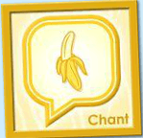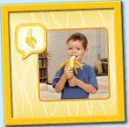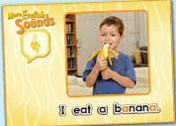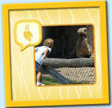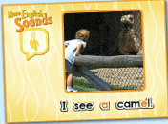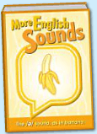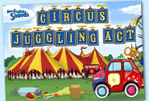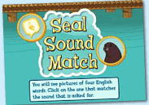
年龄段： 大班上
教学目标：
1.复习已学的诗歌，能熟练演唱。
2.学习并掌握新的诗歌，能模仿跟唱。
3.熟悉并了解/uh/的发音图书。
4.活用句型I see a...
教具准备：1.图书中对应的单词卡 2.食物卡片 3.动物模型
使用游戏：1.Make sentence 2.Ask and answer 3.High and low 4.Touching game
教学步骤： |  | 备注
- 成果公布及展示：
T: Hello kids.
S: Hello, teacher.
T: Ella,can you show us your activities?
E:Yes.
T: Can you sing this chant?
E: "Hear the sound of..."
T: Very good.
T: Can you play this puzzle game?
E: Yes,I can.
T: Can you say this sentence?
E: Yes.
T: Wow. Excellent. Please show us your aquarium,OK?
E: Look, This is my aquarium. I have five...fish.These fish are blue.
These fish cost me 600 tickets. These fish like to hide behind the plants. I feed the fish everyday.
T: Wow,terrific!Thank you Ella.
- 集体学习活动：  - 先复习上节课已学过的诗歌及句型。图1~图3.  T: Let's review these chants. Sing with the radio. OK?  T: Are you ready?  S:...  T: Pretty good. Now, stand up. Let's chant. （跟着音乐边唱边跳）  T: Excellent. Sit down, please!  T: G1 and G2, Let's have a match!  T: Are you ready?  T: Which group is the best?  S: G2...  T: Look, which sentence? （引出上节课所学的句子）  S: I eat a banana.  T: Yes. You're right.  T: Do you want to more food?（T拿出食物卡片，引导S用"I eat a ..."说句子）  S: I eat a break/fish/lemon.  T: Pretty good.  - 学习新的诗歌（见图4）。  T: Kids. Have a rest. Listen, no voice.  T: Once again.  T: What can you hear?  S: Hear the sound of /uh/, I see a camel.  T: Good! Now, sing with the radio. Are you ready?  S: Hear the sound...  T: Wonderful, one more time.（听教师指令，完成大,小声演唱）  T: Loudly!  S:...  T: Lowly!  ...  T: Nice job!  T: Can you find a new sentence in the chant?  S: I see a camel.  T: Right? Let's check.  T: Yes. You're right.  3）教师打开此句对应的句型拼图（见图5），学习并掌握此句。  T: Look and listen carefully.  T: Listen again.  T: OK, read after these words one by one.  S: I/ see/ a/ camel.  T: Read again.  T: Good, Who can play this puzzle?  S: Let me try.  T: Is that right?  S: Yes.  T: Play again.  T: Who wants to try?  S: Let me try!  T: Right?  T: You did a good job!  T: Look , what`s in the picture?  S: A camel.  T: So I see a ...  S: Camel.  T: Look, Now I see a ...(拿出食物卡片或者是一些动物模型，引导幼生造句).  T: Well done.  4）幼生掌握句子后，再次回到chant，把诗歌和句子再次巩固复习一次。  T: Kids, can you sing this "camel" chant?  S: Yes.  T: OK. Sing it together.  T: Very good.  T: Now, let's do the action. Stand up, follow me.  T: Once again.  T: Now, it's your turn. Come on, kids.  T: Well done. Let's chant.（清唱加做动作）  T: Let's have a match. Bs Vs Gs.  - 打开uh/的发音图书，学习发音的内容。（见图6）  T: Look and listen, no voice.  T: Listen again.  T: What can you hear in this book?  S: The /uh/sound as in banana. Banana,gorilla,rabbit,lion,zebra,koala,  flamingo,camel,giraffe,antelope,panda,elephant,animals.  T: Very good.  T: OK. Read after it.  S:Banana,gorilla,rabbit,lion,zebra,koala,flamingo,camel,giraffe,antelope,panda,elephant,animals.  T: Yes, good. Once again.  S:...  T: Let's play a game. "Touching game".  T: Listen, If you hear the word, you should touch the card as quickly as you can.OK?  S: OK.  T: Are you ready?  S: Yes. I am ready.  T: Listen!  C: Banana/gorilla/rabbit/lion...  S:...  T: So nice! Exchange, I touch you say word. OK?  S: OK.  T: I need a "little teacher", who wants to try?  1S: Let me try!  ...  T: Good.Let's read these words one by one.（引导S再次回到网站跟读发音）  S:Banana,gorilla,rabbit,lion,zebra,koala,flamingo,camel,giraffe,antelope,panda,elephant,animals.  T: So the /uh/ sound as in banana.Please make the sentence team by team.  T1:The /uh/ sound as in gorilla.  T2:The /uh/ sound as in rabbit.  ...  6) 玩游戏巩固所学单词和句子。（图7-8）  T: Let`s play the game.OK,look this picture.What`s this?  S:...（幼生认读每个游戏的图片）  T: Which one has the sound /uh/?  T: Listen!Who want to play?  S:...（幼生上台操作，游戏可玩1-2轮）  T: Terrific! Next game.Look at picture.What`s this?  S:...（幼生认读每个游戏的图片）  T: Listen!Which one has the sound /uh/?Who want to play?  S: ...  7）复习本节课所学内容及课堂情况总结  T: Let's review the words.  S:Banana,gorilla,rabbit,lion,zebra,koala,flamingo,camel,giraffe,antelope,panda,elephant,animals.  T: Wonderful! How many stickers do you have today?  S: ... |  | 图1:  图2：  图3：  图4：  图5：  图6：  图7：  图8：
三、家庭游戏活动布置:
T: Wow!So nice!Now look at me ,you have to do one, two,three... activities.
T: XXX come here and show us how to do the activities.
S:...
T: Good job!Thank you XXX!Class is over, Good bye everyone.
S: Goodbye.

