ABCmouse大班下词汇家族-ot-课时8
复习素材内容:  1. Basics Word Family Words: pot  2. Basics Word Family Words: dot  3. Basics Word Family Words: hot  4. Word Family Sentence Puzzle: A Toy For Spot | 新授素材内容:  A Toy For Spot
素材截图:
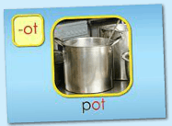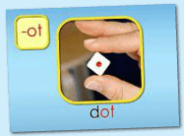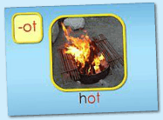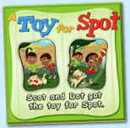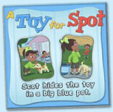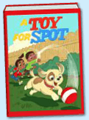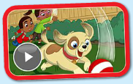
年龄段: 大班下
教学目标:
- 总复习已学单词。
2.掌握新授图书内容第 26-28句。
3.总复习整本图书并熟练表演。
4.观看动画Flash,并给其配音。
教具准备: 1.字母小卡片 2..故事图片或PPT 3.自制的拼图碎块
使用游戏: 1.Fast Game 2.Puzzle game 3.Make sentence 4.Role play 5.Cold and Hot Game.
教学步骤: |  | 备注
- 成果公布及展示:  T: Hello kids.  S: Hello, teacher.  T: XXX, come here please, can you show us your activities?  S: Yes.  T: OK. Can you read these words?  T: Can you play this puzzle game?  T: Can you read this book?  S: Yes. I can.  T: Wow. Excellent. Can you show us your aquarium?  S:OK.This is my aquarium. The background of my aquarium is space.I have one clown fish and two butterfly fish.There are shells and rock tunnel in my aquarium.Look,the shells is over here.I clean my aquarium with the cleaning brush everyday.  T: Wow, terrific! Thank you, XXX. |  | 注：图书展示过程中可多要几位幼生上台朗读读书。以接龙的方式进行。
二、集体学习活动:  1）复习已学过的3个单词（pot,dot,hot.）（图1~3）  T: Kids, let's review "-ot" family words.  Review steps:  - Follow the computer, listen and repeat.  - Game: Bomb Game  - Complete the words: __ ot (p/d/h/rob) Boys vs Girls  2）操作（图4、5）拼图，并用"...hide...in..." "got...for..."句型练习造句。  T: Kids, listen and repeat.  T: Can you read these sentences?  S: Yes. Scot and Dot got the toy for spot.Scot hides the toy in a big blue pot.  T: Good. Let's use "got...for..."make sentences.  T: Who wants to try?  S: Let me try! Lily and Amy got the ball for Sam./Joy and Jerry got the fruit for Kate...  T: Good job, XXX.  T:Let's use"...hide...in..."make sentences.  S: Let me try! Lily hides the ball under the chair./Sam hides the apple in the box./She hides the kite in the bag..  T: Look, what's in my hand? （组织S线下拼图游戏）  S: Puzzles.  T: You're so clever. Let's have a match.  T: Are you ready?  S: Yes, we are ready!  T: Which group is the first?  S: G2...  T: Excellent! Play again.  - 复习《A Toy For Spot》前25句内容.（图6）  T: Now, Let's review< A Toy For Spot >.  Review steps:  a. Follow the computer, listen and repeat.  b. Boys read the story, Girls read the story. Boys team vs Girls team.  c. Look and say. （看PPT或图片说句子）  d. Perform the story. Little teacher.  e. Do and say. （看动作，猜句子内容）  f. Fast Game. （快速翻页，快速朗读）  g. Listen and choose the right card.  T: Kids, listen carefully! Then choose the right picture for me. OK?  h. Role play.  （以上可根据课堂实际情况选择2-3种形式复习）  4）掌握新授图书中的第26-29句（图6）。  T: Please listen carefully! Keep quiet!  T: What can you hear?  S: Will they stop?No,...  T: Great!Listen and repeat.  S: Will they stop?No,they will not!Spot wants to play more "Cold and Hot!"  T: Please repeat2 times.（T做动作提示）  T: Let's perform these sentences team bye team.  S:...  T: Let`s play the "Cold and Hot"Game.（2-3轮游戏）  T: Please close your eyes.I will hide the ball.  S: I want to find the ball.  5）观看《A Toy For Spot》动画Flash（图7）  T: Kids, have a rest! Let's watch <A Toy For Spot>. No voice!  T: Watch again.  T: Good! Look and follow it!  T: This time, Please voice this story. （关闭网站声音，引导幼生给动画配音）  6）复习本节课所学内容及课堂情况总结  T: This month we learned the < A Toy For Spot>story.Do you like it?  S: Yes ! I like!  T: Our class is very good!How many stickers do you have today?  S: ... |  | 图1:  图2:  图3：  图4：  图5：  图6：  图7:
三、家庭游戏活动布置:
T: Wow!So nice!Now look at me ,you have to do one, two,three... activities.
T: XXX come here and show us how to do the activities.
S:...
T: Good job!Thank you XXX!Class is over, Good bye everyone.
S: Goodbye.

