ABCmouse大班下词汇家族-ug~-un&Food Part 2-课时5
新授素材内容:  - Practice Page:He is eating a hot dog.  - Practice Page:We are eating pizza. | 复习素材内容:  - Food,Part 1-B Animation  - He does not like to eat this hot dog  - Practice Page:We like to eat pizza  - Food,Part 2 Practice  - Pizza Server
素材截图:
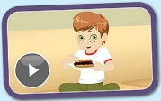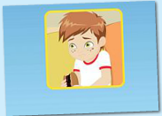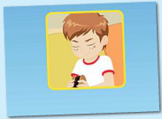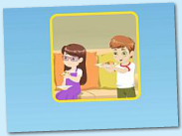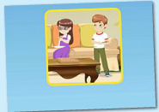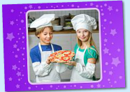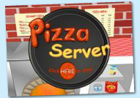
年龄段: 大班下
教学目标:
1.掌握口语中所含的单词及句子。
2.掌握所学歌曲内容，能演唱。
3.掌握所学口语内容，能交流。
教具准备: 1.食物卡片5-6种
使用游戏: 1. Quickly and slowly 2.Make sentences 3.Dragon game 4.Team Game
教学步骤: |  | 备注
- 成果公布及展示:  T: Good morning everyone.  S: Good morning, teacher.  T: What are you wearing today?  S: I am wearing blue T-shirt....  T: XXX, come here please,can you show us your activities?  S: Yes.  T: OK. Can you read these sentence?  T: Can you sing the song?  S: Yes. I can.  T: Please show us your hamster maze.  S: OK.This is my hamster maze. I have two hamsters.  T: Please introduce your hamster maze.  S: Let me show you my hamster maze.I have two hamsters.This one is brown,that one is black. Her/his name is Andy/Amy. These are tubes and cages.I build a beautiful home for my hamsters.They like to travel through the tubes very much.  T: Do you like your hamsters?  S: Yes.I like my hamsters.I feed them everyday.  T: How many hamsters are there?  S: There are two hamsters in the hamster maze.  T: Wow, terrific! Thank you XXX. |  | 老师提前打开2个页面，一个是幼生家庭活动页面，一个是教师授课操作后台。  减少平台切换的时间。
二、集体学习活动:  1）教师拿出单词卡片巩固和学习单词和句型。（图1-4）  T: Look this picture.（T拿出对应卡片）  S: He does not like to eat this hot dog.  S: We like to eat pizza.  T: Listen and repeat!  S: He is eating a hot dog.（幼生跟着电脑复读2-3遍）  T: Good,Next one.Listen and repeat!  S: We are eating pizza.（T拿出对应卡片）  T: Great!Let's play the Quickly and slowly.Read it,quickly!（T拿出对应卡片）  S: ...  T: Wonderful! Read it.slowly!  T: Pretty good.Go on.（游戏2-3轮）  S: ...  T: Let's make sentence."...does not like to eat ...""We like to eat..."（T拿出图片协助造句）  S: He does not like to eat noodles,We like to eat fish. (ice cream/lemon/pizza...)  2）观看《Food,Part 2-B Animation》动画story（图4）  T: Please listen and repeat sentence by sentence.（幼生跟着电脑复读2-3遍）  S: ...  T: Look this ,What are these? Do you like to eat ...?  S: These are pizza./That is fish.I like to eat fish./I like to eat pizza.（T拿出对应卡片）  T: XXX little teacher come here,you can ask this .（T拿出食物单词卡）  S: What are these? Do you like to eat ...?  S: These is noodles,I like to eat noodles.（hamburger/hot dog/pizza/ice cream/meat/soup/fruit）  T: Wonderful! Next one.  S: ...  S: ...  3) 通过练习复习已学过的单词和句子。（图5）  T: Listen and choose.XXX come on.  S: hamburgers.  T: Good ,next one.XXX.  S: hot dog.  T: Good job!XXX.Listen.  S: pizza.  T: Nice!XX come and say.  S: ice cream.  T: Nice!XXX come and choose.  S: These are noodles.  T: XXX Listen and choose.  S: we made a pizza.  T: Pretty good,（T拿出练习中所有的单词卡）  T: Let's make sentence one by one.（造句接龙游戏）  S: This is hamburger,I like to eat hamburger.  S: This is hot dog,I like to eat hot dog.  S: This is ice cream,I like to eat ice cream.  S: This is pizza,we made a pizza.  4) 通过游戏巩固数字单词。（图6）  T: Kids,Let's play the game,ok?  S: OK.  T: Good. Match the numbers on the pizzas with the numbers on the plates.  T: What's this?  S: four.five.nine  T: Good ! XXX come here and play the game.（游戏2-3轮）  S: ...  5）复习本节课所学内容及课堂情况总结  T: Let's review these sentence.Look and say!  S: .... (T展示本节课所学习的句子相对应的卡片进行复习)  T: Who want to be a little teacher?  S1: What would you like to eat ?(小老师展示图片，并询问其他同学)  Ss: ...  T: Wonderful! How many stickers do you have today?  S: I have two stickers. |  | 图1:  图2:  图3:  图4:  备注：  锻炼幼生快速反应能力，能够快速和慢速读出相对应的句子  图4:  图5:  图6:
三、家庭游戏活动布置:
T: Wow!So nice!Now look at me ,you have to do one, two,three... activities.
T: XXX come here and show us how to do the activities.
S:...
T: Good job!Thank you XXX!Class is over, Good bye everyone.
S: Goodbye.

