ABCmouse大班下Review:Ug~Un & Food Part2-课时9
素材内容：
1. Basics Word Family Words: bug,hug,mug
2. Basics Word Family Words: fun, run,sun
3. Word Family Sentence Puzzle: Big Bug and Little Bug
4. Word Family Sentence Puzzle: To Run Is Fun
素材截图：
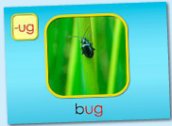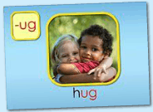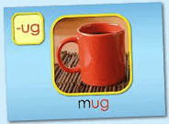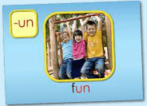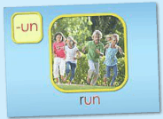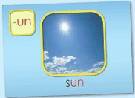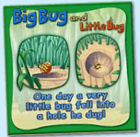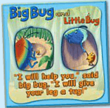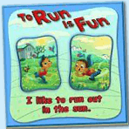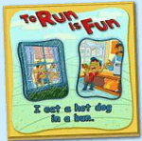

年龄段： 大班上
教学目标：
- 综合复习所学内容
- 能完成各素材基础操作
- 能熟练跟读模仿口语视频内容及跟唱歌曲
教具准备：1.拼图中出现的单词卡
使用游戏：1.Matching game 2.Make sentences
教学步骤： | 备注
- 成果公布及展示:
T: Hello kids.
S: Hello, teacher.
T: XXX, come here please, can you show us your activities?
S: Yes.
T: OK. Can you read these words?
T: Can you play this puzzle game?
T: Can you read this book?（朗读已学内容）
S: Yes. I can.
T: Please show us your hamster maze.
S: OK.This is my hamster maze. I have two hamsters.
T: Please introduce your hamster maze.
S: Let me show you my hamster maze.I have two hamsters.This one is brown,that one is black. Her/his name is Andy/Amy. These are tubes and cages.I build a beautiful home for my hamsters.They like to travel through the tubes very much.
T: Do you like your hamsters?
S: Yes.I like my hamsters.I feed them everyday.
T: How many hamsters are there?
S: There are two hamsters in the hamster maze.
T: Wow, terrific! Thank you XXX.
二、集体学习活动：  1）复习巩固bug,hug,mug, fun, run,sun的发音。（图1-6）。  T: Today, We will review these words. Please listen carefully! No voice!  T: Kids, What can you hear?  S: bug,hug,mug, fun, run,sun  T: Good, listen and repeat!（老师点击中间图片部分，引导幼生跟读）  S: bug,hug,mug, fun, run,sun  T: Pretty good! Look, what's this?（老师拿出单词卡片）  S: bug,hug,mug, fun, run,sun  T: Let's spell this.  S:b-ug,h-ug,m-ug, f-un, r-un,s-un.  T: Good job! Let's play a game. "Listen and find the cards".which card is sun?  S: There is sun.  T: Let's have match. G1 Vs G2/ Bs Vs Gs Which group is the best?  S: Yes...  - 复习句子，进行造句拓展。（图7-10）  T: Kids, look and read !（可以先按顺序跟读，再任意跟读）  S: One day a very little bug fell into a hole he dug!  T: Good. Once again.  T: Look at this picture.Let's make sentences. "... fell into ..."  T: Who wants to try?  S: Let me try! Little bug fell into a hole./ A ball fell into a hole.  T: Good job, Look at this picture.  S: "I will help you,"said the big bug. "I will give your leg a tug!"  T: Good. Once again.  S: ...  T: Let's make sentences. "... give ..."  T: Who wants to try?  S: Let me try! I give you a box./ I give you a toy.  T: Good job, kids.  T: Look at this picture.  S: I like to run out in the sun.  T: Good. Let's use "I like..."make sentences.  T: Who wants to try?  S: Let me try! I like lily./I like to run./I like to eat watermelon....  T: Nice! Read the sentences. Are you ready?  S: I eat a hot dog in a bun.  T: Let's make new sentence.please use"... fell into ..."  S: I eat apple in the house./I eat ice-cream in the park./I eat rice in the classroom.  T: Excellent! XXX, please come here! You can play this puzzle.  T: Is that right?  S: Yes.  T: OK. Next one. Who wants to try? （4张拼图每个难度可以分别点一位幼生上台操作）  S: Teacher teacher let me try!  3）复习本节课所学内容及课堂情况总结  T: Let's review these worlds and sentence.Look and say!  S: ....(T展示本节课所学习的句子相对应的卡片进行复习)  T: Let's review these worlds and sentence one by one or team by team.(句子接龙游戏2-3轮)  Ss: ...  T: Wonderful! How many stickers do you have today? | 图1:  图2:  图3:  图4:  图5:  图6:  图7:  图8:  图9:  图10:
三、家庭游戏活动布置:
T: Wow!So nice!Now look at me ,you have to do one, two,three... activities.
T: XXX come here and show us how to do the activities.
S:...
T: Good job!Thank you XXX!Class is over, Good bye everyone.
S: Goodbye.

