大地ABCmouse小班上Hello课时4
复习素材内容：  - What we say music video.  - Hello Animation Part 2  - Hello Cutout Puzzle.  - Practice Page:My name is Raj. | 新授素材内容：  - What we say music video.  - Hello Animation Part 2  - Practice Page:What is your name?
素材截图：
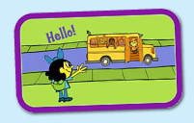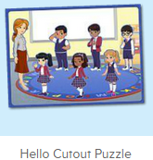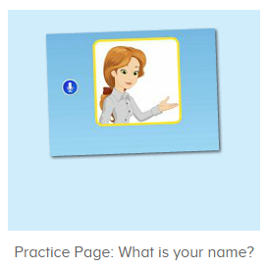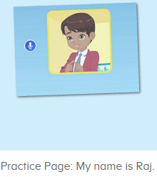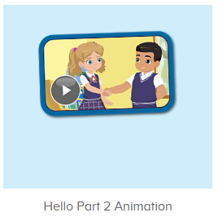
年龄段： 小班上
教学目标：
- 复习巩固口语动画视频中人物的名字Miss Jones,Ken,Carmen,Sara,Nico,Raj,Lina。
2.能完整唱出歌曲what we say第一句When we see people we say hello,wave hello,to all we know并表演相应律动。
3.能流利说出句子what is your name并能应用my name is.....句子介绍自己的名字。
4.能与同伴相互询问姓名。
教具准备：1.hello图卡 2.goodbye图卡 3.口语动画视频人物图卡或头饰
使用游戏：
1.Guessing game 2.TPR 3..I do you say 4.Team match 5.What is missing
教学步骤： |  | 备注
- 成果公布及展示：  T: Hello kids,good morning.  S:Good morning Yama.  T:Today let's welcome our friend "ABCmouse".  Wow, Say hello to ABCmouse.（教师边说边引导幼生挥手说hello）  S:Hello,hello.  T: Now,please follow me "A,B,C,mouse"(ABCmouse TPR)  Excellent!Let's go to ABCmouse.  Wow,look!What can you see?  S:........  T:Listen,what is it?  S:About me...  T:Very nice.Follow it.  S:About me.....  T:Let's see what can we find in "About me".  First,listen.  Follow it.（引导幼生仔细听并跟读关于我板块内容，让幼生粗略了解关于我的组成部分）  S:Change my avatar/go to my room/the pet park/my hamster/my aquarium/my tickets....  T:Very nice.What is this?This is....  S: This is change my avatar/go to my room/the pet park/my hamster/my aquarium/my tickets....  T:What is this?Who can try?  S:Let me try.  T:Lily/Peter/Sam please.What is this?This is.....（邀请单个幼生回答）  S:This is change my avatar/go to my room/the pet park/my hamster/my aquarium/my tickets....  T:Very nice. |  | 引入ABCmouse并简略介绍关于我板块内容
- 集体活动：  T:Now let's watch the video again,please listen and repeat.(播放图1Hello Part 2 Animation，使用暂停播放键进行分句跟读，请幼生跟读完整视频内容)  S:My name is Miss Jones........  T:Once again,let's repeat by boys and girls.  Bs/Gs:My name is Miss Jones........  T:Terrific!Please listen and repeat.(点击图2，请幼生跟读发音)  S:My name is Raj.  T:Listen,how many times?  S:3 times.  T:Repeat please.  S:My name is Raj.......  T:Very nice!My name is Yama.What is your name?  S:My name is.....  T:What is your name?  S:My name is Peter/Sue/kitty/Yuki.......  T:Look at this puzzle game,who is this?（打开图3拼图素材，复习巩固口语动画人物姓名）  S:This is Ken......  T:Right?Let’s check,please listen and repeat.  S:Hello,my name is Miss Jones......  T:Very good!Who can try?  S:Let me try.  T:Susan/Tim/Lily.... please.Everybody listen and repeat.(拼图数量较多可请3-4位幼生轮流上前协作完成，其余幼生跟读发音)  S:Hello,my name is Miss Jones......  T:Who is this?This is....(询问幼生拼图人物的名字，让幼生记住视频中人物的名字)  S:This is Miss Jones/Ken.......  T:Now let’s repeat this sentence.(点击播放图4素材，请幼生跟读句子发音)  S:What is your name?（跟读2-3遍）  T:Peter come here and click the picture,everybody listen and repeat.  S:What is your name?  T:Let’s repeat it by boys and girls.Molly come here,click the picture.  Bs/Gs:What is your name?  T:Very nice.Let’s record,all together.  S:What is your name?  T:Listen,is it nice?  S:Yes.  T:Boys/Girls it’s your turn.Are you ready?  Bs/Gs:Yes,we are ready.  Bs/Gs:What is your name?  T:My name is Yama.What is your name?  S:My name is.......  T:Exchange.This time your will say “What is your name”.  S:What is your name?  T:My name is Yama.  Once again.  S:What is your name?  T:My name is Yama.  Who can try?  S:Let me try.  T:Lily please.  What is your name?  L:My name is Lily.  What is your name?  T:My name is Yama.  Now let’s watch Hello Animation again,please listen and repeat.(播放图1口语动画视频，使用暂停键逐句跟读)  S:My name is Miss Jones........  T:Now I am Miss Jones.Boys you will be Ken and Nico,girls you will be Sara and Carmen,ok?(再次播放口语动画视频，使用暂停键分角色逐句跟读)  S:OK.  T:Let’s repeat.  What is your name?  Bs/Gs:What is your name?.......  T:Very nice,once again.  Now who wants to be Ken/Nico/Carmen/Sara?（请单个幼生扮演视频中人物进行对话演练）  S:Let me try.  T:Tom/Susan/Kitty/Jim,you will be Ken/Nico/Carmen/Sara.Are you ready?  T:What is your name?  T1:Ken  T:Very good!Next team,who can try?  S:Let me try.  T:Well done!Thank you.Everybody stand up please,let's sing and dance.(播放图5歌曲，请幼生边唱边做动作)  S:Say hello,wave hello,to all we know........say goodbye,wave goodbye, bye bye bye.  T:Once again.  S:Say hello,wave hello,to all we know........say goodbye,wave goodbye, bye bye bye.  T:Now let’s follow this sentence.(利用暂停键重复跟唱第一句前半段)  S:When we see people.....（重复4-5遍）  T:Nice,stand up sing and dance with ABCmouse.  S:When we see people we say hello,wave hello,to all we know....say goodbye,wave goodbye, bye bye bye.  T:One more time,ready go!  S:When we see people we say hello,wave hello,to all we know....say goodbye,wave goodbye, bye bye bye.  T:Great job!Look at this picture,what is the sentence?(打开图4素材，回顾复习句子what is your name，并引导幼生正确回答问题)  S:What is your name?  T:Right?Let’s check.Repeat please.  S:What is your name?  T:Good,so what is your name?  S:My name is......  T:Great job!Now let's count our tickets.(总结回顾完毕后带领幼生到我的奖励票去数奖票)  Where can we find our tickets?  S: "About me".  T:Listen and repeat.（让幼生跟读我的奖励票的发音）  S:"About me".....  T:Which one is "My tickets"  S:Here......  T:Right?Listen and repeat.  S:My tickets.(跟读2-3遍)  T:Nice job!Let's count how many tickets do we have today.（选择数票模式，引导幼生跟随网站一起数数）  S&ABCmouse:one,two.......  T:Wow,great job! |  | 图1  图2  图3  图4  图5
三、家庭游戏活动布置
T:Look,here is your homework.
We can find our homework in "About me",then click in "My lesson",ok?
S:OK!
T:Where can we find our homework?
S:About me/my lesson.
T:Who can try?
S:Let me try.
T:Tom,please.Look,is he right?
S:Yes.
T:Very good!There are 5 activities,let's count,one,two......
S:One,two......
T:Very nice!Now look at me and I will show you how to do it.
Are you clear?
S:Yes.
T:Who can show us how to do it?
S:Let me try.
T:Tom please.
T1:Go to My lesson.......
T:Great!Thank you Tom,class is over, goodbye everyone.
S:Goodbye Yama.

