大地ABCmouse小班上Hello课时5
复习素材内容：  - What we say music video.  - Hello Animation Part 2  - Practice Page:My name is Raj.  - Practice Page:What is your name? | 新授素材内容：  - What we say music video.  - Hello Animation Part 2  - What is your name?  - Hello Animation Part 3
素材截图：
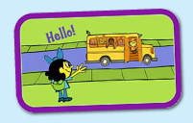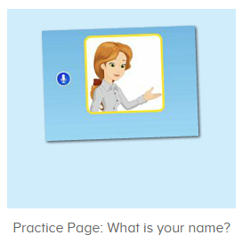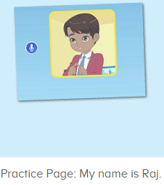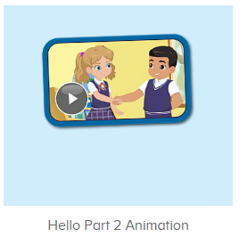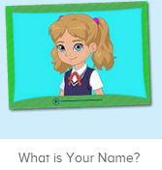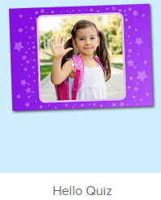
年龄段： 小班上
教学目标：
- 复习巩固口语动画视频中人物的名字Miss Jones,Ken,Carmen,Sara,Nico,Raj,Lina。
2.能完整唱出歌曲what we say第一句When we see people we say hello,wave hello,to all we know并表演相应律动。
3.能流利说出句子what is your name并能应用my name is.....句子介绍自己的名字。
4.能扮演口语视频中人物进行模拟对话。
教具准备：1.hello图卡 2.goodbye图卡 3.口语动画视频人物图卡或头饰
使用游戏：
1.Guessing game 2.TPR 3..I do you say 4.Team match 5.What is missing
教学步骤： |  | 备注
- 成果公布及展示：  T: Hello kids,good morning.  S:Good morning Yama.  T:Today let's welcome our friend "ABCmouse".  Wow, Say hello to ABCmouse.（教师边说边引导幼生挥手说hello）  S:Hello,hello.  T: Now,please follow me "A,B,C,mouse"(ABCmouse TPR)  Excellent!Let's go to ABCmouse.  Wow,look!What can you see?  S:........  T:Listen,what is it?  S:About me...  T:Very nice.Follow it.  S:About me.....  T:Let's see what can we find in "About me".  First,listen.  Follow it.（引导幼生仔细听并跟读关于我板块内容，让幼生粗略了解关于我的组成部分）  S:Change my avatar/go to my room/the pet park/my hamster/my aquarium/my tickets....  T:Very nice.What is this?This is....  S: This is change my avatar/go to my room/the pet park/my hamster/my aquarium/my tickets....  T:What is this?Who can try?  S:Let me try.  T:Lily/Peter/Sam please.What is this?This is.....（邀请单个幼生回答）  S:This is change my avatar/go to my room/the pet park/my hamster/my aquarium/my tickets....  T:Very nice. |  | 引入ABCmouse并简略介绍关于我板块内容
- 集体活动：  T:Everybody stand up please,let's sing and dance.(播放图1歌曲，请幼生边唱边做动作)  S:When we see people we say hello,wave hello,to all we know....say goodbye,wave goodbye, bye bye bye.  T:Once again.  S:When we see people we say hello,wave hello,to all we know....say goodbye,wave goodbye, bye bye bye.  T:Let's have a match,I will sing first then you are the next,ok?(分组跟唱，可以加入老师和幼生接唱的游戏，让幼生多熟悉第一句歌词，再进行互换，可进行2-3遍)  S:Ok.  T:When we wee people we...  S:Say hello,wave hello,to all we know........say goodbye,wave goodbye, bye bye bye....  T:You are so great!Now please listen,what is the sentence?(打开图2素材，请幼生仔细听并跟读，且引导幼生说出正确回答)  S:What is your name?  T:Nice!Follow it.  S:What is your name?  T:So what is your name?  S:My name is.....  T:Nice,let's listen and repeat.(打开图3素材，请幼生跟读发音)  S:My name is Raj......  T:Let's play a game.Listen to the music and pass the ball one by one.(加入击鼓传球游戏，音乐停止时手拿球的幼生需回答教师的问题)  Stop,Peter has the ball.Stand up please.  What is your name?  P:My name is Peter.  T:Very nice.Let's continue.  Now please watch the video and repeat it.(播放图4口语视频，使用暂停播放键请幼生跟读逐句发音)  S:What is your name?.......  T:Let's repeat it by boys and girls,are you ready?  S:Yes,we are ready.  Bs/Gs:What is your name?........  T:Now who wants to be Ken/Nico/Carmen/Sara?（教师把口语视频人物头饰分发给单个幼生，请其扮演视频中人物进行对话演练）  S:Let me try.  T:Tom/Susan/Kitty/Jim,you will be Ken/Nico/Carmen/Sara.Are you ready?  T:What is your name?  T1:Ken  T:Very good!Next team,who can try?  S:Let me try.  T:Very nice.Let's continue our game,but this time we have 2 balls.Are you ready?  S:Yes,we are ready.  T:John and Kitty have the balls,come here and make conversation.  J/K:What is your name?/My name is.....  T:Terrific!Continue!  Now look here,first listen and no voice.(打开图5素材，请幼生看和听，不跟读)  What can you hear?  S:What is your name?/My name is Sara........  T:Right?Let's check.Listen,shh.....  Very nice!This time listen and repeat.  S:What is your name?........  T:Once again,let's have a match by boys and girls.Are you ready?  S:Yes,we are ready.  Bs/Gs:What is your name?........  T:You all did a good job!Do you want to play a game?  S:Yes.  T:Ok,it's game time!Let's go!(打开图6素材，请幼生听发音并选出答案)  First listen and choose.  What can your hear?  S: “Hello”.  T:Which picture is “hello”?  S:This one......  T:Sam come here and choose.  So good!Next one who can try?  S:Let me try?  T:Paul/Ken.Click here,please.  Everybody,what can you hear?  S:What is your name?/My name is Kate.  T:Good!Paul/Ken choose the right picture.  Wow,wonderful!Thank you.  Everybody stand up please,let's sing and dance.(播放图1歌曲，请幼生边唱边做动作)  S:When we see people we say hello,wave hello,to all we know....say goodbye,wave goodbye, bye bye bye.  T:Once again.  S:When we see people we say hello,wave hello,to all we know....say goodbye,wave goodbye, bye bye bye.  T:Great job!Now let's count our tickets.(总结回顾完毕后带领幼生到我的奖励票去数奖票)  Where can we find our tickets?  S: "About me".  T:Listen and repeat.（让幼生跟读我的奖励票的发音）  S:"About me".....  T:Which one is "My tickets"  S:Here......  T:Right?Listen and repeat.  S:My tickets.(跟读2-3遍)  T:Nice job!Let's count how many tickets do we have today.（选择数票模式，引导幼生跟随网站一起数数）  S&ABCmouse:one,two.......  T:Wow,great job! |  | 图1  图2  图3  图4  图5  图6
三、家庭游戏活动布置
T:Look,here is your homework.
Where can we find our homework?
S:About me/my lesson.
T:Who can try?
S:Let me try.
T:Tom,please.Look,is he right?
S:Yes.
T:Very good!There are 6 activities,let's count,one,two......
S:One,two......
T:Very nice!Now look at me and I will show you how to do it.
Are you clear?
S:Yes.
T:Who can show us how to do it?
S:Let me try.
T:Tom please.
T1:Go to My lesson.......
T:Great!Thank you Tom,class is over, goodbye everyone.
S:Goodbye Yama.

