大地ABCmouse小班上Hello课时6
复习素材内容：  - What we say music video.  - Hello Animation Part 2  - Practice Page:My name is Raj.  - What is your name? | 新授素材内容：  - What we say music video.  - Hello Animation Part 3  - What is your name?  - Hello Practice.  - Hello Quiz.  - Hello!What is your name?
素材截图：
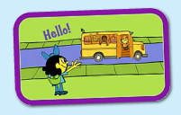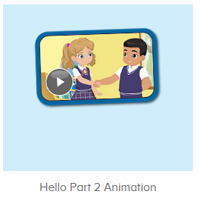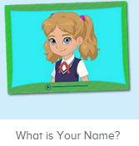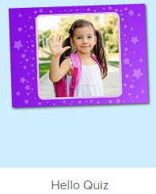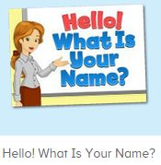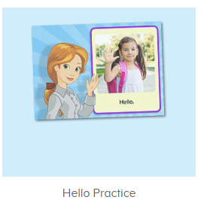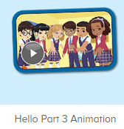
年龄段： 小班上
教学目标：
1.能完整唱出歌曲what we say第一句及第二句，并表演相应律动。
2.能扮演口语视频中人物进行模拟对话。
教具准备：1.口语动画视频人物图卡或头饰 2.句子图卡3.口语视频人物头饰
使用游戏：
1.TPR 2.Team match 3.Role play
教学步骤： |  | 备注
- 成果公布及展示：  T: Hello kids,good morning.  S:Good morning Yama.  T:Today let's welcome our friend "ABCmouse".  Wow, Say hello to ABCmouse.（教师边说边引导幼生挥手说hello）  S:Hello,hello.  T: Now,please follow me "A,B,C,mouse"(ABCmouse TPR)  Excellent!Let's go to ABCmouse.  Wow,look!What can you see?  S:........  T:Listen,what is it?  S:About me...  T:Very nice.Follow it.  S:About me.....  T:Let's see what can we find in "About me".  First,listen.  Follow it.（引导幼生仔细听并跟读关于我板块内容，让幼生粗略了解关于我的组成部分）  S:Change my avatar/go to my room/the pet park/my hamster/my aquarium/my tickets....  T:Very nice.What is this?This is....  S: This is change my avatar/go to my room/the pet park/my hamster/my aquarium/my tickets....  T:What is this?Who can try?  S:Let me try.  T:Lily/Peter/Sam please.What is this?This is.....（邀请单个幼生回答）  S:This is change my avatar/go to my room/the pet park/my hamster/my aquarium/my tickets....  T:Very nice. |  | 引入ABCmouse并简略介绍关于我板块内容
- 集体活动：  T:Everybody stand up please,let's sing and dance.(播放图1歌曲，请幼生边唱边做动作)  S:When we see people we say hello,wave hello,to all we know....say goodbye,wave goodbye, bye bye bye.  T:Once again.  S:When we see people we say hello,wave hello,to all we know....say goodbye,wave goodbye, bye bye bye.  T:Very nice,now let's sing it sentence by sentence.(使用暂停播放键逐句跟唱第一二句)  S:When we see people we say hello,wave hello,to all we know.When we see people we say hello to all our friends and family.  T:Once again.  S:When we see people we say hello,wave hello,to all we know.When we see people we say hello to all our friends and family.  T:Stand up please,let's dance and sing with ABCmouse.(加上动作跟唱第一二句)  S:When we see people we say hello,wave hello,to all we know.When we see people we say hello to all our friends and family.  T:Let's have a match,I will sing first then you are the next,ok?(分组跟唱，可以加入老师和幼生接唱的游戏，让幼生多跟唱第二句歌词，可进行2-3遍，然后再分男女生分组跟唱)  S:Ok.  T:When we wee people we...  S:When we see people we say hello to all our friends and friends.  T:This time,boys and girls will have a match,are you ready?  S:Yes,we are ready.  Bs/Gs:When we see people we say hello,wave hello,to all we know.When we see people we say hello to all our friends and family.  T:Terrific!Now look here,listen and repeat.(打开图2素材，请幼生跟读)  S:What is your name?........  T:Once again,let's have a match by boys and girls.Are you ready?  S:Yes,we are ready.  Bs/Gs:What is your name?........  T:You all did a good job!Let's play a game!(打开图3素材，请幼生跟读发音并选择正确选项，第1-2个可由教师操作，后面的轮可邀请几位幼生上台操作)  Listen and repeat.  S:Hello./My name is Miss Jones.....  T:Which one is right?  S:Hello.  T:Let's have a try.Great job!Let's continue.  S:My name is Carmen./What is your name.....  T:Who can try?  S:Let me try.  T:Peter/Sam/Gina...please.Everybody listen and repeat.  S:My name is Ken......  T:Great job!Thank you!  Now please watch the video and repeat it.(播放图4口语视频，请幼生跟读逐句发音)  S:What is your name?.......  T:Let's repeat it by boys and girls,are you ready?  S:Yes,we are ready.  Bs/Gs:What is your name?........  T:Now who wants to be Ken/Nico/Carmen/Sara?（教师把口语视频人物头饰分发给单个幼生，请其扮演视频中人物进行对话演练）  S:Let me try.  T:Tom/Susan/Kitty/Jim,you will be Ken/Nico/Carmen/Sara.Are you ready?  T:What is your name?  T1:Ken  T:Very good!Next team,who can try?  S:Let me try.  T:Very nice.Let's continue to watch the video,listen and no voice.(打开图5口语视频动画请幼生先听不跟读)  What can you hear?  S:What is your name?/My name is Lina.....  T:Right?Let's check.Listen again.  Wow,you are so clever!Now listen and repeat.(使用暂停播放键，逐句跟读，可进行2-3遍)  S:What is your name?My name is Lina.....  T:Let's have a match by boys and girls,are you ready?  S:Yes,we are ready.  Bs/Gs:What is your name?My name is Lina.....  T:Good job!Now I am Raj,who wants to be Lina?(第一轮由老师跟幼生扮演视频中人物进行对话，后续可完全邀请幼生进行)  S:Let me try.  T:Lily please.  What is your name?  L:My name is Lina.What is your name?  T:My name is Raj.  L:Hello,Raj.  T:Very good,Lily thank you!Next,who wants to be Raj and Lina?  S:Let me try.  T:Lucy and Fiona come here please.把人物头饰分发给幼生进行模拟对话）  L:What is your name?  F:My name is Lina.What is your name?  L:My name is Raj.  F:Hello,Raj.  T:So good!Look here,who is this?（出示口语视频人物图卡，询问幼生人物名称）  S:Ken,Nico,Carmen,Sara....  T:Who wants to be Miss Jones/Ken/Nico/Carmen/Sara?(把人物头饰分发给幼生，模拟口语视频对话)  S:Let me try.  T:Coco,Henry.....please.  C:What is your name?  H:My name is Ken/Nico/Carmen/Sara....  T:Great job!Now let's be the little recorder,listen and record.(打开图6素材，邀请幼生进行跟读及录音，第一个可由老师操作示范，第二三个由幼生自主操作)  S:Hello,hello,hello  T:Listen,is it nice?  S:Yes!  T:Good,next one,Peter/Molly come and click it.  Everybody get ready,one two go!  S:What is your name/My name is Kate.  T:Listen!Is it the same?  S:Yes!  T:Very nice!Now stand up and sing a song.(打开图1歌曲素材，请幼生边唱边做动作，回顾第1-2句歌词)  S:When we see people we say hello,wave hello,to all we know.When we see people we say hello to all our friends and family.  T:Once again.  Great job!Now let's count our tickets.(总结回顾完毕后带领幼生到我的奖励票去数奖票)  Where can we find our tickets?Who can try?  S:Let me try.  T:Everybody look,is it right?  S:Yes.  T:What is this?This is...  S:This is "My tickets"  T:Good!Listen and repeat.  S:My tickets.(跟读2-3遍)  T:Nice job!Let's count how many tickets do we have today.（选择数票模式，引导幼生跟随网站一起数数）  S&ABCmouse:one,two.......  T:Wow,great job! |  | 图1  图2  图3  图4  图5  图6
三、家庭游戏活动布置
T:Look,here is your homework.
Where can we find our homework?
S:About me/my lesson.
T:Who can try?
S:Let me try.
T:Tom,please.Look,is he right?
S:Yes.
T:Very good!There are 6 activities,let's count,one,two......
S:One,two......
T:Very nice!Now look at me and I will show you how to do it.
Are you clear?
S:Yes.
T:Who can show us how to do it?
S:Let me try.
T:Tom please.
T1:Go to My lesson.......
T:Great!Thank you Tom,class is over, goodbye everyone.
S:Goodbye Yama.

