ABCmouse大班下词汇家族-ig-课时8
总复习素材内容:
1. Basics Word Family Words: pig
2. Basics Word Family Words: wig
3. Basics Word Family Words: dig
4. Word Family Puzzle:Big Pig and Little Pig
5. Big Pig and Little Pig
素材截图:
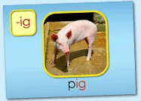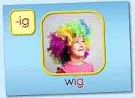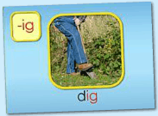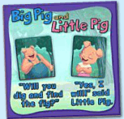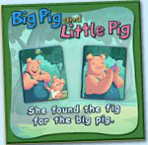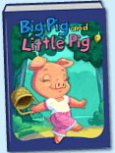
年龄段: 大班下
教学目标:
1.总复习已学单词。
2.总复习整本图书并熟练表演。
教具准备: 1.自制的拼图碎块 2. Big Pig and Little Pig的头饰 3.自制红绿灯 4.单词卡片 5.故事图片或PPT
使用游戏: 1.Traffic light 2.Puzzle game 3.Make sentence 4.Role play
教学步骤: | 备注
- 成果公布及展示:  T: Hello kids.  S: Hello, teacher.  T: XXX, come here please,can you show us your activities?  S: Yes.  T: OK. Can you read these words?  T: Can you play this puzzle game?  T: Can you read this book?  L: Yes. I can.  T: Excellent. Can you show us your room?  S: Yes!Welcome to my room!This is my room.Can you find my avatar?It's here.There are two tables and a red chair in my room.I bought the chair yesterday.They are so cool.I have a ABC mouse tea set on my round table.My room cost me more than 366 tickets. I can change the scene of my room.The next scene is a beach.  T: Wow,terrific!Thank you XXX. | 注：图书展示过程中可多要几位幼生上台朗读读书。以接龙的方式进行。
二、集体学习活动:  1）复习已学过的3个单词（pig,wig,dig）（图1~3）  T: Kids, let's review "-ig" family words.  Review steps:  - Game: Traffic light（线下"红绿灯"游戏）  - Complete the words: ____ig (p/w/d) Bs vs Gs G1 Vs G2（锻炼拼读能力）  2）操作（图4、5）拼图，复习句子。  T: Kids, listen and repeat.  T: Can you read these sentences?  S: Yes. "Will you dig and find the fig?""Yes I will said little pig."  T: Good. Team 1 repeat please.  T1: "Will you dig and find the fig?""Yes I will said little pig."  T: Good job,Team 2 repeat please.  T2: "Will you dig and find the fig?""Yes I will said little pig."  T: Now, let's have a match. Who wants to try?  （每组派一个代表，挑战级别3，谁用时最短获胜）  T: Kids, tell me. Which group is the first?  S: G1...  T: Excellent! Next one.Team 1 repeat please.  T1:She found the fig for the big pig.  T: Nice,Team 2 repeat please.  T2: She found the fig for the big pig.  T: Let’s make new sentence.What’s this?  S: wig/fig/toy/car  T: Look here. She found the __ for the big pig.(将不同的物品替换，进行造句练习)  S:She found the fig for the big pig.  S:She found the wig for the big pig.  S:She found the toy for the big pig.  T: Look, what's in my hand? （组织幼生线下拼图游戏）  S: Puzzles.  T: You're so clever. Let's have a match.  T: Are you ready?  S: Yes, we are ready!  T: Excellent! Play again.  3）复习已学图书 《Big Pig and Little Pig》（图6）  T: Now, Let's review<Big Pig and Little Pig>  Review steps:  a.Follow the computer, listen and repeat.  b.Bs read the story, Gs read the story. Bs Vs Gs  c.Look and say. （关闭网站，看PPT或图片说句子）  d.Perform the story.  e.Do and say. （看动作，猜句子内容）  T: Kids, guess, which sentence?  f.Page turning （随机翻页，翻到哪也读哪页）  T: I'll close my eyes! What's this?/What can you see?  （可请说得又快又准的幼生上台翻页）  g.Listen and choose the right card.  T: Kids, listen carefully! Then choose the right picture for me. OK?  h.Role play.  （以上可根据课堂实际情况选择2-3中形式复习）  4）复习本节课所学内容及课堂情况总结  T: This month we learned the < Big Pig and Little Pig>story.Do you like it?  S: Yes ! I like!  T: Our class is very good!How many stickers do you have today?  S: ... | 图1:  图2：  图3：  注："红绿灯"游戏玩法：借助交通灯的规则，"红灯停，绿灯行"。T出示红灯，Ss停止认读，T出示绿灯，Ss方可继续认读。  图4：  图5：  图6:
三、家庭游戏活动布置:
T: Wow!So nice!Now look at me ,you have to do one, two,three... activities.
T: XXX come here and show us how to do the activities.
S:...
T: Good job!Thank you XXX!Class is over, Good bye everyone.
S: Goodbye.

