ABCmouse大班下词汇家族-en~-ig&My Clothes-课时3
复习素材内容:  1. Basics Word Family Words: jet,pet,wet  2. Pet on a Jet  3. My Clothes ,Part 1 Animation  4. Practice Page:I like this hat.  5. Practice Page:I don't like this hat.  6. The Wheels on the Bus Music Video | 新授素材内容:  1. My Clothes Practice
素材截图:
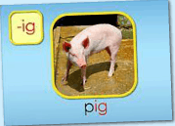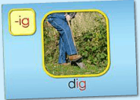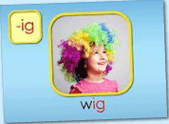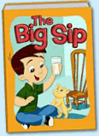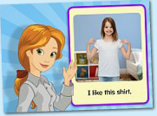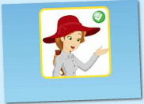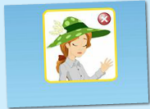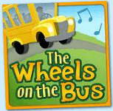
年龄段: 大班下
教学目标:
- 能熟练掌握词汇家族-ig对应的发音。
- 能熟练掌握所学句型。
- 能表演所学故事内容。
- 掌握所学口语内容中单词及句子。
- 掌握所学口语内容，能交流。
- 掌握所学歌曲内容，能演唱。
教具准备: 1.口语视频中对应实物（红绿色的帽子） 2.单词和故事图卡
使用游戏: 1. Fast Game 2Little teacher 3.Team Game
教学步骤: |  | 备注
- 成果公布及展示:
T: Good morning everyone.
S: Good morning, teacher.
T: What day is today?
S: Today is Monday/ Tuesday/ Wednesday/Thursday/Friday.
T: XXX, come here please,can you show us your activities?
S: Yes.
T: OK. Can you read these sentence?
T: Can you sing the song?
S: Yes. I can.
T: Betty,Please show us your room.
B: Welcome to my room!This is my room.Can you find my avatar?It's here.There are two tables and a red chair in my room.They are so cool.I have a ABC mouse tea set on my round table.
T: Very good!What can you see in Betty's room?
S: I can see two tables and a red chair in Betty's room.
S: I can see a ABC mouse tea set on round table.
T: Betty,How many tickets have you cost in your room?
B: My room cost me more than 366 tickets. I can change the scene of my room.The next scene is a beach.
T: When did you buy the chair?
B: I bought the chair yesterday.
T: Wow, terrific! Thank you Betty.
二、集体学习活动:  1）复习巩固pig,dig,wig的发音（图1-3）  T: Today, We will review these words. Please listen carefully! No voice!  T: Kids, What can you hear?  S: pig,dig,wig  T: Good, listen and repeat!（老师点击中间图片部分，引导幼生跟读）  S: pig,dig,wig  T: Pretty good! Look, what's this?（老师拿出单词卡片）  S: pig,dig,wig  T: Let's spell this.  S: p-ig;d-ig;w-ig.  T: Good job! Let's play Fast Game.（单词图片快速游戏）  T: Let's have match. G1 Vs G2/ Bs Vs Gs Which group is the best?  S: Yes...  2）复习巩固 《The Big Sip》内容.（图4）  T: Today, we will review this story. Listen and repeat.  S: The Big Sip.Bob likes milk.He takes a sip...  T: Wonderful! Now, Listen these sentences and find the picture!（T拿出出故事图片）  1S: ...  2S: ...  3S: ...  T:Great! Let's perform these story.  Ss: ...  T: Pretty good! Team game.Let's perform these story team by team.  A: ...  B: ...  C: ...  3）观看《My Clothes ,Part 1 Animation》动画story,巩固对应口语句子（图5）  T: Please listen carefully! Look and follow it!Sentence by sentence.（幼生跟着电脑复读2-3遍）  S: ...  T: This time, Please voice this story. （关闭网站声音，引导幼生给动画配音,可以循环播放句子）  S: ...  T: Now I will choose four students to play this story.（T分配好头饰角色，如果有帽子道具，可以使用食物道具来表演）  Ss: ...  T: Great！  4) 学习《My Clothes Practice》口语练习。（图6）  T: Please listen carefully and answer the question.  S: I like this shirt.  T: Great!XX come and say.  S: I don't like this jacket.  T: Good job!Next one.  S: I like this red dress.  T: Nice!XX come and say. Listen.  S: I don't like my green socks.  T: Good!XX come and say.  S: I am wearing red shoes.  T: Pretty good,now look this.（T拿出练习中所有的单词卡）  T: Let's read it one by one.（接龙游戏）  S: ...  5）通过练习复习已学过的单词和句子。（图7-8）  T: Listen and repeat.  S: I like this hat.  T: Great!XX come and say.  S: I like this hat.  T: Good job!Next one.Listen and repeat.  S: I don't like this hat.  T: Nice!XX come and say.  S: I don't like this hat.  T: Let's read it one by one.（接龙游戏）  S: I don't like this hat./I don't like this hat.  6) 学习《The Wheels on the Bus》歌曲（图9）  T: Kids,Let's sing,ok? （播放歌曲2-3遍）  S: ...  T: Good. Everybody stand up!  T: Let's move.(TPR学习3、4段)  S: ...  T: Please sing it sentence by sentence.(TPR分段教学，让幼生一句一句学习)  S: ...  T: Good job,one more time.  S: ...  T: Excellent! Girls, please sing the song.(Gs VS Bs)  G: Yes.  T: OK. Next one. Boys come on?  B: ...  T: Wonderful!  7) 复习本节课所学内容及课堂情况总结  T: Let's review these words!  S: pig,dig,wig.  T: Wonderful! How many stickers do you have today?  S: ... |  | 图1:  图2:  图3:  图4:  备注：  句子接龙形势，第一遍跟着电脑朗读，第二遍，看图朗读。可以一个接着一个；也可以一组接着一组.  图5:  图6:  图7:  图8:  图9:
三、家庭游戏活动布置:
T: Wow!So nice!Now look at me ,you have to do one, two,three... activities.
T: XXX come here and show us how to do the activities.
S:...
T: Good job!Thank you XXX!Class is over, Good bye everyone.
S: Goodbye.

