ABCmouse大班下词汇家族-en~-ig&My Clothes-课时7
复习素材内容:  - My Clothes,Parr 3 Animation  - I am wearing my orange dress.  - Practice Page:I like my orange dress.  - My Clothes  - The Wheels on the Bus  - The Wheels on the Bus Music Video | 新授素材内容:  1. My Clothes Matching Cards
素材截图:
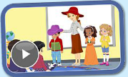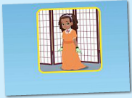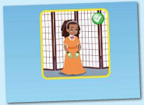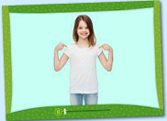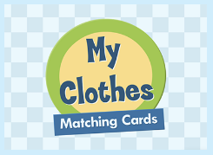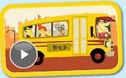
年龄段: 大班下
教学目标:
1.掌握口语中所含的单词及句子。
2.掌握所学歌曲内容，能演唱。
3.掌握所学口语内容，能交流。
教具准备: 1.句子卡片 2.人物头饰 3.动画中对应服饰
使用游戏: 1. How Many Game 2.Dragon Game 3.Role play 4.Team Game
教学步骤: |  | 备注
- 成果公布及展示:  T: Good morning everyone.  S: Good morning, teacher.  T: What color do you like?  S: I like pink..  T: XXX, come here please,can you show us your activities?  S: Yes.  T: OK. Can you read these sentence?  T: Can you sing the song?  S: Yes. I can.  T: Please show us your room.  S:OK.Welcome to my room!This is my room.Can you find my avatar?It's here.There are two tables and a red chair in my room.I bought the chair yesterday.They are so cool.I have a ABC mouse tea set on my round table.My room cost me more than 366 tickets. I can change the scene of my room.The next scene is a beach.  T: Wow, terrific! Thank you XXX. |  | 老师提前打开2个页面，一个是幼生家庭活动页面，一个是教师授课操作后台。  减少平台切换的时间。
二、集体学习活动:  1）教师拿出单词卡片复习单词和句型。（图1-2）  T: Look ,please read together.  S: I am wearing my orange dress.  T: Please listen carefully! Close your eyes.Let's play How Many Game.  C:I am wearing my orange dress...（幼生听着电脑，心中默数）  T: How many times?  S: 2  T: Good! Please repeat 2 times.  T: Look this picture.（电脑展示下一张图）  S: I like my orange dress.  T: OK,listen and close.  T: How many times?  S: 3  T: Nice! Please repeat 3 times.  S: ...  2）观看《My Clothes,Part3 Animation》动画story（图3）  T: Please listen and repeat sentence by sentence.（幼生跟着电脑复读2-3遍）  S: ...  T: Wonderful! Let's read again.（T播放动画，消除声音，让幼生配音）  S: ...  T: I want choose 6 students to play this Animation.  S: ...（幼生佩戴人物头饰表演故事）  3) 通过拼图游戏复习已学过的单词和句子。（图4）  T: Look listen and repeat.  S: I like this shirt.  S: I have a jacket  S: I don't like this hat.  S: I don't have a glove.  S: I like this red dress.  S: I don't like this green jacket.  S: I have blue and purple hat.  T: Pretty good.Let's read team by team.（句子接龙游戏）  Ss: ...  T: Wonderful!  4) 通过拼图游戏复习已学过的单词和句子。（图5）  T: Look listen and choose.Lily come here.  S: I like this red dress.  S:I don't like this hat.  S:I don't like this green jacket.  S:I have a blue and purple hat.  T: Good job! Who want to play this.  S: Let me try.（上机操作2-3轮.level3级别）  5) 学习《The Wheels on the Bus》歌曲（图6）  T: Kids,Let's sing,ok? （播放歌曲2-3遍）  S: ...  T: Good. Everybody stand up!  T: Let's move.  S: ...  T: Good job,one more time.  S: ...  T: Excellent! Girls, please sing the song.(Gs VS Bs)  G: Yes.  T: OK. Next one. Boys come on?  B: ...  T: Wonderful!  6) 观看《The Wheels on the Bus Music Video》（图7）  T: Kids, have a rest! Let's play <The Wheels on the Bus Music Video>. No voice!  T: Watch again.  T: Please sing it sentence by sentence.(降低电脑声音，让幼生一句一句唱读)  S: ...  T: Excellent! Team A please sing the song.(team game)  A: Yes.  T: OK. Next one.Team B come on.  B: ...  T: Wonderful!  7）课堂情况总结  T: How many stickers do you have today?  S: ... |  | 图1:  图2:  备注：  线上游戏环节作为单个复习，线下游戏环节作为集体复习.  图3:  备注：  配音游戏- 老师播放动画，让幼生配音，先集体配音；然后可以分组配音或者点表演者上台配音。  图4:  图5:  图6:  图7:
三、家庭游戏活动布置:
T: Wow!So nice!Now look at me ,you have to do one, two,three... activities.
T: XXX come here and show us how to do the activities.
S:...
T: Good job!Thank you XXX!Class is over, Good bye everyone.
S: Goodbye.

