ABCmouse大班下词汇家族-en~-ig&My Clothes-课时8
复习素材内容:
- My Clothes Animation
- My Clothes
- My Clothes Matching Cards
- Colors in My Closet:Girl's Clothes
- The Wheels on the Bus
- The Wheels on the Bus Music Video
素材截图:
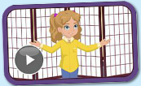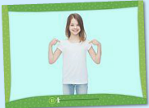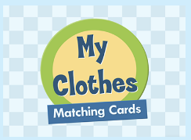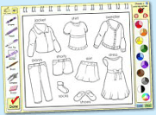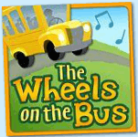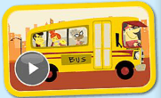
年龄段: 大班下
教学目标:
总复习：1.能熟练运用所学的句子内容对话。
- 能准确表达出自己喜欢或不喜欢穿什么服饰。
- 能主动用所学的句子描述喜欢或不喜欢穿什么颜色的服饰。
教具准备: 1.衣服服装道具 2.人物头饰
使用游戏: 1. Role play 2.Make sentences 3.Dragon game 4.Team Game
教学步骤: | 备注
- 成果公布及展示:  T: Good morning everyone.  S: Good morning, teacher.  T: What food do you like to eat?  S: I like to eat meat..  T: XXX, come here please,can you show us your activities?  S: Yes.  T: OK. Can you read these sentence?  T: Can you sing the song?  S: Yes. I can.  T: Please show us your room.  S: OK.Welcome to my room!This is my room.Can you find my avatar?It's here.There are two tables and a red chair in my room.I bought the chair yesterday.They are so cool.I have a ABC mouse tea set on my round table.My room cost me more than 366 tickets. I can change the scene of my room.The next scene is a beach.  T: Wow, terrific! Thank you XXX. | 老师提前打开2个页面，一个是幼生家庭活动页面，一个是教师授课操作后台。  减少平台切换的时间。
二、集体学习活动:  1）观看《My Clothes Animation》动画story,巩固对应口语句子（图1）  T: Please listen carefully! Look and follow it!Sentence by sentence.（幼生跟着电脑复读2-3遍）  S: ...  T: This time, Please voice this story.（关闭网站声音，引导幼生给动画配音,可以循环播放句子）  S: ...  T: Now I will choose seven students to play this story.（T分配好头饰角色，和道具）  Ss: ...  T: Great！Who want to try again?  Ss: ...  2) 学习《My Clothes》口语练习（图2）  T: Please repeat it one by one.（小组或单人跟读练习）  S: I like this shirt.  S: I have a jacket  S: I don't like this hat.  S: I don't have a glove.  S: I like this red dress.  S: I don't like this green jacket.  S: I have blue and purple hat.  3) 通过拼图游戏复习已学过的单词和句子（图3）  T: Look listen and choose.Lily come here.  S: I don't have a glove.  S: I like this shirt.  S: I don't like this green jacket.  S: I don't like this hat.  T: Good job! Who want to play this.  S: Let me try.（上机操作2-3轮.level3级别）  4) 上机玩涂色游戏（图4）  T: Let's do some painting! What is this?  S: jacket/shirt/sweater/pants/shorts/skirt/dress/socks/shoes.  T: OK.listen and repeat.  S: jacket/shirt/sweater/pants/shorts/skirt/dress/socks/shoes.  T: Who wants to be a "little artist"?  1S: Let me try!  T: OK, you please.  T: Can you tell me what's in the picture?  1S: Clothes.  T: What color do you want to paint?  S: Black/Blue/Pink...  T: OK, who wants to try?  2S: Let me try!（请4-5位S上台参加比赛）  T: Do you know, who get "a little artist"?  T: XXX!  T: Congratulation! XXX!  5) 学习《The Wheels on the Bus》歌曲（图5）  T: Kids,Let's sing,ok? （播放歌曲2-3遍）  S: OK!...  T: Good. Everybody stand up!  T: Let's move.  S: ...  T: Good job,one more time.  S: ...  T: Excellent! Girls, please sing the song.(Gs VS Bs)  G: Yes.  T: OK. Next one. Boys come on?  B: ...  T: Wonderful!  6) 观看《The Wheels on the Bus Music Video》（图6）  T: Kids, have a rest! Let's play <The Wheels on the Bus Music Video>. No voice!  T: Watch again.  T: Please sing it sentence by sentence.(降低电脑声音，让幼生一句一句唱读)  S: ...  T: Excellent! Team A please sing the song.(team game)  A: Yes.  T: OK. Next one.Team B come on.  B: ...  T: Wonderful!  7）复习本节课所学内容及课堂情况总结  T: How many stickers do you have today?  S:... | 图1:  备注：  配音游戏- 老师播放动画，让幼生配音，先集体配音；然后可以分组配音或者点表演者上台配音。  图2:  备注：  句子接龙形势，第一遍跟着电脑朗读，第二遍，看图朗读。可以一个接着一个；也可以一组接着一组.  图3:  图4:  图5:  图6:
三、家庭游戏活动布置:
T: Wow!So nice!Now look at me ,you have to do one, two,three... activities.
T: XXX come here and show us how to do the activities.
S:...
T: Good job!Thank you XXX!Class is over, Good bye everyone.
S: Goodbye.

