ABCmouse大班下词汇家族-am~-at&Clothes Part 2-课时3
复习素材内容:  1. Basics Word Family Words: cat  2. Basics Word Family Words: mat  3. Basics Word Family Words: sat  4. Word Family Sentence Puzzle:cat and the rat  5. Clothes,Part2-A Animation | 新授素材内容:  - Clothes,Part2-A Animation  - Practice Page:These are red socks  3. Look at All the Colors I Can See
素材截图:
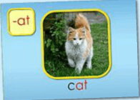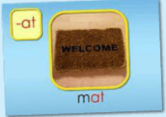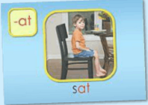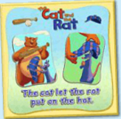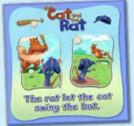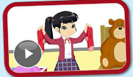
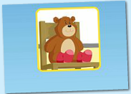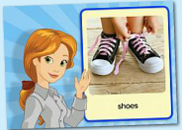
年龄段: 大班下
教学目标:
- 能熟练掌握词汇家族-at对应发音。
- 能熟练掌握所学句型。
- 能表演所学故事内容。
- 掌握所学口语内容中单词及句子。
- 掌握所学口语内容，能交流。
- 掌握所学歌曲内容，能演唱。
教具准备: 1.对应的单词卡片和句子拼图卡片
使用游戏: 1.Missing Game 2.Make sentences 3.Team Game
教学步骤: |  | 备注
- 成果公布及展示:
T: Good morning everyone.
S: Good morning, teacher.
T: What day is today?
S: Today is Monday/ Tuesday/ Wednesday/Thursday/Friday.
T: XXX, come here please,can you show us your activities?
S: Yes.
T: OK. Can you read these sentence?
T: Can you sing the song?
S: Yes. I can.
T: XXX,please show us your tickets.
S: OK.My total tickets are 300.I got 25 tickets today,five,ten,fifteen,twenty,twenty-five.I got many tickets from ABC mouse.I want to be the queen of tickets.I can buy many things with my tickets.I want to buy a new jacket for my avatar.I want to buy a new pet with my tickets.Now my tickets are not enough.So,I need to study hard.
T: Wow, terrific! Thank you XXX.
二、集体学习活动:  1）复习巩固cat,sat,mat的发音。 （图1-3）  T: Today, We will review these words. Please listen carefully! No voice!  T: Kids, What can you hear?  S: cat,sat,mat  T: Good, listen and repeat!（老师点击中间图片部分，引导幼生跟读）  S: cat,sat,mat.  T: Pretty good! Look, what's this?（老师拿出单词卡片）  S: cat,sat,mat  T: Let`s spell this.  S: c-at;s-at;m-at.  T: Good job! Let's play a game. "Listen and find the cards".which card is dot?  S: There is cat.  T: Let's have match. G1 Vs G2/ Bs Vs Gs Which group is the best?  S: Yes...  2) 复习巩固《Cat and the Rat》内容.（图4）  T: Today, we will review these story. Read the book.  S: ...  T: Yes. You're right!  T: Now, Listen to these sentences and find the picture!（T拿出出故事图片）  1S: ...  2S: ...  T:wonderful! Let's perform these story.  S: ...  T: Great! Team game.Let's perform these story team by team.  A: ...  B: ...  3) 复习句子，进行句子拓展。（图4-5）  T : Look this puzzle.Listen and repeat.  S: The /rat /let /the /cat /swing /the /bat.  T: Good.Listen and repeat again.（跟读句子2-3遍）  S: The rat let the cat swing the bat.  T: Let`s play the puzzle.  S:Yes! Let me try.  T: Wonderful. Next puzzle.  T: Listen and repeat.  S: The /cat /let /the /rat /put /on /the/ hat.  S: The cat let the rat put on the hat.  T: Let`s play the puzzle.  S:...  4）观看《Clothes,Part2-A Animation》动画story（图6）  T: Please listen carefully! Look and follow it!Sentence by sentence.（幼生跟着电脑复读2-3遍）  S: ...  T: Team game listen and repeat.  T1/T2: ...(分组句子跟读比赛)  T: Wonderful!What’s this?(实物展示)  S: These are socks.  T: What color are the socks that Miss bear is wearing?  S: These are red socks.  T: Very good! Please read this video.  S: ...(为动画配音)  5）句子练习，复习巩固口语单词和句子。（图7）  T: Listen and no voice.What can you hear?  S: Mr. Bear is Wearing red socks.  T: Good job! Listen and repeat!(跟读3遍)  S: Mr. Bear is Wearing red socks.  T: Please read this sentence one by one.  S: Mr. Bear is Wearing red socks.(朗读接龙)  - 听力练习，巩固单词和句子。（图8）  T: Listen and repeat!  S: Socks.  S: Pants.  S: Shorts.  S: Shoes.  S: Sweater.  S: She is wearing blue shorts.  T: Great!  7) 学习《Look at All the Colors I Can See》歌曲。（图9）  T: Kids,Let`s sing,OK? （播放歌曲2-3遍）  S: ....  T: Good. Everybody stand up!.  T: Let`s move.(TPR学习整首歌曲)  S: ...  T: Please sing it sentence by sentence..(TPR分段教学，让幼生一句一句学习)  S: ... (段落2)  T: Good job,one more time.  S: ...(段落2)  T: Excellent! Girls, please sing the song.(Gs VS Bs)  G: Yes.  T: OK. Next one. Boys come on?  B: ...  T: wonderful!  7）复习本节课所学内容及课堂情况总结  T: Let's review this sentence.Look and say!  S: Mr. Bear is Wearing red socks.  T: Wonderful! How many stickers do you have today? |  | 图1-3:  图4:  图4-5:  备注：  接龙游戏可以让幼生一个一个接龙这读单个句子或者是所有句子；可以分组接龙。  接龙顺序可以由左到右，由前到后，也可以老师突然点名切换顺序，这样提高幼生注意力。  图6:  图7:  图8:  图9:
三、家庭游戏活动布置:
T: Wow!So nice!Now look at me ,you have to do one, two,three... activities.
T: XXX come here and show us how to do the activities.
S:...
T: Good job!Thank you XXX!Class is over, Good bye everyone.
S: Goodbye.

