ABCmouse大班下词汇家族-am~-at&Clothes Part 2-课时6
新授素材内容:  - Practice Page:These are blue shoes.  - Clothes,Part 2 Memory Match  - Colors and Clothing Part 1 | 复习素材内容:  - Clothes,Part2-C Animation  - Practice Page:Wearing a sweater  - Look at All the Colors I Can See  - Look at All the Colors I Can See Music Video
素材截图:
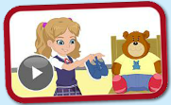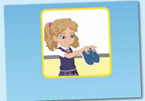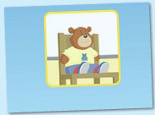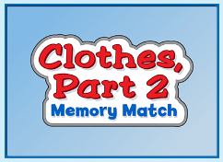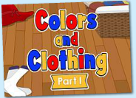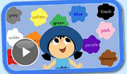
年龄段: 大班下
教学目标:
1.掌握口语中所含的单词及句子。
2.掌握所学歌曲内容，能演唱。
3.掌握所学口语内容，能交流。
教具准备: 1.句子练习卡片
使用游戏: 1. Quickly and slowly 2.Make sentences 3.Dragon game 4.Team Game
教学步骤: |  | 备注
- 成果公布及展示:  T: Good morning everyone.  S: Good morning, teacher.  T: How do you go to school?  S: I go to school by bus/car/bike/on food.  T: XXX, come here please,can you show us your activities?  S: Yes.  T: OK. Can you read these sentence?  T: Can you sing the song?  S: Yes. I can.  T: XXX,please show us your tickets.  S: OK.My total tickets are 300.I got 25 tickets today,five,ten,fifteen,twenty,twenty-five.I got many tickets from ABC mouse.I want to be the queen of tickets.I can buy many things with my tickets.I want to buy a new jacket for my avatar.I want to buy a new pet with my tickets.Now my tickets are not enough.So,I need to study hard.  T: Wow, terrific! Thank you XXX. |  | 老师提前打开2个页面，一个是幼生家庭活动页面，一个是教师授课操作后台。  减少平台切换的时间。
二、集体学习活动:  1）教师拿出单词卡片学习巩固单词和句型。（图1、2）  T: Please listen carefully! Keep quiet!What can you hear?  S: These are blue shoes.（幼生跟着电脑复读2-3遍）  T: Look this picture.（T拿出对应卡片）  S: These are blue shoes.  T: Good,Next one.Listen and repeat!  S: Mr. Bear is wearing blue shoes.（T拿出对应卡片）  T: Great!Let`s play the Matching game.Listen,which picture ?（T拿出对应卡片）  S: A  T: OK,match it,XXX come and repeat the sentence.  S:  T: Pretty good.Go on.（游戏4-5轮）  S: ...  T: Let`s make sentence.”These are...”（T拿出准备的衣服片协助造句）  S: These are red shoes.  S: These are pink pants.  S: ...  2）观看《Clothes,Part2-C Animation》动画story（图4）  T: Please listen and repeat sentence by sentence.（幼生跟着电脑复读2-3遍）  S: ...  T: Wonderful! Let`s read again.（T播放动画，消除声音，让幼生配音）  S: ...  T: I want choose 3 teams to play this Animation.  S: ...  3) 通过游戏素材复习已学过的单词和句子。（图5）  T: Clothes,Part 2 Memory Match.Lily come here,listen and choose.  L: ...  T: Great!Next one.Tommy.  T: ...  T: Good job!Amy.Listen.  A: ...  T: Pretty good,（T拿出练习中所有的单词卡）  T: Let`s make sentence one by one.（造句接龙游戏）  S: This is jacket.  S: These are pants.  S: These are socks.  S: These are shoes.  S: These are shorts.  4) 学习《Look at All the Colors I Can See》歌曲。（图6）  T: Kids,Let`s sing,OK? （播放歌曲2-3遍）  S: ....  T: Good. Everybody stand up!.  T: Let`s move.(TPR学习整首歌曲)  S: ...  T: Please sing it sentence by sentence..(TPR分段教学，让幼生一句一句学习)  S: ... (段落5)  T: Good job,one more time.  S: ...(段落5)  T: Excellent! Girls, please sing the song.(Gs VS Bs)  G: Yes.  T: OK. Next one. Boys come on?  B: ...  T: wonderful!  5) 观看《Look at All the Colors I Can See》（图7）  T: Kids, have a rest! Let's play <Look at All the Colors I Can See>. No voice!  T: Watch again.  T: Please sing it sentence by sentence.(消除电脑声音，让幼生一句一句唱读)  S: ...  T: Excellent! Team A please sing the song.(team game)  A: Yes.  T: OK. Next one.Team B come on.  B: ...  T: wonderful!  6) 通过游戏素材复习已学过的单词和句子。（图8）  T: Colors and Clothing game.Who want to play?  S: ...  T: Next one.(邀请幼生上机操作游戏)  S: ... |  | 图1:  图2:  图4:  备注：  配音游戏- 老师播放动画，让幼生以小组为单位进行分角色配音；  图5:  图6:  图7:  图8:
三、家庭游戏活动布置:
T: Wow!So nice!Now look at me ,you have to do one, two,three... activities.
T: XXX come here and show us how to do the activities.
S:...
T: Good job!Thank you XXX!Class is over, Good bye everyone.
S: Goodbye.

