Letters Review J-K-L&How Are You课时2
素材内容：
- Letter j-k-l chant.
- j-k-l Review Cutout Puzzle.
- Simple Letter Story: K
- Simple Letter Story: L
- j-k-l Matching Card Game.
素材截图：
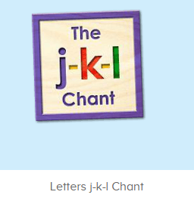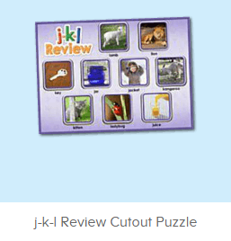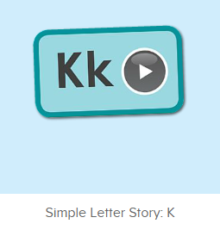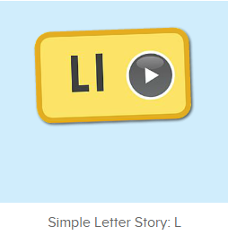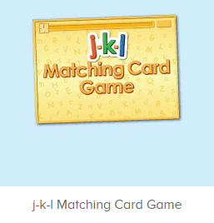
年龄段：小班下
教学目标：
- 能熟练掌握字母J, K,L的发音并表演对应字母律动。
- 能熟练掌握对应的单词，看图能说。
- 能熟练将字母及对应单词进行配对。
- 能自如念唱诗歌并表演对应TPR。
- 能自如流利地跟读字母故事K, L，能看图说故事。
教具准备：
1. Matching Game 2. Team Match
教学步骤： | 备注
- 成果公布及展示：  T: Hello kids, good morning.  S: Good morning.  T: First, let's praise Lily, Andy, Peter, Jimmy... They have finished all their activities.  Everybody look,what is this? This is... (带领全体幼生回顾前三个字母已学过的关于我的名称)  S: This is my room/ my aquarium/ my hamster.  T: Is it right? Let’s listen and repeat.  S: Go to my room./ go to my aquarium/ go to my hamster.  Coco come here, please show us your room.  C: Yes.  C: This is my room.This is my bed. My bed is yellow.  T: Wow, terrific! Thank you Coco.  Everybody together.  S: This is my room.This is my bed. My bed is yellow. （带领幼生整体描述一遍）  T: Well done! | 公布家庭活动成果并展示关于我（我的房间/我的鱼缸/我的仓鼠）
- 集体学习活动：  快乐唱片机  T: Now, let’s listen to the chant, no voice, OK? （教师点击播放图1诗歌，请幼生先听不跟唱并留意诗歌内容）  S: OK.  T: What can you hear?  S: Letter j/ “j”/ kangaroo/ lion/ ...  T: Right? Let’s check, listen carefully, if you hear kangaroo, key... Please clap your hands, OK?  S: OK  T: Wow, very good, now follow it please.（教师配合手势和动作引导幼生，教师唱的那遍听，学生唱的那遍跟唱）  S: Letter j says “j” ... （跟唱2遍）  T: Very good! Now boys and girls will have a match, are you ready? （教师配合手势示意小组跟唱，可进行2-3次）  S: Yes.  Bs/Gs: Letter j says “j” ...  T: Now, let’s add some actions. Follow me please. （请幼生跟着音乐一起边唱边做动作）  Wow! So nice, again.  T: Girls/ boys come here, you will be the little teacher. Boys/ girls follow girls, ready?  S: We are ready.  Letter j says “j” ...  T: Great job!  单词拼拼乐  T: Puzzle time! Please listen and repeat. （教师打开图2拼图，选择级别1，完成拼图并请幼生跟读发音，可操作2遍）  S: jacket, jar, lion  T: Good! Now look, what is it?（选择级别2，空出拼图，询问幼生拼图内容，请幼生上前操作核对，并引导幼生跟读发音）  S: It is key, ladybug...  T: Right? Who can try?  S: Let me try.  T: Sarah/ Ted/ Coco ... Please.  Everyone follow it.  S: jar/ key/ ladybug...  T: Well done! Now let’s play I do you say. Are you ready? （教师表演单词TPR，猜出的幼生，请其上前完成该拼图，其余幼生跟读发音）  S: Yes, we are ready.  T: What is it?  S: It is jar/ key/ lion/ ladybug...  T: Jimmy/Molly/Candy...you are right, please finish the puzzle. Everybody repeat it.  S: jar/ key/ lion/ ladybug...  字母小剧场  T: Story time! Listen and repeat. （打开图3字母故事K，请幼生跟读）  S: This is Kimmy...  T: Boys and girls have a match, are you ready?  S: Yes, we are ready.  Bs/ Gs: This is Kimmy...  T: Let’s add some action. Ready, Go! （加上动作表演字母故事K）  S: This is Kimmy...  T: Nice! Now let’s play a role game. Lucy, Lily... Come here please. （幼生带角色头饰，分配角色，依照字母故事剧情，表演字母故事）  T: They perform the story, and you say the sentence.  S: This is Kimmy...  T: Pretty good! Now, let’s look and say. （请幼生看图说话）  S: This is Kimmy...  T: Next story! Listen and repeat. （打开图4字母故事L，请幼生跟读）  S: This is Leo...  T: Boys and girls have a match, are you ready?  S: Yes, we are ready.  Bs/ Gs: This is Leo...  T: Let’s add some action. Ready, Go! （加上动作表演字母故事L）  S: This is Leo...  T: Nice! Now let’s play a role game. Lucy, Lily... Come here please. （幼生带角色头饰，分配角色，依照字母故事剧情，表演字母故事）  T: They perform the story, and you say the sentence.  S: This is Leo...  T: Pretty good! Now, let’s look and say. （请幼生看图说话）  S: This is Leo...  单词对对碰  T: You all did a great job! Let’s play a game.（打开图5游戏素材，请幼生操作并跟读发音）  Who can try?  S: Let me try.  T: Jimmy/ Susan/ Peter... Please.  Everybody listen and repeat.  S: kangaroo, ladder, jam...  T: Nice job!  Whisper Game  T: Let’s play the Whisper Game! （第一次做此游戏可用中文讲解游戏规则：将幼生均分为若干组，每组幼生排成一列，教师给第一位幼生轻声说一个单词，幼生用接力方式轻声传给后面的幼生，每组最后一名幼生听到单词后，最快最准说出单词的组胜利。）  T: We have 2/3/4 teams. The first word is ... （教师轻声对每组第一位幼生说）  T: Are you ready?  S: Yes!  T: Ready! Go! （每组幼生用接力的方式轻声传给后面的幼生）  S1: jam  T: Good job! Team 1 win! What’s the word?  S: jam  T: Good job! Continue. The next word is ... （教师轻声对每组第一位幼生说）  T: Are you ready?  S: Yes!  T: Ready! Go!  S: ...  T:Very good! Now let's count our tickets.  Who can try?  S:Let me try.  T:Tommy please.  Where can we find our tickets?  S:"About me".  T:Tommy click it please.  Now let's count with ABCmouse.  S&ABCmouse:One,two,three ....  T:So we have ten tickets today,great job! Thank you Tommy. | 图1：  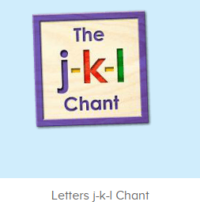  图2：  图3：  图4：  图5：
三、家庭游戏活动布置：  T: Now, I’ll show you the activities. (将已放入功课的作业界面打开)  Here are your activities for today.  You have to do these activities.  How many activities? Let’s count together.  S: One, two, three, four.  T: You have to do these activities, OK?  S: OK!  T: Each of them, you need to play 5 times. OK?  S: OK!  T: Look at me, I will show you.  Please listen and repeat. (加上肢体动作演示)  OK?  S: OK!  T: Clear?  S: Yes!  T: Who can show us how to do it?  S: Let me try!  T: Mary come here and show us how to do the activities. (每一位幼生上前演示如何操作)  T: Good job! Thank you Mary!  T: Who can retell how to do it?  S: Let me try!（教师可引导幼生）  T: Good! Please finish your activities and show me tomorrow, OK?  S: OK  T: Class is over, Goodbye, everyone.  S: Goodbye. | 家庭游戏活动：

