Letters Review J-K-L&How Are You课时3
素材内容：
- How Are You? Part 1 Animation
- How Are You? Animation
- Practice Page: How are you?
- My body Music Video
- Let’s Learn English: Lesson 5
素材截图：
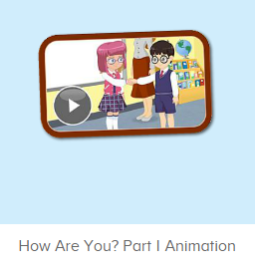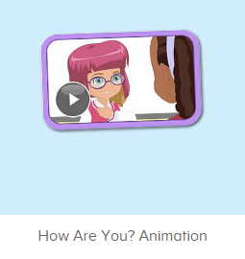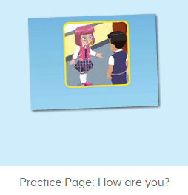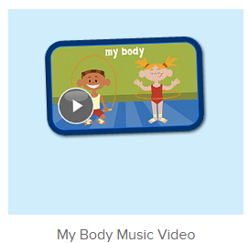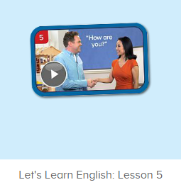
年龄段：小班下
教学目标：
- 能从口语动画小剧场中听出关键句子How are you.
- 能理解并运用句子How are you，并能用I’m fine回答.
- 学习打招呼对话，能进行操练。
教具准备：
1. 一些头饰、眼镜等装扮道具
使用游戏：
1. 舞蹈接龙游戏 2. Role play
教学步骤： | 备注
- 成果公布及展示：  T: Hello kids, good morning.  S: Good morning.  T: First, let's praise Lily, Andy, Peter, Jimmy... They have finished all their activities.  Everybody look,what is this? This is... (带领全体幼生回顾前三个字母已学过的关于我的名称)  S: This is my room/ my aquarium/ my hamster.  T: Is it right? Let’s listen and repeat.  S: Go to my room./ go to my aquarium/ go to my hamster.  Coco come here, please show us your room.  C: Yes.  C: This is my room.This is my bed. My bed is yellow.  T: Wow, terrific! Thank you Coco.  Everybody together.  S: This is my room.This is my bed. My bed is yellow. （带领幼生整体描述一遍）  T: Well done! | 公布家庭活动成果并展示关于我（我的房间/我的鱼缸/我的仓鼠）
- 集体学习活动：  口语动画小剧场  T: Now, let’s watch the video, listen and no voice. （打开图1口语动画素材，请幼生认真观看和听，不跟读）  What can you hear?  S: How are you./ This is my eye./ ...  T: Right? Let’s check it, listen again. （教师再次播放口语动画，在幼生说出来的地方进行鼓励，在幼生没有说出来的地方进行提示）  T: This time, when you hear How are you, please clap your hands, OK?  S: OK!  T: Good! Now, let’s watch again. When you hear How are you, please follow it, OK? （教师再次播放口语动画，在播放到How are you的句子后暂停，示意让幼生跟读）  T: Follow it.  S: How are you. （在幼生跟读的同时，教师也做TPR做提示）  T: One more time.  S: How are you.  T: Good job! Continue! This time, when you hear I am fine, please stamp your feet, OK?  S: OK!  T: Good! Now, Let’s watch again. When you hear “How are you” and “I am fine”, please follow it, OK? （教师再次播放口语动画，在播放到How are you和I am fine的句子后暂停，示意让幼生跟读）  T: Follow it.  S: How are you?  T: Follow it.  S: I am fine.  T: One more time. Girls! （可进行分组练习）  Gs: How are you?  Bs: I am fine.  T: Boys!  Bs: How are you.  Gs: I am fine.  T: Good job!  T: Lily, come here please. （邀请一位幼生进行示范）  T: Lily, How are you? （可做握手的动作）  I am ...  Lily: I am fine.  T: Good job! One more time!  T: How are you?  Lily: I am fine.  T: Good job! Thank you Lily, go back to your seat please. Who can try?  S: Let me try?  T: Peter and Candy, come here please.  Peter: How are you? （提示幼生做握手的动作）  Candy: I am fine.  T: Good job! Who can try?  S: Let me try...（继续邀请幼生练习对话）  T: Now, let’s watch the video again. （教师播放图2口语动画素材-How Are You Animation, 在已学写对话部分，示意幼生一起做TPR，其余部分让幼生继续观看）  趣味复读机  T: Now, listen and repeat. （打开图3素材，请幼生跟读发音）  What can you hear?  S: How are you.  T: Good! Follow it please.  S: How are you. （让幼生跟读3-5遍）  T: Nice! Let’s add the action.  T: How are you? （幼生边做边说，示意幼生一起）  S: How are you?  T: Good job! How are you?  I am ...  S: I am fine.  T: Good job! Lisa, How are you? （教师做TPR提示，可再询问多位幼生）  Lisa: I am fine. （提示幼生做TPR）  T: Good job!  快乐唱片机  T: Now, let’s sing the song - My Body, together. （打开图4歌曲素材，请幼生一起唱）  S: My head is on top of my body. ...  T: Good! Now, everybody stand up, let’s sing and dance. （教师再次播放歌曲，请幼生边唱边做TPR）  S: My head has...  T: Good! Now, let’s play a game. We sing and dance one bye one. （舞蹈接龙游戏：请一组幼生上台排成一行，播放音乐，每位幼生跟随音乐按顺序表演一句歌词）  T: Team1 come here. （可分几组进行比赛）  Are you ready?  Team1: Yes.  T: Ready! Go!  Team1: ...  T: Wow, good job! Now, Team2 come here please.  Team2: ...  T: Well done! Team 1 win!  外教口语课  T: Now, let’s see a video. （教师播放图5素材，播放到视频中的老师戴着帽子、眼镜等道具示范打招呼后暂停）  T: What can you hear?  S: How are you?/ I am fine.  T: Let’s check. （再次播放视频中老师戴着帽子、眼镜等道具示范打招呼）Is it right?  S: Yes!  T: Let’s follow it. （再次播放老师示范打招呼，共3句对话，每播放一句暂停，示意幼生跟读）  S: Hello! How are you?  S: I am fine. How are you?  S: I am fine. Thank you!  T: Good job! One more time. （再次播放老师示范打招呼，每播放一句暂停，示意幼生跟读）  S: Hello! How are you?  S: I am fine. How are you?  S: I am fine. Thank you!  T: Good job! Let’s have a match. Boys and Girls, are you ready?  S: Yes. （再次播放，让幼生分组跟读）  Boys: Hello! How are you?  Girls: I am fine. How are you?  Boys: I am fine. Thank you!  T: One more time. This time, girls first!（再次播放，让幼生分组跟读）  Girls: Hello! How are you?  Boys: I am fine. How are you?  Girls: I am fine. Thank you!  T: Excellent! How are you? Children.  S: I am fine. How are you? （教师可提示）  T: I am fine. Thank you!  T: Sunny, How are you? （提问个别幼生进行检验，教师做握手动作）  Sunny: I am fine. How are you?  T: I am fine. Thank you! （可再提问多个幼生）  T: Now, let’s do some role play. Tom, come here please. （教师带上装扮道具，和幼生练习对话）  T: Hello! How are you? （做出握手的动作）  Tom: I am fine. How are you?  T: I am fine. Thank you!  T: Excellent! Thank you, Tom. Who wants to try?  S: Let me try!  T: Ron and Jenny come here please.（请2位幼生上台，让幼生互相为对方挑选装扮道具，进行对话练习）  R: Hello! How are you?  J: I am fine. How are you?  R: I am fine. Thank you!  T: Nice! Who can try? （继续邀请幼生继续操练）  S: Let me try!...  T: Very good! Now let's count our tickets.  Who can try?  S: Let me try.  T: Tommy please.  Where can we find our tickets?  S: "About me".  T: Tommy click it please.  Now let's count with ABCmouse.  S&ABCmouse: One,two,three......  T: So we have ten tickets today, great job! Thank you Tommy. | 图1：  图2：  图3：  图4：  图5：
三、家庭游戏活动布置：  T: Now, I’ll show you the activities. (将已放入功课的作业界面打开)  Here are your activities for today.  You have to do these activities.  How many activities? Let’s count together.  S: One, two, three, four.  T: You have to do these activities, OK?  S: OK!  T: Each of them, you need to play 5 times. OK?  S: OK!  T: Look at me, I will show you.  Please listen and repeat. (加上肢体动作演示)  OK?  S: OK!  T: Clear?  S: Yes!  T: Who can show us how to do it?  S: Let me try!  T: Mary come here and show us how to do the activities. (每一位幼生上前演示如何操作)  T: Good job! Thank you Mary!  T: Who can retell how to do it?  S: Let me try!（教师可引导幼生）  T: Good! Please finish your activities and show me tomorrow, OK?  S: OK  T: Class is over, Goodbye, everyone.  S: Goodbye. | 家庭游戏活动：

