Letters Review J-K-L&How Are You课时4
复习素材：  - How Are You? Animation  - My body Music Video  - Practice Page: How are you? | 新授素材：  - How Are You?  - Hello! How are you?  - I am fine. How are you?
素材截图：
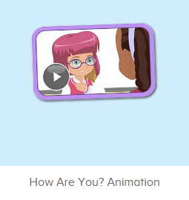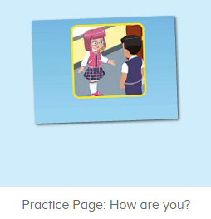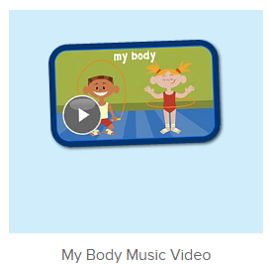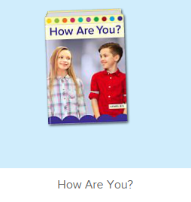
教学目标：
- 能从口语动画小剧场中听出关键问候句型。
- 熟练掌握打招呼句式 “How are you?”, “I am fine, thank you!”
- 学习故事图书前4句。
教具准备：
1. 一些头饰、眼镜等装扮道具
使用游戏：
1. Role play 2. 舞蹈接龙游戏
教学步骤： |  | 备注
- 成果公布及展示：  T: Hello kids, good morning.  S: Good morning.  T: First, let's praise Lily, Andy, Peter, Jimmy... They have finished all their activities.  Everybody look,what is this? This is... (带领全体幼生回顾前三个字母已学过的关于我的名称)  S: This is my room/ my aquarium/ my hamster.  T: Is it right? Let’s listen and repeat.  S: Go to my room./ go to my aquarium/ go to my hamster.  Coco come here, please show us your room.  C: Yes.  C: This is my room.This is my bed. My bed is yellow.  T: Wow, terrific! Than  k you Coco.  Everybody together.  S: This is my room.This is my bed. My bed is yellow. （带领幼生整体描述一遍）  T: Well done! |  | 公布家庭活动成果并展示关于我（我的房间/我的鱼缸/我的仓鼠）
- 集体学习活动：  口语动画小剧场  T: Now, let’s watch the video, when you hear “How are you” and “I am fine”, please follow it, OK? （教师打开图1口语动画素材进行复习）  S: How are you...  T: Good job! How are you? Kids.  S: I am fine. How are you. （教师可提示）  T: I am fine. Thank you!  T: Nice, let’s do some role play. Tom, come here please. （教师带上装扮道具，和幼生练习对话）  T: Hello! How are you? （做出握手的动作）  Tom: I am fine. How are you?  T: I am fine. Thank you!  T: Excellent! Thank you, Tom. Who wants to try?  S: Let me try!  T: Ron and Jenny come here please.（请2位幼生上台，让幼生互相为对方挑选装扮道具，进行对话练习）  R: Hello! How are you?  J: I am fine. How are you?  R: I am fine. Thank you!  T: Nice! Who can try? （继续邀请幼生继续操练）  S: Let me try!...  趣味复读机  T: Look! What can you see ?（教师打开图2素材，教师可把音量调至静音）  S:I can see ...（引导幼生说出图片上的人名）  T:Listen.What’s the sentence of this picture? S: How are you.  T: Really? Let’s check it! （教师点击图片）  Is it right?  S: Yes.  T: Good! Follow it! （教师点击图片，让幼生跟读）  S: How are you?  T: Good job!  T: One more time.  S: How are you.  T: Good job!  T: How are you? Kids. （与幼生练习对话）  S: I am fine. How are you?  T: I am fine. Thank you!  T: Excellent!  快乐唱片机  T: Now, let’s sing the song - My Body together.  （打开图3曲素材，请幼生一起唱）  S: My head is on top of my body...  T: Good! Now, everybody stand up, let’s sing and dance. （教师再次播放歌曲，请幼生边唱边做TPR）  S:My head has a ...  T: Good! Now, let’s play a game. We sing and dance one by one. （舞蹈接龙游戏：请一组幼生上台排成一行，播放音乐，每位幼生跟随音乐按顺序表演一句歌词）  T: Team 1 come here. （可分几组进行比赛）  Are you ready?  Team1: Yes.  T: Ready! Go!  Team1: ...  T: Wow, good job! Now, Team 2 come here please.  Team2: ...  T: Well done! Team 2 win!  趣味图书：  T: Book time!（教师打开图4图书素材）  T: Listen and no voice. And then tell me what’s the name of this book? （教师加以手势示意幼生认真听书的名字，不跟读）  T: What is the name of this book?  S: How Are You?  T: Let’s check it, listen again. （再播放一遍书名）  Is it right?  S: Yes!  T: Listen and repeat. （播放一次书名，让幼生跟读）  S: How Are You?  T: Tell me again. What’s the name of this book?  S: How Are You?  T: Good job! Let’s enjoy the book “How Are You?”.  （教师在播放图书的同时，教师可一边做TPR进行提示）  T: This time, please listen and no voice, and then tell me what can you hear, OK?  S: OK!  T: What can you hear?  S: How are you?/ I am fine.  T: Is it right? Let’s check it, good job!  T: Now! Listen and repeat. （播放图书至第4页暂停，让幼生跟读每一句）  S: Hello! How are you? I am fine. How are you?  T: One more time.  S: Hello! How are you? I am fine. How are you?  T: Excellent!  T: Anna. Hello! How are you? （教师做出握手的动作）  Anna: I am fine. How are you?  T: I am fine. Thank you!  T: Oral. Hello! How are you?  Oral: I am fine. How are you?  T: I am fine. Thank you! （可再询问多位幼生进行句型操练）  T: Who wants to be the little teacher?  S: Let me try.  T: Pam, come here, you will be the little teacher. Say “Hello. How are you?” to your students. （示意幼生做出握手的动作）  Pam: Hello. How are you?  S1: I am fine. How are you?  Pam: I am fine. Thank you.  Pam: Hello. How are you?  S2: I am fine. How are you?  Pam: I am fine. Thank you. （可再要求多位幼生做小老师，操练句子）  T: Good job! Thank you Pam! Go back to your seat please. Now, let’s enjoy the book - How Are you. （教师示意幼生跟读前4句，其余的继续播放）  S: Hello! How are you? I am fine. How are you?  T:Very good! Now let's count our tickets.  Who can try?  S:Let me try.  T:Tommy please.  Where can we find our tickets?  S: "About me".  T:Tommy click it please.  Now let's count with ABCmouse.  S&ABCmouse: One,two,three......  T: So we have ten tickets today, great job! Thank you Tommy. |  | 图1：  图2：  图3：  图4：
三、家庭游戏活动布置：  T: Now, I’ll show you the activities. (将已放入功课的作业界面打开)  Here are your activities for today.  You have to do these activities.  How many activities? Let’s count together.  S: One, two, three, four.  T: You have to do these activities, OK?  S: OK!  T: Each of them, you need to play 5 times. OK?  S: OK!  T: Look at me, I will show you.  Please listen and repeat. (加上肢体动作演示)  OK?  S: OK!  T: Clear?  S: Yes!  T: Who can show us how to do it?  S: Let me try!  T: Mary come here and show us how to do the activities. (每一位幼生上前演示如何操作)  T: Good job! Thank you Mary!  T: Who can retell how to do it?  S: Let me try!（教师可引导幼生）  T: Good! Please finish your activities and show me tomorrow, OK?  S: OK  T: Class is over, Goodbye, everyone.  S: Goodbye. |  | 家庭游戏活动：  