Letters Review J-K-L&How Are You课时5
学习素材：
- How Are You? Part 2 Animation
- Practice Page: This is my face.
- Practice Page: This is my nose.
- Practice Page: This is my eye.
- Practice Page: This is my mouth.
- How Are You?
- I am fine. What is your name?
- My name is Kate. What is your name?
- My name is Reed. It is nice to meet you.
素材截图：
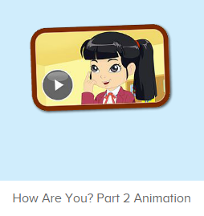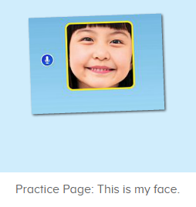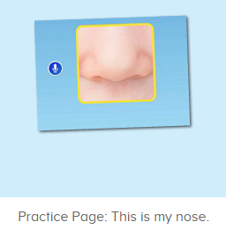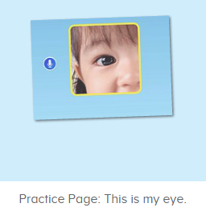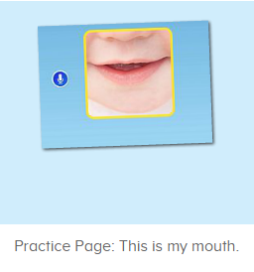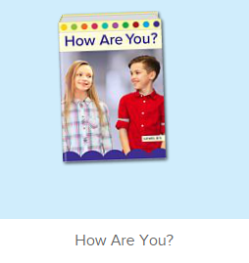
教学目标：
- 能从口语动画小剧场中听出关键句型This is my ...
- 熟练掌握句型This is my..., 并能介绍自己的五官。
- 掌握问答句式 “What is your name?”, “My name is ...”
教具准备：
1. 五官的词汇图卡
使用游戏：
2. Choosing Game
教学步骤： | 备注
- 成果公布及展示：  T: Hello kids, good morning.  S: Good morning.  T: First, let's praise Lily, Andy, Peter, Jimmy... They have finished all their activities.  Everybody look,what is this? This is... (带领全体幼生回顾前三个字母已学过的关于我的名称)  S: This is my room/ my aquarium/ my hamster.  T: Is it right? Let’s listen and repeat.  S: Go to my room./ go to my aquarium/ go to my hamster.  Coco come here, please show us your room.  C: Yes.  C: This is my room.This is my bed. My bed is yellow.  T: Wow, terrific! Than  k you Coco.  Everybody together.  S: This is my room.This is my bed. My bed is yellow. （带领幼生整体描述一遍）  T: Well done! | 公布家庭活动成果并展示关于我（我的房间/我的鱼缸/我的仓鼠）
- 集体学习活动：  口语动画小剧场  T: Now, let’s watch the video, listen and no voice. （教师打开图1口语动画素材,请幼生认真观看和听，不跟读）  What can you hear?  S: This is my ...  T: Right? Let’s check it, listen again. （教师再次播放口语动画，在幼生说出来的地方进行鼓励，在幼生没有说出来的地方进行提示）  T: This time, when you hear This is my face, this is my eye,... Please repeat it and do the action, OK? （教师再次播放口语动画，在播放到This is ...等关键句子后暂停，示意让幼生跟读和做动作）  T: follow it.  S: What is this?  This is my face. （在幼生跟读的同时，教师也做TPR提示）  This is my eye./ Eyes.  This is my mouth.  This is my ear.  This is my nose.  T: One more time.  S: ...  T: Good job! Let’s have a match. Boys and Girls, are you ready? （分组跟读练习，播放口语动画，每一个关键句子后暂停，让幼生跟读）  S: Yes.  T: Boys. Ready! Go!  Boys: This is my face.  T: Girls.  Girls: This is my eye./ Eyes.  Boys: ...  Girls: ...  T: Good job! Lily, what is this? （教师示意幼生的脸）  Lily: This is my face.  T: Good job! What is this? （与幼生互动，询问幼生的五官）  S1: This is my eye.  T: What is this?  S2: This is my mouth. （以此类推，与幼生练习句型）  T: Now, who wants to be the little teacher?  S: Let me try.  T: Ron, come here, you will be the little teacher. （邀请幼生当小老师，询问幼生）  R: What is this?  S3: This is my mouth.  R: What is this?  S4: This is my ear.  T: Good job, thank you, Ron, go back to your seat please. Who wants to try? （继续邀请幼生当小老师，操练句型）  S: Let me try.  趣味复读机  T: Now, listen carefully.（打开图2素材，请幼生跟读发音）  What can you hear?  S: This is my face.  T: Good! Follow it please.  S: This is my face. （让幼生跟读3-5遍）  T: Nice! Let’s add the action.  T: This is my face. （教师边做边说，示意幼生一起）  S: This is my face.  T: Good job! What is this? （教师示意脸）  S: This is my face.  T: Good job! Next one. Listen carefully.（打开图3素材，请幼生跟读发音）What can you hear?  S: This is my nose.  T: Good! Follow it please.  S: This is my nose. （让幼生跟读3-5遍）  T: Nice! Let’s add the action.  T: This is my nose. （教师边做边说，示意幼生一起）  S: This is my nose.  T: Good job! What is this? （教师示意鼻子）  S: This is my nose.  T: Good job! Next one. Listen carefully. （打开图4素材，请幼生跟读发音）What can you hear?  S: This is my eye.  T: Good! Follow it please.  S: This is my eye. （让幼生跟读3-5遍）  T: Nice! Let’s add the action.  T: This is my eye. （教师边做边说，示意幼生一起）  S: This is my eye.  T: Good job! What is this? （教师示意眼睛）  S: This is my eye.  T: Good job! The last one! Listen carefully. （打开图5素材，请幼生跟读发音）What can you hear?  S: This is my mouth.  T: Good! Follow it please.  S: This is my mouth. （让幼生跟读3-5遍）  T: How to do the action?  T: This is my mouth. （教师边做边说，示意幼生一起）  S: This is my mouth.  T: Excellent.  Choosing Game  T: Let’s play the Choosing Game. When you choose the card, please say the sentence and do the action. （教师拿出五官的词汇图卡，让幼生抽，要读出抽中图卡的句子，并做TPR）  S1: This is my face.  S2: This is my ...  T: Let’s do it one by one.  S3: This is my face.  S4: This is my mouth.  S5: ...  趣味图书  T: Book time! （教师打开图6图书素材）  T: What’s the name of this book?  S: How Are You?  T: Let’s check it, listen again. （再播放一遍书名）  Is it right?  S: Yes!  T: Listen and repeat. （播放一次书名，让幼生跟读）  S: How Are You?  T: Tell me again. What’s the name of this book?  S: How Are You?  T: Now, let’s perform the book. （教师打开图6故事图书，播放至学过的部分，请幼生边跟读边做TPR）  S: Hello! How are you? I am fine. How are you?  T: Good! Now, let’s listen and repeat. Are you ready? （每次播放1句就暂停，让幼生跟读，以此类推到第6页）  S: How Are You.  Hello! How are you?  I am fine. How are you?  I am fine. What is your name?  T: Repeat again. （重复播放第6页）  What ...  S: What is your name?  T: One more time.  S: What is your name?  T: Continue. Listen and repeat. （播放第8页）  S: My name is Kate. What is your name?  T: One more time.  S: My name is Kate. What is your name?  T: What is her name? （指着图书中的人物）  S: Kate.  T: Really? Let’s check it.  Is it right? （再次播放第8页检验）  T: Good! What is your name?  My name is...  S: My name is...  T: What is your name? （询问个别幼生）  S1: My name is Lily.  T: What is your name?  S2: My name is Sarah.  T: Good job! （以此类推，询问多个幼生）  T: Now, who can be the little teacher?  S: Let met try.  T: Bonnie, come here please. You’ll be the little teacher. Please ask “What is your name?”  B: What is your name?  S3: My name is ...  B: What is your name?  S4: My name is ...  T: Good job! Who can try? （再邀请幼生继续句型操练）  S:...  T: Continue! Listen and repeat. （播放第10页，让幼生跟读）  S: My name is Reed. It is nice to meet you.  T: One more time.  S: My name is Reed. It is nice to meet you.  T: Good. My name is Abby. It is nice to meet you.  My name is ... （教师做出握手的动作，与幼生练习句型）  S5: My name is ....  T: It is nice ...  S5 It is nice to meet you.  T: Good! My name is Abby. It is nice to meet you.  S6: My name is ..., it is nice to meet you.  T: Excellent! Who can be the little teacher?  S: Let me try.  T: Come here please. Benny. Listen! My name is Abby. What is your name?  B: My name is Benny. ...  T: Benny, can you ask me?  My name is ...  What is your name?  Benny: My name is Benny. What is your name? （教师做提示）  T: My name is Abby. It is nice to meet you. （教师做出握手的动作）  T: One more time!  Benny: My name is Benny. What is your name?  T: My name is Abby. It is nice to meet you. （教师做出握手的动作）  T: Benny, you will be the little teacher, please. （示意幼生提问其余幼生）  B: My name is Benny. What is your name? （示意幼生做出握手的动作）  S7: My name is ..., It is nice to meet you.  B: My name is Benny. What is your name? （示意幼生做出握手的动作）  S8: My name is ..., It is nice to meet you.  T: Good job! Thank you Benny. Go back to your seat please.（可再邀请多位幼生做小老师）  T: Look! What is his name? What is her name? （回到故事图书上）  S: Reed./ Kate...  T: Really? Let’s check it. （再次播放第8-第10页）  T: Follow it together.  S: My name is Kate. What is your name?  My name is Reed. It is nice to meet you.  T: Good job! Continue! Listen and repeat. （让幼生熟悉剩下的内容）  T:Very good! Now let's count our tickets.  Who can try?  S:Let me try.  T:Tommy please.  Where can we find our tickets?  S: "About me".  T:Tommy click it please.  Now let's count with ABCmouse.  S&ABCmouse: One,two,three......  T: So we have ten tickets today, great job! Thank you Tommy. | 图1：  图2：  图3：  图4：  图5：  图6：
三、家庭游戏活动布置：  T: Now, I’ll show you the activities. (将已放入功课的作业界面打开)  Here are your activities for today.  You have to do these activities.  How many activities? Let’s count together.  S: One, two, three, four.  T: You have to do these activities, OK?  S: OK!  T: Each of them, you need to play 5 times. OK?  S: OK!  T: Look at me, I will show you.  Please listen and repeat. (加上肢体动作演示)  OK?  S: OK!  T: Clear?  S: Yes!  T: Who can show us how to do it?  S: Let me try!  T: Mary come here and show us how to do the activities. (每一位幼生上前演示如何操作)  T: Good job! Thank you Mary!  T: Who can retell how to do it?  S: Let me try!（教师可引导幼生）  T: Good! Please finish your activities and show me tomorrow, OK?  S: OK  T: Class is over, Goodbye, everyone.  S: Goodbye. | 家庭游戏活动：

